

Council Improvement Plan

As at 30th September 2015

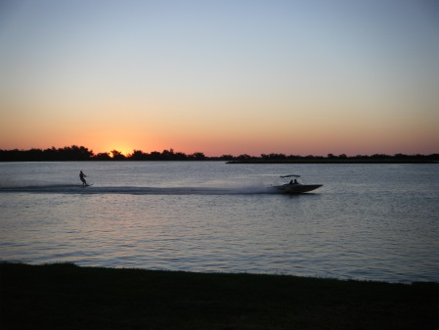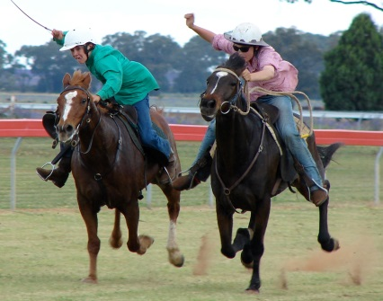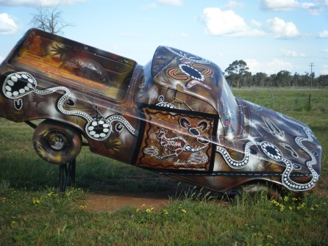

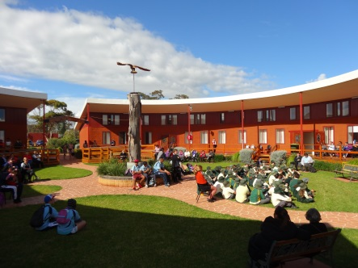

## IMPROVEMENT ACTION PLAN 2015-16 YEAR

This section summarises the key improvement actions that will be commenced and/or achieved in the first year of this Plan.

| No | ACTIONS | STATUS | | LINK TO CSP |
| --- | --- | --- | --- | --- |
| 1 | Apply for a special rate variation of 33% over 4 years | By February 2016 for 1 July 2016 | | Income shown in LTFP from 2016/17 |
| 2 | Develop and adopt a Section 94A Contributions Plan | **Completed** | | Income shown in LTFP from 2015/16 |
| 3 | Examine assets not required for operations such as housing, plant, commercial premises, land, etc. and utilise sale income for asset renewal and reducing infrastructure backlog. | **Commenced**  3 houses currently on market. 1 res. lot under offer.  Medical centre under offer | | LTFP allows for sale of 3 houses and all remaining Council land in its industrial and residential subdivisions. Other assets to be identified not included at this time. |
| 4 | Reduction of donations budget for community groups, schools, organisations and individuals to $16,000 p.a. | **Completed** | | $50,000 reduction in 2015/16 and a further $50,000 reduction thereafter has been included in LTFP |
| 5 | Develop, in conjunction with staff, an Enterprise Risk Management Plan | **Commenced** | | Recommendation of Better Practice Review |
| 6 | Engage an independent Internal Auditor to prepare an internal audit plan from the Enterprise Risk Management Plan and undertake internal audit function. | **Commenced** | | Engagement of Internal Auditor budgeted in LTFP from 2015/16 |
| 7 | Review organisation structure and workforce strategy following review of service levels to determine if staff and skill levels are appropriate. | By December 2016 | | To be included after service level review and after next Council election |
| 8 | Prepare and implement an Economic Development Plan to increase investment, employment and population. Construct Jockey’s Garden Memorial. | **Commenced** | | Funds allowed in LTFP 2015/16 and 2016/17 |
| 9 | Engage Micromex Pty ltd to undertake a customer satisfaction survey to assess satisfaction and importance of services provided by LSC | By June 2016 | Funds allowed in LTFP from 2015/16 onwards | | |
| 10 | Undertake a service level review in line with the ACELG Service Delivery Review in Australian Local Government Report. | **To commence in 2016** | Refer Page 9 of CSP | | |
| 11 | Engage independent professional valuer to assess all building assets and determine cost to bring to a satisfactory standard.  Develop a buildings programmed maintenance plan | **Commenced** | Consultant costs included in LTFP in 2015/16 | | |
| 12 | Utilise loans as a source of funding for the construction of the Showground Hall – access TCorp borrowing facility. | By June 2016 | Included in LTFP 2015/16 | | |
| 13 | Asset management plans to be reviewed in-house and integrated with the Long Term Financial Plan | **Commenced** | Included in Resourcing Strategy | | |
| 14 | Engage independent professional engineer to assess all road infrastructure assets and determine cost to bring to a satisfactory condition. | **Commenced** | Consultant costs included in LTFP in 2015/16 | | |
| 15 | Introduce Zero Based Budgeting (ZBB) | In place for 1 July 2016 | In-house by existing staff – No savings identified at this time | | |
| 16 | Revise current work practices to reduce costs and improve efficiencies | By June 2016 | In-house by existing staff – No savings identified at this time | | |
| 17 | Negotiate a new Enterprise Agreement and eliminate payment of untaken sick leave on termination and introduce fortnightly pays. | **Commenced** | In-house by existing staff – No savings identified at this time | | |
| 18 | Establish leave plans for individuals with excessive annual and long service leave | **Commenced** | In-house by existing staff – No savings identified at this time | | |
| 19 | Review all delegations and staff who have delegated functions. | **Completed** | In-house by existing staff – No savings identified at this time | | |
| 20 | Strengthen Friendship alliance with Penrith City Council and utilise their staff and expertise to improve governance processes. | **Commenced** | In-house by existing staff – No savings identified at this time | | |
| 21 | Develop a formal MOU with the Mid Lachlan Alliance (Forbes, Parkes and Lachlan) setting out opportunities for Resource Sharing. | **Commenced** | In-house by existing staff – No savings identified at this time | | |
| 22 | Assign relevant staff to the various working committees of the CENTROC JO. | **Commenced** | In-house by existing staff – No savings identified at this time | | |
| 23 | Develop Management Plans for Gumbend Lake Recreational Area and Condobolin Showground/Racecourse. | By December 2016 | In-house by existing staff – No savings identified at this time | | |