**Capacity to Pay – Cootamundra-Gundagai Regional Council**

**Report Prepared by Prof Joseph Drew**

Office of Local Government Guidelines require Councils to ‘establish that the proposed rate of increases are affordable having regard to the community’s capacity to pay’ (Office of Local Government, 2020, p. 9). Moreover, from the outset, the Councillors have been keen to understand whether the community does indeed have the capacity to absorb the proposed increases to taxation, required to repair the budget following the very significant cost pressures imposed by the May 2016 forced amalgamation and subsequent rate path freeze.

There are various ways to ascertain capacity to pay which range from the common rudimentary approaches taken in most Special Rate Variation (SRV) applications, through to the sophisticated. In response to the large size of the proposed SRV it is appropriate for this report to detail the most comprehensive and sophisticated analysis possible.

The report begins with the standard comparison of taxation levels in other OLG 11 local governments, which is the category to which Cootamundra-Gundagai belongs. This kind of rudimentary comparison only has limited value because it implicitly assumes: (i) that extant taxation rates are both affordable and adequate (by no means certain – see, Drew and Dollery, 2015), (ii) that the mean is indeed a good measure of central tendency (which it isn’t), and (iii) that the OLG categorisation system is fit-for-purpose (which is not the case– see Drew and Dollery, 2016). Nevertheless, despite the clear deficiencies of this type of approach, it does seem to be *de rigueur*, thus I commence with this comparison.

In addition, it is generally considered important to investigate the revenue streams accruing to residents. This is also a rudimentary task undertaken in most SRV applications. Here one tends to see comparisons of the Socio-Economic Indexes for Areas (SEIFA) compiled in census years. This is not the most helpful approach that might be taken given that: (i) important changes in inter-censal years will be neglected, (ii) the mathematical task of creating an index necessarily results in the loss of important information (see, for example, Coelli et al., 2006), (iii) such indexes are more likely to neglect intra-jurisdictional (LGA) variation, and (iv) the index does not really respond to two of the three relevant rating categories (farmland and business respectively). Therefore, I augment this coarse measure with a number of metrics grouped according to their relevance to the three rating categories in operation at Cootamundra-Gundagai.

To understand residential capacity to pay I look at a range of data relating to various welfare receipts, equivalised household income data, median wage data, wage inequality data, household stress (census) data, and median house price data.

I then analyse unincorporated business data. Unincorporated businesses are operations that are not carried out under a company structure as per the definition in the Corporations Act (CTH, 2001). This data encompasses many small businesses, suppliers of trade services, and farm enterprises. Unfortunately, incorporated business data is not available on a local government area (LGA) level as this operating structure is often used by national and multinational firms where it would not be practical to record data on such a small scale.

Following this analysis of unincorporated business data, I make a study of agricultural income by employing Australian Bureau of Agricultural and Resource Economics and Sciences (ABARES) data. This is also both a necessary and critical task to undertake given that almost half (49.8%) of local government taxation revenue collected at Cootamundra-Gundagai in 2019-20 was sourced from the farmland category. I also provide, in an appendix, Bureau of Meteorology data because rainfall is the main driver of agricultural production.

All of these additional analyses that I conduct provide a much more comprehensive picture of revenue capacity than what one generally finds in SRV applications.

However, to have a truly thorough understanding of capacity one also needs to conduct more sophisticated, broader, and deeper empirical analysis. Accordingly, in the penultimate part of this report, I conduct a three-year panel multiple regression analysis based on financial and socio-economic data of all rural New South Wales local governments.

I conclude this report with a statement regarding the community’s capacity to absorb the proposed special rate variation which is my professional opinion – the quality of which is attested to by over seventy peer reviewed scholarly works in some of the best scholarly journals in the world.

**2. Comparison of Average Rates.**

Table 1 presents average rate data for the three categories used at Cootamundra-Gundagai Council for the 2020-21 financial year. At the time of writing the most recent data available from the Office of Local Government was for the 2018-19 financial year. The Cootamundra-Gundagai Council data came direct from the 2020-21 operational plan. To ensure fair comparisons I multiplied each data point by the appropriate rate cap. For local governments that had received an SRV during the intervening period, I used the approved SRV increase figure. Moreover, to facilitate quick and accurate comparison I calculated common measures of central tendency (mean, standard deviation, median, Quartile 1, Quartile 3, and inter-quartile range[1]).

As can be seen in Table 1, the existing average local government taxation levels for each category are far below the average for the OLG11 cohort in all instances. However, it seems that the data is skewed – thus only two of the categories are below the median (residential and business respectively).

For the reasons I have already described in the introduction to this report, a comparison of extant average taxation levels is not terribly useful, and indeed may prove misleading. Moreover, we need to be mindful of the inevitable distortion to these averages from the most recent land valuations[2]. Indeed, average rate levels are not a suitable basis for comparison and the OLG would be better served by recording comprehensive summaries of central tendency (similar to Table 1), as well as the actual tax rate in the dollar applied (which is a far more appropriate basis of comparison given the natural law foundations of unimproved land value taxation – see Drew, 2020).

**Table 1. Comparison of Average Rates, OLG 11 Councils 2020-21.**



Source: OLG Time Series data 2018-19, with cap and special rate variations applied as appropriate.

I chart these key measures of central tendency and spread in Figure 2 (please see Figure 1 for a description of how to interpret a box and whisker plot). Notably, the charts for farm and business categories clearly show the large spread in this data which makes it difficult to draw meaningful comparisons.

**Figure 1. Interpreting Box and Whisker Plots**

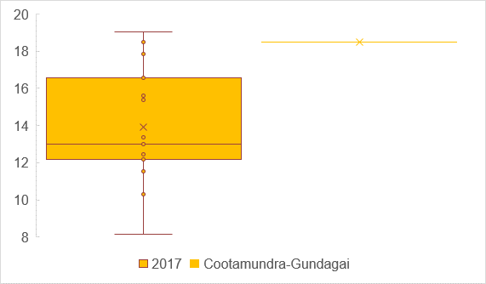

Quartile 1 (25% of results below this line)

Whiskers mark atypical results

Median (50% of results below this line)

Mean (average)

Cootamundra-Gundagai’s result

Quartile 3 (75% of results below this line)

**Figure 2. Comparative Rates, 2020-21**

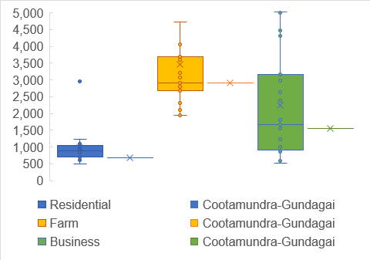

When it comes to assessing the capacity of ratepayers to absorb the proposed special rate variation it is helpful to also consider the rates and charges outstanding data from Note 26a of the audited financial statements. As detailed in Figure 3, the levels of outstanding fees and rates has decreased in a relative sense over the last few years. It is now well below the mean for the OLG11 cohort and slightly below the median. This seems to confirm that the community might have additional capacity (although to know this for certain we must conduct robust empirical work of the kind that I undertake in the penultimate section of this report). Cootamundra-Gundagai Council should monitor the rate and charges outstanding metric carefully over the term of the SRV to ensure that its hardship provisions are working effectively. Indeed it is important for all Councils to monitor this outstanding fee and rate data carefully from the second quarter of 2021 onwards, so that they get early warning of the expected cash flow disruptions that will inevitably arrive following scheduled termination of stimulus measures, reinstatement of insolvent trading laws, as well as the winding up of bad and doubtful bank debts.

**Figure 3. Rates and Charges Outstanding**

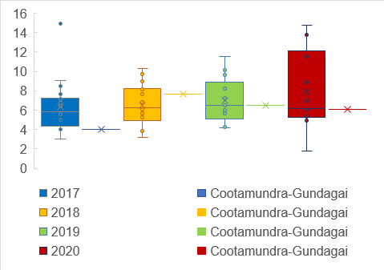

In sum, the extant levels of average taxation in Cootamundra-Gundagai are significantly lower than typical (as measured by the mean) for the OLG11 cohort. Moreover, rates and charges outstanding are also lower than typical at Cootamundra-Gundagai. When one combines these observations it seems to point to a judgement that the ratepayers at Cootamundra-Gundagai have capacity to absorb the proposed special rate variation. However, as I have detailed, comparative work based on averages is less than ideal, hence the sections of this report which follow.

**3. Socio-Economic Indicators.**

Page 10 of the Office of Local Government Guidelines (2020) call for the Independent Pricing and Regulatory Tribunal (IPART) to consider the SEIFA data for the local government area. For the reasons that I have already discussed, this is not a terribly useful exercise and could easily result in the IPART being misled regarding ratepayer capacity. As may be known, the SEIFA is actually four different indexes (I believe the Index of Socio-Economic Disadvantage is the most relevant and hence intended by the OLG) and data is reported in the Australian Bureau of Statistics *Data by Region* in terms of deciles (thus making it even less precise). However, in view of the Guidelines I have set-out the appropriate SEIFA in Table 2.

**Table 2. 2016 Census Data Socio-Economic Indexes for Areas (SEIFA).**

|  |  |  |
| --- | --- | --- |
| **Council** | **SEIFA IRSD Australia Decile** | **SEIFA IRSD State Decile** |
| Bellingen | 5 | 5 |
| Cabonne | 8 | 8 |
| Cootamundra Gundagai | 3 | 3 |
| Cowra | 2 | 2 |
| Federation | 5 | 5 |
| Greater Hume | 6 | 7 |
| Gunnedah | 4 | 4 |
| Hilltops | 4 | 3 |
| Inverell | 2 | 2 |
| Leeton | 4 | 4 |
| Moree Plains | 2 | 2 |
| Murray River | 7 | 7 |
| Muswellbrook | 3 | 3 |
| Nambucca | 2 | 1 |
| Narrabri | 4 | 4 |
| Parkes | 3 | 3 |
| Snowy Valleys | 4 | 4 |
| Upper Hunter | 6 | 6 |
| Yass Valley | 10 | 9 |
| Average | 4.4 | 4.3 |
| Standard Deviation | 2.1 | 2.2 |
| Median | 4.0 | 4.0 |
| Quartile 1 | 3.0 | 3.0 |
| Quartile 3 | 5.5 | 5.5 |
| Interquartile Range | 2.5 | 2.5 |
| Cootamundra Gundagai | 3 | 3 |

From this data one might conclude that capacity to pay at Cootamundra-Gundagai is well below central tendency. However, as we will see later in this report – particularly in our discussion of both unincorporated income and the regression results – this *prima facie* conclusion is indeed rather misleading.

I have charted the relevant SEIFA data in Figure 4 below.

**Figure 4. SEIFA Scores, 2016 Census**

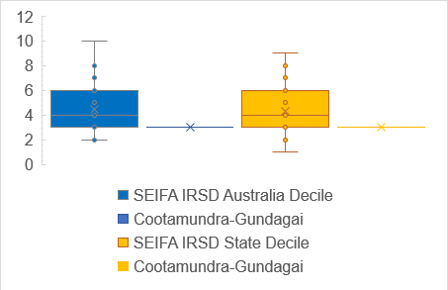

One way of mitigating the significant limitations arising from the use of a census index is to examine the data relating to various welfare receipts, and also wage income, over the inter-censal period.

Figure 5 charts the proportion of people on an Aged pension. As can be seen, Cootamundra-Gundagai is in the top quartile relative to the OLG11 peer group. On the whole, relatively large proportions of people on welfare payments suggest constrained capacity to pay, which is particularly relevant to residential assessments. Aged pensioners generally have incomes far lower than full-time wage earners. However, it should be noted that their incomes are more predictable and often larger than most casual workers, as well as the recipients of many kinds of alternate welfare payments. Moreover, we need to be mindful that this group does attract a discount to their local government taxation, and also receives a range of subsidies for items such as healthcare, and transport. Indeed, during the federal government response to COVID people on the pension received several rounds of stimulus payments which means that their financial situation, and hence capacity to pay local government taxation, is likely to be better than it was in the recent past. Notably, other welfare recipients also received windfall stimulus payments during the 2020 calendar year.

**Figure 5. Aged Pension**

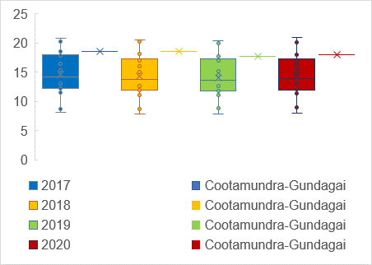

In similar vein, Cootamundra-Gundagai Regional Council has relatively high proportions of its population in receipt of the Disability Support pension. This further suggests relatively constrained revenue capacity with respect to residential assessments.

**Figure 6. Disability Support Pension**

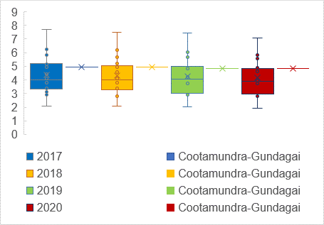

The Newstart Allowance data, in Table 7, paints a relatively better picture for Cootamundra-Gundagai. This data is particularly important because Newstart recipients are paid far lower levels of support and do not receive the same extensive range of discounts. Notably, these figures will have changed somewhat since the advent of COVID. Moreover, Newstart rates and stimulus have been higher than usual, in the 2020 calendar year, as part of the federal government response to the COVID. Data for this welfare receipt is pretty typical of the OLG11 peer group.

**Figure 7. Newstart Allowance**

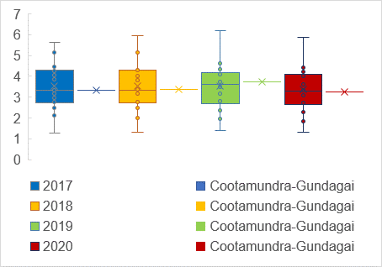

The proportion of people on the Single Parent pension is far lower than typical for the OLG11 peer group. This is a point in favour of the capacity of residential ratepayers to absorb the SRV relative to other OLG11 citizens (please see Figure 8).

**Figure 8. Single Parent Pension**

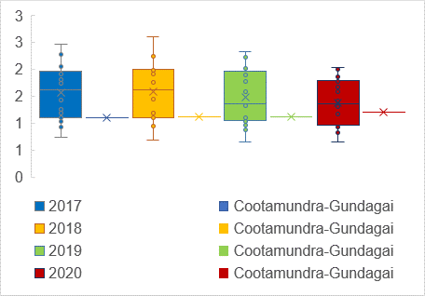

It is important to be mindful that notwithstanding the large proportion of Aged pensioners, in particular, the majority of ratepayers do indeed receive an income from working. In Figure 9, I chart the median income for wage-earners. As can be seen, earnings at Cootamundra-Gundagai are well below average and slightly less than the median (that is, in the second quartile). This suggests slightly constrained capacity to pay local government taxation for residential ratepayers relative to the OLG11 peer group. It should be noted that ABS data on income is generally a few years behind, as per Figure 9.

**Figure 9. Median Wage-Earner Income**

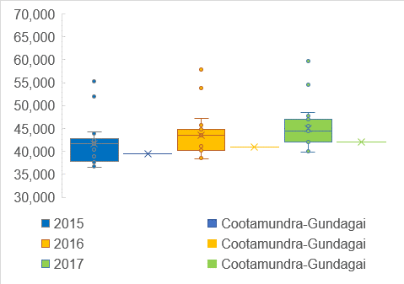

In Figure 10 I chart the mean income with similar results.

**Figure 10. Mean Wage-Earner Income**

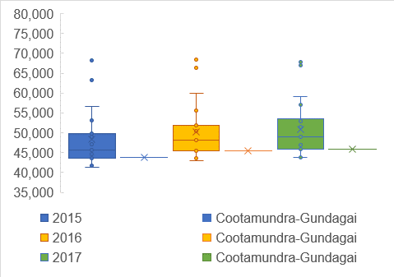

Notably incomes in Cootamundra-Gundagai are distributed relatively equitably (at least compared to the peer group) as demonstrated by Figures 11 and 12 which present two alternate measures of income equality. Income equality is important in a taxation sense because it suggests, ceteris paribus, that more reliance can be put on measures of central tendency (such as those set out in Figures 9 and 10) when assessing ratepayer capacity.

The P80/20 ratio, presented in Figure 11, is a measure of spread (the 80th percentile earnings divided by the 20th percentile, where higher numbers suggest relative inequality). It is notable that in the most recent year for which data was available there was greater income equality in Cootamundra-Gundagai, than for the typical peer.

**Figure 11. P80/20 Income Inequality Ratio**

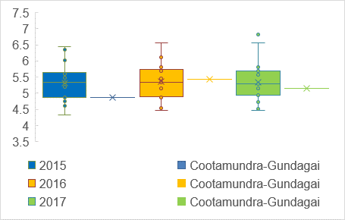

The Gini coefficient is a common way that economists analyse inequality across the entire distribution. Stiglitz (2013, p. 28) does a fine job of explaining the Gini coefficient which bears quoting at length:

‘If income was shared in proportion to the population – the bottom 10 percent getting roughly 10 percent of the income, the bottom 20 percent getting 20 percent, and so forth – then the Gini coefficient would be zero. There would be no inequality. On the other hand, if all the income went to the top person, the Gini coefficient would be one, in some sense ‘perfect’ inequality. More equal societies have Gini coefficients of 0.3 or below….The most unequal societies have Gini coefficients of 0.5 or above’ (Stiglitz, 2013, p. 28)

Notably by this measure Australia has high levels of inequality (a fact well known to people living in rural areas) because our national GINI stands at a disappointing 0.482 (ABS, 2020). Inequality across the entire distribution is also similarly high at Cootamundra-Gundagai in an absolute sense, but pretty typical for the OLG11 peer group

**Figure 12. Gini Coefficient Income Inequality Metric**

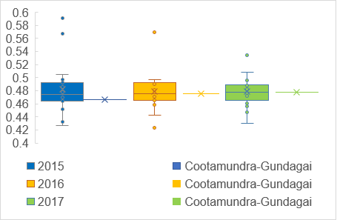

Of course, all of the aforementioned data is not definitive with respect to the capacity to absorb a special rate variation. First, people need to be mindful that the figures are most relevant to residential assessments. Farm assessments inevitably have additional revenue sources which I examine later in this report. Moreover, non-farm business capacity is influenced not only by the relative wealth of citizens in the catchment area, but also volumes, as well as the nature of the good sold (non-discretionary goods are far less influenced by the wealth of residents than are discretionary goods and services). Thus, the data that we have reviewed to date has little relevance to the capacity of the farm category to absorb a special rate variation, and only limited relevance for non-farm business capacity.

In addition, it must be remembered that rates are paid out of only a *portion* of household income flows. In Figure 13, I chart the median ‘equivalised[3]’ household income for Cootamundra-Gundagai relative to the OLG11 peer group. In a relative sense household income seems low, but this figure alone is likely to mislead.

**Figure 13. Median Equivalised Household Income (weekly)**

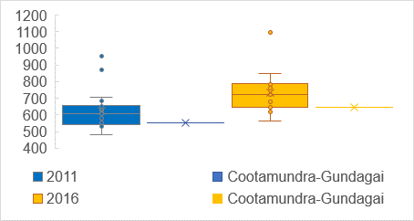

Each census the ABS calculates two important household stress indicators that put equivalised household income into better perspective. The first is the proportion of households where the mortgage repayments are greater or equal to thirty percent. This metric is important because it provides an insight into how much of a household’s income is dedicated to perhaps the largest category of expenditure – housing costs. As Figure 14 shows Cootamundra-Gundagai residents have some of the lowest household stress indicators in the peer group.

**Figure 14. Household Stress (mortgage greater or equal to 30%)**

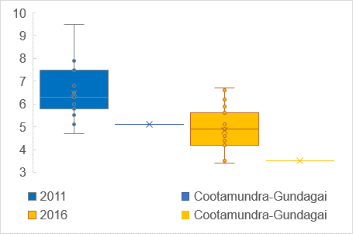

The second important indicator is household stress arising for renters which I present in Figure 15. Of course, people who rent their housing generally do not pay rates directly. However, local government taxes are indeed effectively incorporated into the rental price. Moreover, relatively low levels of renter stress indicate potential for landlords to better cope with the outcomes from a special rate variation. In this matter also, Cootamundra-Gundagai is shown to have relatively low levels of household stress.

**Figure 15. Household Stress (rent greater or equal to 30%)**

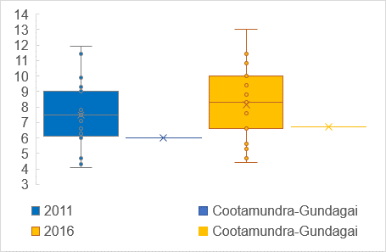

The reason for the very low levels of household stress in Cootamundra-Gundagai is, of course, very low house prices (in a relative sense). In Figure 16 I chart the median house sales prices which are consistently in the lowest quartile of the OLG11 peer group over the post-census period. This suggests that the census measures of household stress probably have not changed much since 2016.

**Figure 16. Houses (Median Sales Price)**

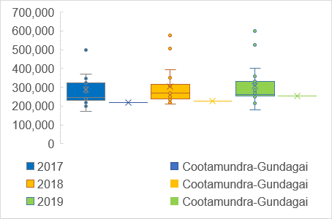

In sum, most intercensal economic metrics suggest that Cootamundra-Gundagai residential ratepayers have lower than typical flows of income. However, one must be mindful that the low flows of income are more than mitigated by consistently low housing costs. Indeed, Cootamundra-Gundagai had very low levels of household stress in the last census which is likely to still be the case given stubbornly low median house prices. When one considers the whole picture in this way, one can only reasonably conclude that residential ratepayers do have the capacity to bear additional local government taxation burdens. Indeed, this interim conclusion will be conclusively demonstrated in the regression analysis detailed in the penultimate section of this report. In the next section, I outline a generally overlooked but very important measure of income flows that relates directly to the capacity to pay of business and farm business ratepayers, who combined account for almost sixty-two percent of the gross tax-take in the local government area.

**4. Unincorporated Business Income**

Table 3 lists both commonly employed measures of central tendency for unincorporated business income for the most recent year available from the ABS. As can be seen, unincorporated business income at Cootamundra-Gundagai is far higher than the OLG11 peer group by either measure.

**Table 3. Unincorporated Business Income, 2017.**

|  |  |  |
| --- | --- | --- |
| **Council** | **Median Unincorporated Business Income** | **Mean Unincorporated Business Income** |
| Bellingen | 8421 | 16843 |
| Cabonne | 8489 | 22146 |
| Cootamundra Gundagai | 13016 | 27392 |
| Cowra | 11787 | 19970 |
| Federation | 14048 | 23164 |
| Greater Hume | 11277 | 27225 |
| Gunnedah | 7323 | 21314 |
| Hilltops | 12295 | 25667 |
| Inverell | 8381 | 19897 |
| Leeton | 8407 | 19584 |
| Moree Plains | 21971 | 61681 |
| Murray River | 9925 | 21500 |
| Muswellbrook | 3338 | 8064 |
| Nambucca | 7957 | 15969 |
| Narrabri | 9721 | 23853 |
| Parkes | 10651 | 21586 |
| Snowy Valleys | 12371 | 23270 |
| Upper Hunter | 2904 | 11855 |
| Yass Valley | 5028 | 15699 |
| Average | 9858 | 22457 |
| Standard Deviation | 4138 | 10417 |
| Median | 9721 | 21500 |
| Quartile 1 | 8169 | 18214 |
| Quartile 3 | 12041 | 23562 |
| Interquartile Range | 3872 | 5348 |
| Cootamundra Gundagai | 13016 | 27392 |

In Figure 17 I chart this data which makes it clear that Cootamundra-Gundagai unincorporated business income lies in the top quartile of the OLG11 peer group. This suggests far higher capacity to pay by farm and non-farm business owners, ceteris paribus. Unfortunately the ABS does not provide data on incorporated business incomes. Nor does it separate unincorporated business incomes into activities (such as agricultural and non-agricultural income). However, given the prominence of agriculture in the region it is not unreasonable to assume that much of the income is indeed derived from agrarian pursuits.

**Figure 17. Median Unincorporated Business Income**

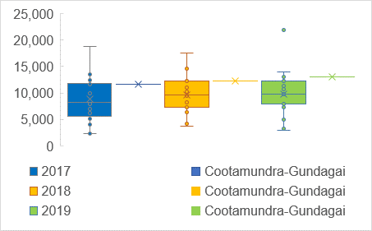

Accordingly, I have obtained ABS (2016) data on the value of agricultural commodities produced in the local government area and have augmented this with ABARES (2020) data to paint a picture of the capacity of this category of ratepayers to absorb the proposed special rate variation. The data in Table 4 is derived from an ABS publication that is only available quinquennially (the last issue being 2016). As can be seen, the major commodities produced, in a value sense, are broadacre crops (oats, barley, wheat and triticale), wool (extremely fine micron wool is grown in the high country), and meat (both a bi-product of the wool industry as well as a dedicated venture).

**Table 4. Agricultural Production by Value, Cootamundra-Gundagai, 2016.**



In Figure 18, I chart the relative values of these categories of commodities and it is clearer that the major source of value is meat (46%), followed by broadacre crops (29%), and wool (17%). Indeed, these three activities account for over ninety percent of agricultural production in the local government area.

**Figure 18. Agricultural Production By Value, Cootamundra-Gundagai 2016.**

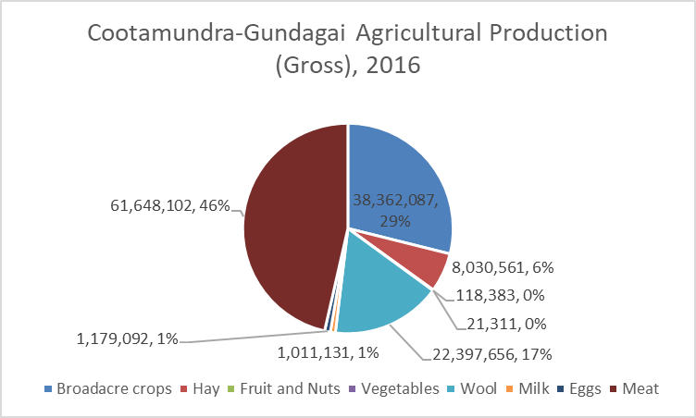

Now that we understand the main agricultural activities in the local government area we can get a sense of the capacity to pay of farmers by examining price trend data. In Figure 19 I employ ABARES (2020) data to show that the major meat enterprises in Cootamundra-Gundagai have been subject to quite positive growth in prices of recent years. This is especially the case for lamb and mutton.

**Figure 19. Meat Prices**

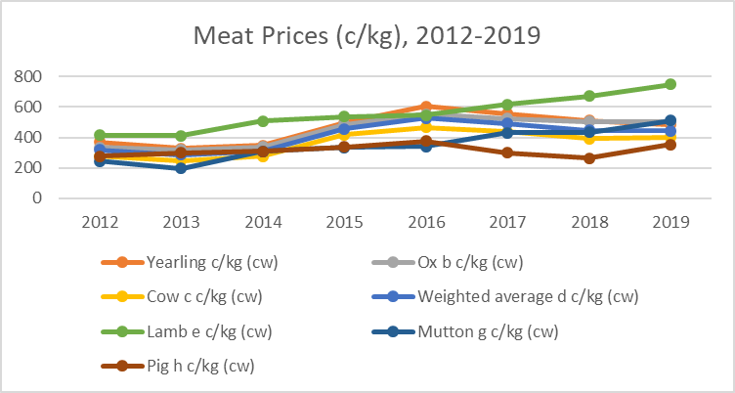

Moreover, the current year has seen strong growth in prices for cattle – Meat and Livestock Australia (2020) *Daily Indicators* suggest that prices have jumped from 477EYCI[4] on the 9 January to peak at 829.25EYCI on the 17th November, 2020. Similarly sheep prices have also been relatively good commencing at 702 NTLI[5] on the 5th of January, 2020 and peaking at 949 NTLI on the 4th of March 2020.

The second largest area of agricultural activity is broadacre farming mostly concentrated on barley, oats, wheat and triticale. ABARES data shows that this area of activity has also yielded strong returns in recent years (se Figure 20).

**Figure 20. Grain Prices.**

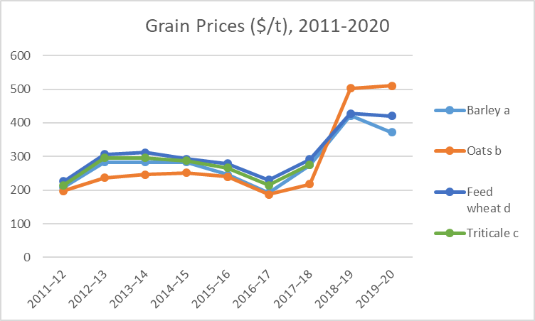

The final major area of agricultural endeavour is wool. Wool prices were very subdued in the 2019-20 financial year after coming off peaks in 2018-19. (see Figure 21). Indeed, rising stockpiles and a relatively stronger Australian dollar have combined to put a fair bit of pressure on wool growers in the second half of 2020. However, it must be remembered that some of this recent market pain is offset by strong meat prices and lower feed prices as a result of the breaking of the drought.

**Figure 21. Wool Prices**

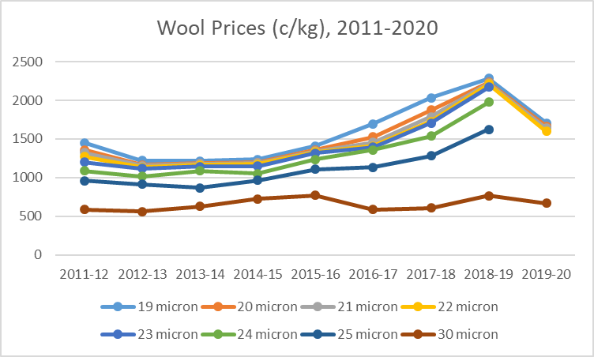

Indeed, rainfall is a key driver of agricultural production. In the appendix to this report I include Bureau of Meteorology (BOM) data that shows rainfall for the calendar year has been the best in almost a decade for both Cootamundra and Gundagai. Dams are filling up and soil moisture levels have increased. Moreover the BOM is predicting higher than average rainfall up until at least March 2021. Therefore it is reasonable to predict higher yields and income flows for Cootamundra-Gundagai farmers for at least the near future.

In sum, the unincorporated business income of Cootamundra-Gundagai stands in stark contrast to the wage earner and welfare recipient data that we examined in earlier sections of this report. Indeed, Cootamundra-Gundagai is in the top quartile for unincorporated business income, relative to the OLG11 peer group. This suggests that business and farm ratepayers in Cootamundra-Gundagai area have relatively greater capacity to pay rates than do their peers. Moreover, prices in most of the major agricultural pursuits conducted in the region have been very good and recent rains and forecasts suggest unusually strong conditions for next year.

**5. Robust Econometric Analysis of Rate Capacity.**

Thus far we have examined a large number of metrics which seem to suggest that the ratepayers of Cootamundra-Gundagai do have the capacity to pay additional local government taxation. However, the large number of metrics are difficult to reconcile for an overall assessment of rate capacity. Moreover, our comparisons, up to this point, have only been made with respect to other large rural councils (OLG11). A deeper appreciation of revenue effort might therefore be expected to be had by examining the statistical association between the determinants of revenue capacity over a broader cohort of peers.

Accordingly, it seems necessary to conduct multiple regression analysis over a panel (three years) of data for all rural local governments in the state in order to get the most accurate overall appraisal of rate capacity for Cootamundra-Gundagai Regional Council. Multiple regression analysis is a sophisticated statistical approach for analysing data which is regularly employed by econometricians and other scholars. Regression measures the mean response in a desired dependent variable, with respect to changes in specified independent variables, and thus allows scholars to understand the likely outcome for an association given certain determinants. It is indeed both the most robust and most sophisticated method for accurately evaluating the revenue capacity for local governments.

The econometric analysis that follows can be specified as:

**R** = α + β1**A** + β2**X** + **μ.**

In this specification **R** (the dependent variable) is the natural log of the total rates revenue for each council in each year, **A** is a vector of the respective number of assessments in each of the four categories, and **X** is a vector of controls for income characteristics for the population. Mu (**μ**) is an independent identically distributed random error term. Notably natural log transformations were executed where required to correct for skewed distributions as detailed in Table 5. All standard econometric tests were conducted and the residuals were confirmed to be near-normal in distribution (an important assumption for valid statistical reasoning).

**Table 5. Definitions and Means of Variables, 2018-2020**

|  |  |  |
| --- | --- | --- |
| **Variable** | **Definition** | **Mean** |
| **Rates** |  |  |
| Rates (ln) | Total taxation (rate) take, logged. | 9.104 |
| **Assessments** |  |  |
|  |  |  |
| Residential (ln) | Number of residential assessments, logged. | 7.901 |
| Farm | Number of farm assessments, divided by 100. | 11.230 |
| Business (ln) | Number of business assessments, logged. | 5.786 |
| Mine | Number of mine assessments, divided by 100. | 0.020 |
| **Income Controls** |  |  |
| Mean employee income | Mean employee income (lagged), divided by 1,000. | 46.981 |
| Mean unincorporated business income | Mean unincorporated business income (lagged), divided by 1,000. | 25.155 |
| Aged (ln) | Proportion of people on an Aged pension, logged. | 2.579 |
| DSP (ln) | Proportion of people on a Disability Support pension, logged. | 1.475 |
| Newstart | Proportion of people on a Newstart allowance. | 3.918 |
| Carer (ln) | Proportion of people on a Carers’ pension, logged. | 0.370 |
| Single (ln) | Proportion of people on a Single Parent pension, logged. | 0.417 |
| Youth (ln) | Proportion of people on the Youth Allowance, logged. | -0.317 |
| Dummy variable | A control for the three respective years analysed. |  |

The data in Table 5 has been extracted from various sources. Rate data was obtained directly from Note 3(a) of the audited financial statements for the respective years. Number of assessment data is a lagged variable obtained from the Office of Local Government *Time Series Data*. The remaining data was obtained from the ABS (2020) *Data by Region* reports. Lagging certain data is a common practice in scholarly work to ensure consistency with theoretical expectations and also to deal with data availability problems. All reasonable precautions were taken to ensure that lagged data did not have a material effect on results and sensitivity analysis has been done to assure so.

In Table 6, which follows, I detail the coefficient and robust standard errors for the regression that I specified earlier. All four assessment types have positive coefficients as expected. Income regressors have negative coefficients which is consistent with observed disparities in revenue effort which is an artefact of the almost five decade old rate capping regime that operates in New South Wales (see Drew and Dollery, 2015; Drew, 2020). The Aged pension also has a negative coefficient which is consistent with the data and conclusions I drew earlier in the report. Moreover, the regression as a whole has exceptionally high explanatory power, as indicated by the coefficient of determination (0.8956). Various specifications were tested to ensure that the model was robust.

**Table 6. Multiple Regression Results, All Rural Councils, 2018-2020 inclusive.**

|  |  |
| --- | --- |
|  |  |
| Number of residential assessments (ln) | 0.8299** (0.0652) |
| Number of farm assessments | 0.0115** (0.0029) |
| Number of business assessments (ln) | 0.0848 (0.0610) |
| Number of mine assessments | 0.6199 (0.3715) |
| Mean employee income | -0.0183** (0.0048) |
| Mean unincorporated income | -0.0038** (0.0019) |
| Age pensions (ln) | -0.2386* (0.1268) |
| 2019 | 0.1243** (0.0400) |
| 2020 | 0.2014** (0.0394) |
| Other welfare receipts | Yes** |
| n | 171[6] |
| Coefficient of Determination | 0.8956 |

Standard errors in parentheses.

+ p<0.10, * p<0.05, ** p<0.01

To get the full benefit of this exercise one needs to use the derived regression coefficients to predict the mean revenue expected to be yielded by Cootamundra-Gundagai (given the values of variables specified). I used standard econometric software (STATA) to do so and present the results in Table 7.

**Table. 7. Predicted Rate Capacity, Cootamundra-Gundagai ($’000)**

|  |  |  |
| --- | --- | --- |
| **Financial Year** | **Predicted Rate Capacity** | **Actual Rate Take** |
| 2018-19 | 11,381.5 | 6,797 |
| 2019-20 | 11,847.15 | 6,993 |
| 2020-21 | 13,265.9 | 7,653.6[7] |

As can be seen, robust econometric modelling indicates that average taxation take expected of a council with Cootamundra-Gundagai’s profile stands at almost twice the 2020-21 financial year levels. This result is consistent with our earlier more rudimentary analysis that showed average rates levels for CGRC were much lower than its peers, that relatively low flows of personal incomes were mitigated in large part by low household stress (arising from relatively low property prices), and that unincorporated business incomes were far higher than most of the peer group. I emphasise here that the econometric evidence is far more robust than the individual metrics examined earlier because it employs a far larger comparator group (all rural NSW local governments) as well as much more sophisticated multi-variate statistical reasoning (see Kennedy (2003) for a thorough explanation of the assumptions and sophistication embodied in econometric analyses).

In other documents the expected outcomes from the proposed special rate variation have been outlined in considerable detail. Below I present a copy of the total tax-take expected for Cootamundra-Gundagai should the proposed special rate variation be approved. As can be seen, even in five years hence, and *after* the cumulative effect of a 62.6% increase (including the assumed rate peg), the total tax-take would still be considerably less than the predicted capacity as at 2020-21 (detailed in Table 7).

**Table 8. Impact on Total Rate Revenue of an Expiring Special Rate Variation and a s508A Special Variation of 19%, 18%, 5%, 5%, 5% ($’000)**



Thus, by using the most sophisticated and robust tools available I have demonstrated that the proposed SRV is well below the average tax-take expected of a Council with Cootamundra-Gundagai’s characteristics. This should provide considerable comfort to IPART and the Councillors that the rather large increases to local government taxation required to deal with the shock of the amalgamation and four year rate path freeze are indeed within the capacity of tax payers. However, I hasten to add that my conclusion should not be construed to suggest that I feel that the required tax increases will not cause pain – I deeply regret that poor public policymaking has given rise to an urgent need for additional revenue – merely that I believe that most people will have the capacity to absorb the special rate variation.

**6. Conclusion**

The only reasonable conclusion that can be drawn from a sober consideration of the entire data included in this report is that the community of Cootamundra-Gundagai Regional Council do have the capacity to pay additional taxation. Indeed, the regression analysis clearly shows that *current* capacity is greater than the total tax-take that is *proposed* at the end of the special rate variation period (2025/26). To argue otherwise is to deny the evidence of tax levels actually paid at rural local government areas in New South Wales over the last three financial years.

Of course, capacity to pay and willingness to pay are two entirely different matters. I wouldn’t be at all surprised to learn that the people of Cootamundra-Gundagai are not happy about the prospect of a substantial increase to local government tax to pay for the outcomes of a deeply unpopular forced amalgamation in 2016. However, I do feel that most people would prefer a tax increase to an extended period of Administration – especially given the disastrous outcomes arising from the two Administrators appointed by the State government in the early period following the amalgamation. An important part of the community engagement activities is directed towards understanding whether this impression is indeed valid.

The Councillors at Cootamundra-Gundagai have committed to continued pursuit of efficiencies in order that they might soften the burden of taxation wherever possible. Moreover, the Boundaries Commission is currently deliberating on a proposal to de-amalgamate and hence mitigate the substantial diseconomies of scale that have emerged – somewhat predictably for anyone conversant with neo-classical economic theory (see Drew, 2020) – since amalgamation. I also continue to hope that the State government may yet have their consciences piqued and respond with some additional untied operational grant money that might go some way towards mitigating the extra fiscal burdens of diseconomies brought about as a result of poor public policymaking in 2016.

Should the current grave financial predicament improve – perhaps as a result of one or more of the aforementioned contingencies – then the Council has committed to delaying, or even foregoing, some of the granted SRV as is now possible under the new catch-up provisions. Unfortunately, my professional opinion is that Council is unlikely be in the fiscal position to do so given the seriousness of their predicament. However, the community should draw some solace from the Council’s fervent desire to mitigate matters should contingencies combine to improve its fiscal plight beyond that which is predicted.

**References**

Australian Bureau of Statistics (ABS) (2020). *Data by Region*. Available at: <https://itt.abs.gov.au/itt/r.jsp?databyregion>. Consulted Tuesday 22nd December, 2020.

Australian Bureau of Statistics (2016). *Value of Agricultural Commodities Produced, Australia*, 2015-16. ABS: Canberra.

Australian Department of Agriculture, Water and the Environment ABARES. (2020). *Agricultural Commodity Statistics*. ABARES: Canberra.

Coelli, T., Rao, P., O’Donnell, C., and Battese, G. (2006). *An Introduction to Efficiency and Productivity Analysis*. Springer: Singapore.

Drew, J. (2020). *Reforming Local Government*. Springer Palgrave: Singapore.

Drew, J. and Dollery, B (2015). A Fair Go? A Response to the Independent Local Government Review Panel’s Assessment of Municipal Taxation in New South Wales. *Australian Tax Forum*, 30(3): 471-489.

Drew, J., McQuestin, D. and B. Dollery. (2019). Good to Share? The Pecuniary Implications of Moving to Shared Service Production for Local Government Services. *Public Administration*, https://doi.org/10.1111/padm.12575.

Drew, J. and Dollery, B. (2016) What’s In a Name? Assessing the Performance of Local Government Classification Systems. *Local Government Studies*, 42(2): 248-266.

Kennedy, P. (2003). *A Guide to Econometrics*. MIT Press: Cambridge.

Office of Local Government. (2020). *Guidelines for the Preparation of an Application for a Special Variation to General Income*. OLG: Nowra.

Meat and Livestock Australia (2020). *Daily Indicators*. Available at: <https://www.mla.com.au/prices-markets/>. Consulted 22nd December, 2020.

Stiglitz, J. (2013). *The Price of Inequality*. Penguin: New York.

1. The mean is the average (all numbers for each category added together and divided by the number of data points). Standard deviation is a measure of average spread from the mean. The median is the middle number when data points are ranked in ascending order. Quartile 1 is the middle of the lowest half of the data (marked by the median), and Quartile 3 is the middle of the top half. Twenty-five percent of the data points lie below Quartile 1 and twenty-five percent above Quartile 3. The interquartile range is the measure of spread for use with quartile data and is the difference between Quartile 3 and Quartile 1.
2. Because I use actual 2020-21 data for Cootamundra-Gundagai the recent land values are imputed to the average rate level. However, because I merely indexed 2018-19 data for the comparators these average figures will not necessarily reflect new land valuations. Changes to land valuations have a high potential to change mean rate data.
3. A term employed by the ABS (2020) which reflects household income adjusted to facilitate the comparison of income levels between households of differing size.
4. EYCI is the Eastern Young Cattle Indicator expressed in cents per kilogram of dressed carcase weight.
5. NTLI is the national trade lamb indicator expressed in cents per kilogram of dressed carcase weight.
6. The odd number arises because a few of the rural councils (such as Hilltops) have received an extension for the preparation of their audited financial statements.
7. Data obtained from Long Term Financial Plan budgeted data 2020/21.