**Addendum – Update for 2019/20 Data**

My original report (dated March 2020) only included the data that was available at the time (in most cases up to the 2019 financial year). Below I have updated the graphs to reflect new data for the 2019/20 financial year.

It should be noted that the budget cuts and fee increases that Cootamundra Gundagai Regional Council (CGRC) implemented following my recommendations won’t become visible till the completion of the current financial year (2020/21). This data won’t become available till December 2021.

On the whole, the picture of CGRC’s financial sustainability has changed little – Council need is still great and a Special Rate Variation (SRV) is absolutely essential to not only ensure financial sustainability, but also ultimately solvency. Indeed, the recent spectacular failure of Central Coast Council is good evidence of the kind of outcome that we could reasonably expect, down the track, in the absence of the approval of an SRV.

I have made some notes where appropriate below relevant graphs. Graphs are numbered in the same sequence as my original report to facilitate easy comparison.

**Figure 2. Operating Performance Ratio**

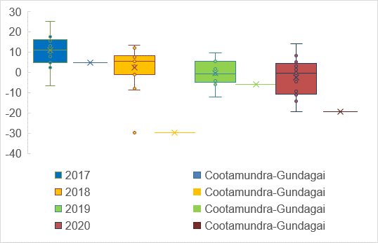

The continued decline in the operating ratio is most alarming and must be urgently redressed to ensure sustainability. CGRC has already executed an aggressive cost-cutting program and has committed to even further cuts in the future. However, there is no getting away from the fact that increases to revenue will also be required in order to carry-out the necessary budget repair.

**Figure 3. Own Source Ratio**

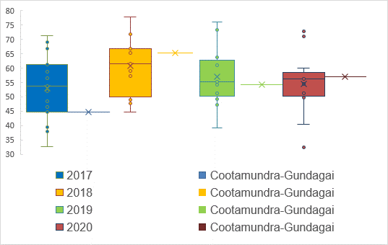

The own-source ratio has limited relevance to financial sustainability and various parties’ emphasis on it is mostly misguided and symptomatic of a misapprehension regarding the purpose of horizontal fiscal equalisation grants, such as the Financial Assistance Grants (FAG).

**Figure 4. Road Grant per Kilometre**

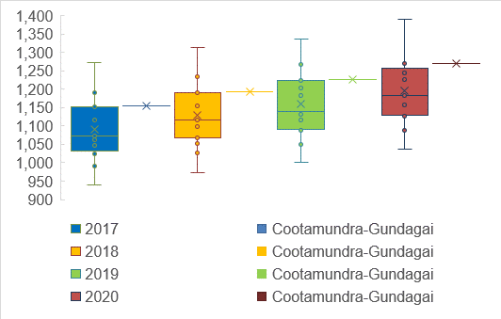

Pleasingly, this grant has not been reduced to date. However, attention should continue to focus on this metric as new formulas are implemented and the federal government is drawn into its’ own budget crisis (which last time resulted in a freeze to FAGs).

**Figure 5. General Component of Financial Assistance Grant per Person**

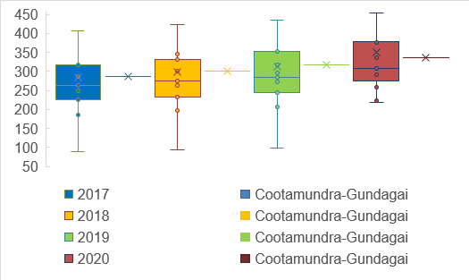

This is also a pleasing result – but certainly a metric that warrants continued attention in the future.

**Figure 6. Unrestricted Current Ratio**

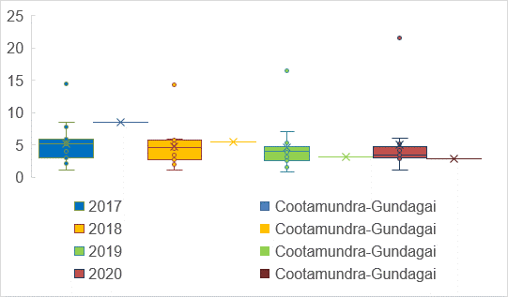

This ratio continues to wane and demonstrates the urgency of securing a SRV.

**Figure 7. Debt Service Ratio**

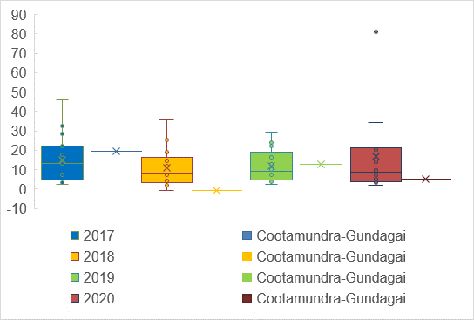

This ratio also demonstrates consistent and alarming decline.

**Figure 8. Nett Financial Liabilities**

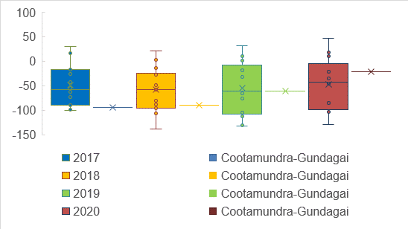

This ratio, which is more comprehensive than the previous metric, continues to decline (indicated by the result moving northwards). Clearly financial sustainability is declining at an alarming rate.

**Figure 9. Depreciation Rate**

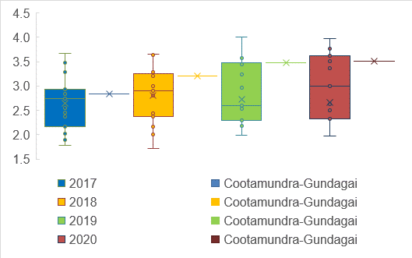

The depreciation rate continues to be relatively high. However, it is notable that the median is moving up, which is consistent with my recent research that shows an increase in depreciation in response to the introduction of central auditing in New South Wales.

**Figure 10. Nexus**

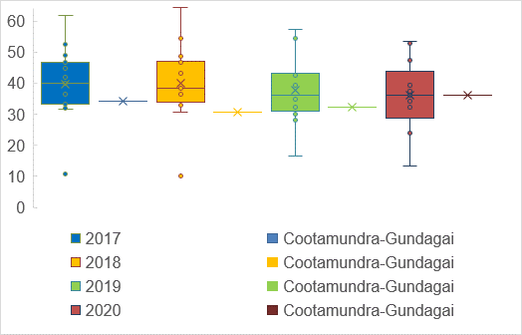

The nexus rate has improved of late and I expect to see significant improvement from the 2020/21 financial year as the metric responds to the comprehensive review of fees and charges implemented by CGRC.

**Figure 11. Rates, Fees and Charges per Assessment**

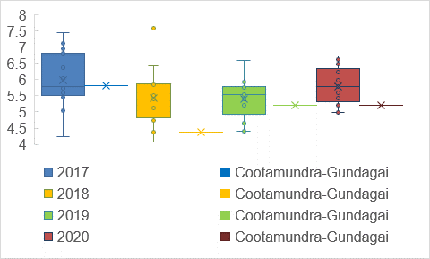

This ratio will also certainly improve – as it must do – from the 2020/21 financial year onwards. The metric underlines the need for the new fee structure implemented this year, as well as the proposed SRV from 2021/22. Council is currently collecting some of the lowest levels of revenue in the cohort, measured on a per assessment basis, and this clearly is not sustainable.

**Figure 16. Deviation from Budgeted Expenditure (2017 unavailable)**

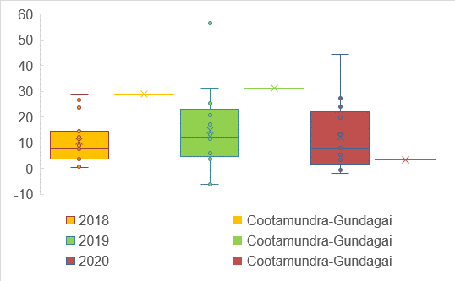

This is a very pleasing result which reflects the hard work that Council has been doing lately with respect to budget control.

**Figure 17. Deviation from Budgeted Revenue (2017 unavailable)**

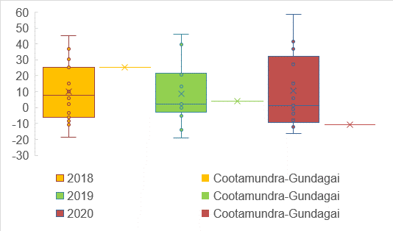

Unfortunately, this result is not so pleasing. However, it principally relates to lower than expected capital grant revenue which is largely beyond Council’s control. This further illustrates what I have been saying – that high reliance on capital grants does pose a financial sustainability risk to Council.

**Figure 18. Proportion of Expenditure on Staff**

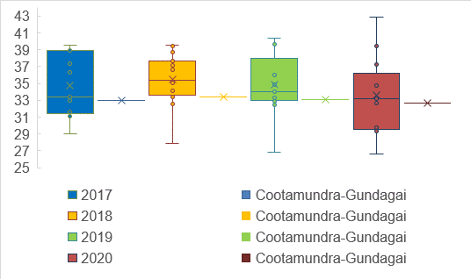

This metric has remained relatively stable, although I expect it will reduce in coming years as the Council puts in place plans outlined in its SRV application.

**Figure 19. Staff Expenditure per Assessment**

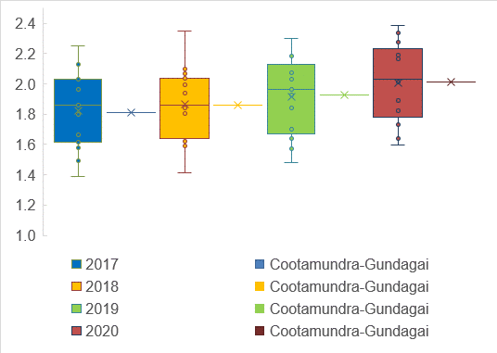

The relative position with respect to peers has been maintained and hence the apparent increase is clearly mostly an artefact of annual wage increases. According to the SRV application Council intends to reduce staff expenditure quite markedly in the future and we can therefore expect improvement relative to the peer group from 2022/23 onwards (at which time staff expenditure is planned to reduce by $500,000 p.a.).

**Figure 20. Nett Operating Cash Flows (deflated by revenue)**

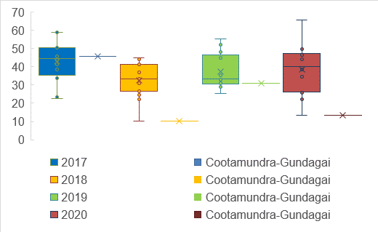

CGRC has continued to decline in this metric which emphasises the urgency of a SRV.

**Figure 21. Nett Investing Cash Flows (deflated by revenue)**

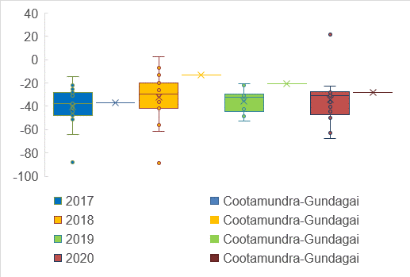

Council continues to have relatively greater outflows in this area as it addresses urgent capital work on water and sewer assets.

**Figure 22. Nett Finance Cash Flows (deflated by revenue)**

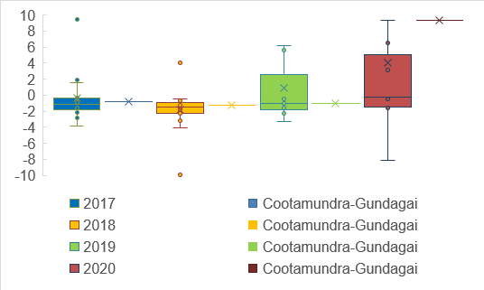

This metric has spiked in response to drawing down of debt. Council does not compare well to the peer group and this underlines the fiscal distress that it finds itself in. Council must now be at or above debt capacity (I will address this specific question in a forthcoming report) and therefore additional debt is not an option for mitigating the budget imbalance – hence the request for a SRV.

**Figure 23. Buildings and Infrastructure Renewal Ratio**

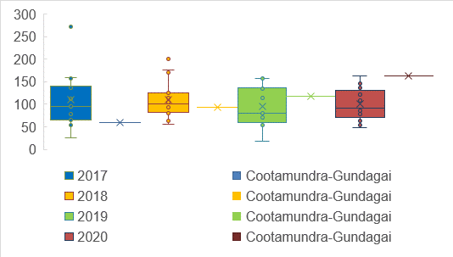

CGRC has had to undertake a lot of work on its assets over the last few years to bring them up to an acceptable level. The scale of this work is reflected in this metric. Once the sewer work is finished I would expect this ratio to return to more typical levels.

**Figure 24. Infrastructure Backlog Ratio**

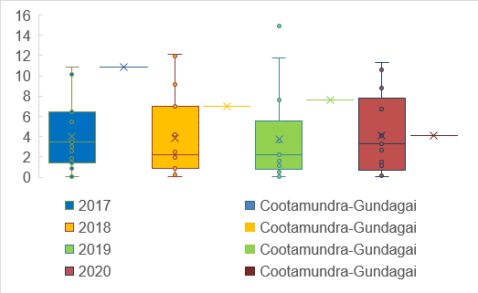

The asset backlog has been steadily reducing for a number of years and now approaches a more typical level with respect to similar local governments. Part of the plan to ensure solvency in the early years revolves around delaying capital spending on transport assets. The recent result suggests that there is indeed sufficient scope to do so in the short term which will help to ensure that Council has sufficient unrestricted cash moving forward.

**Figure 25. Asset Maintenance Ratio**

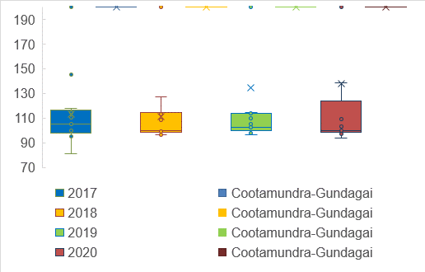

This is a rather unhelpful metric that Councils continue to struggle to interpret. I do not agree with the results presented by CGRC, or indeed many other councils. Because the data is unreliable, and the metric inputs open to interpretation, it would not be reasonable to draw any conclusions from this chart.

**Figure 26. Rates and Annual Charges Outstanding**

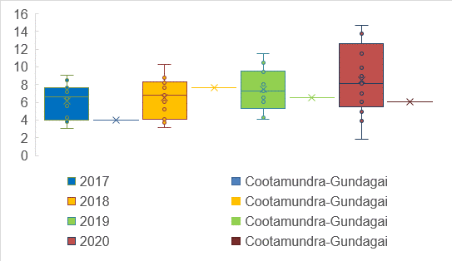

CGRC continues to have relatively lower levels of outstanding rates and charges than its peers. This suggests that the community probably does have the capacity to bear additional burdens, as suggested in the SRV application. Council should continue to monitor this metric carefully over the term of the SRV.

**Figure i. Growth in Number of Assessments**

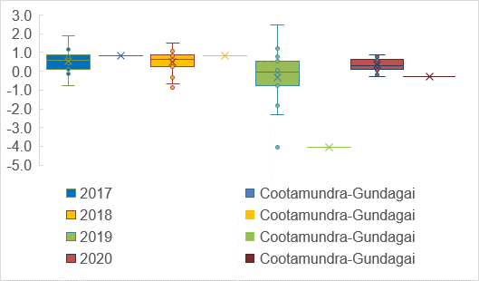

CGRC continues to record low growth in number of assessments relative to the peer group. This has no effect on the total tax take, because of the way that the rate cap is applied in NSW. However, it does affect fee and charge revenue. Generally for low growth councils there is a need for relatively higher average rates, all other things held constant.

**Figure ii. Growth in Residential Assessments**

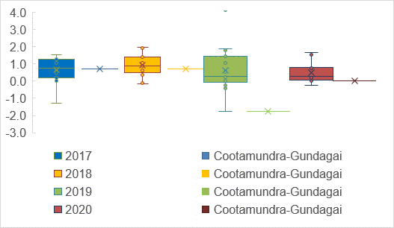

Continued low growth in residential assessments suggests that average rates will need to be higher to ensure sustainability, all other things held constant. As it stands average rates at CGRC are well below the mean for OLG11 councils – hence the financial sustainability crisis currently faced.

**Figure iii. Growth in Business Assessments**

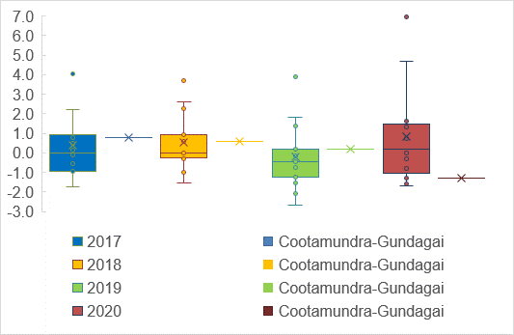

Growth in business assessments are also trending downwards. This has implications for both gross fee revenue (which will be relatively lower all things held constant) and average tax burden.

**Figure iv. Population Growth**

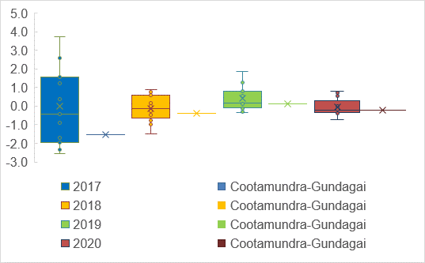

As noted in my earlier report, this data is subject to significant error in inter-censal periods and little reliance should therefore be placed on the metric.

**Figure v. Population Density**

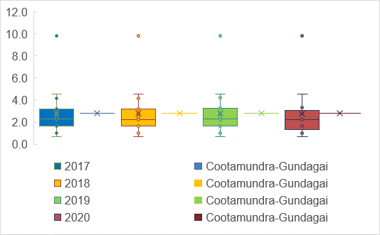

CGRC has higher population density than many of its peers which has helped Council to implement aggressive efficiencies this financial year which are an absolutely essential ingredient for the budget repair effort.

**Figure vi. Aged Pension**

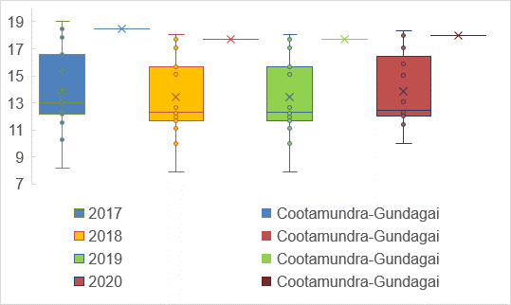

High proportion of pensioners is a significant revenue disadvantage that CGRC suffers from. Because of state government policy (which includes only partial refunds for mandated pensioner discounts) large numbers of pensioners means that the remaining members of the community essentially have to bear more of the burden. The disadvantaged operating environment that CGRC finds itself in is also born out in the next two charts.

**Figure vii. Disability Pension**

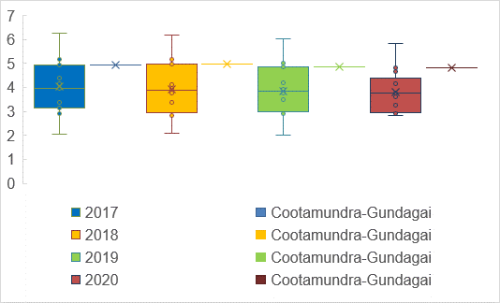

**Figure viii. Newstart**

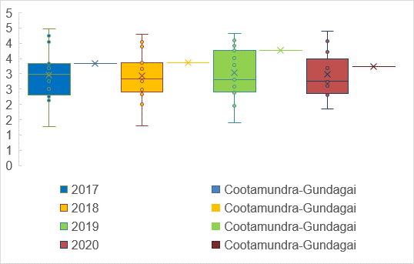

**Figure ix. Single Parent Pension**

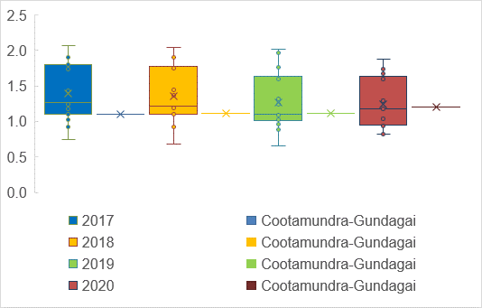

**Figure x. Median Income**

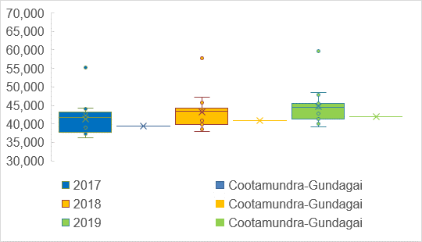

Unfortunately the Australian Bureau of Statistics (ABS) is still rather behind in their data dissemination so I cannot provide more up-to-date figures at this time. Suffice to say the residents at Cootamundra Gundagai seem to accrue relatively less wage income than is typical of their peers. In my other reports (see my forthcoming report on capacity to pay) I draw attention to unincorporated business income, which is relatively good for CGRC and thus provides some support for the case that higher taxes are able to be borne by the community.

**Cash Expense Ratio**

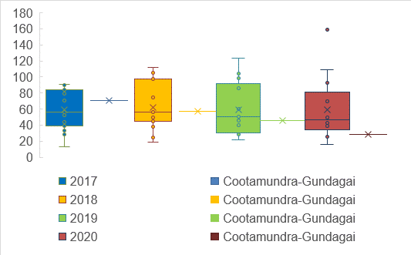

The cash expense cover ratio was not included in the body of my original report as it provides a misleading picture of Council’s true position. This is because the ratio includes restricted cash – which generally cannot be used for common operating expenditures. As of the 2019/20 financial year CGRC had just $1.25 million in unrestricted cash. This is an incredibly small amount of unrestricted reserves which would mean that Council would need to take rather drastic action to ensure solvency should the SRV not be approved or an economic shock arise[1]. Quite simply without the savings measures, changes to fees and charges, as well as the proposed SRV the CGRC would not be a viable proposition in the near future.

1. Notably bona fide local government experts expect a shock to cash flows from the second quarter of 2021 onwards when most stimulus measures, protections for renters and borrowers, as well as the suspension of insolvent trading laws are reversed. It is likely that CGRC will have to draw on this very slim quantum of unrestricted reserves around this time as it seeks to respond to the likely cash flow disruption.