**Cootamundra-Gundagai Financial Sustainability Review**

**Report Date: 30th March, 2020.**

This report paints a bleak picture of a rural council that has struggled to adapt in the wake of an unpopular forced amalgamation. Mistakes were made early on in its amalgamation administration period, and it is only recently that the elected representatives and new General Manager have come on to the scene and sought appropriate independent expert assistance. I don’t think it would be reasonable to blame any of the existing leadership team for the problems that we are now faced with.

Drastic changes will be required to assure the financial sustainability of Cootamundra-Gundagai Regional Council for the next three to five years. These changes will cause pain and hardship. However, they must be implemented shortly in a decisive manner.

**Financial Sustainability of Cootamundra-Gundagai Regional Council**

To gauge the current financial sustainability situation of Council, I constructed over 40 different measures of performance from audited financial statement data, long term financial plans, Australian Bureau of Statistics data, and NSW Local Government Grant Commission data. In most cases I have presented the results in a box and whisker plot for the last three years. This illustrates both Cootamundra-Gundagai’s performance against itself over time as well as performance against similar peer councils (mostly selected from the same OLG category by Council). Figure 1 illustrates how to read a boxplot and Table 1 lists the peer group used for comparison (Cootamundra-Gundagai is classified by the Office of Local Government as a Group 11 local government).

**Figure 1. Interpreting Box and Whisker Plots**

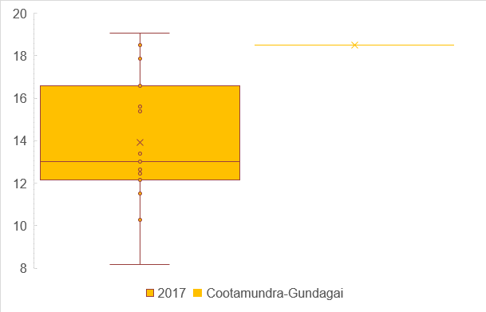

Quartile 1 (25% of results below this line)

Median (50% of results below this line)

Mean (average)

Cootamundra-Gundagai’s result

Quartile 3 (75% of results below this line)

Whiskers mark atypical results

**Table 1 Peers Used in Comparisons**

|  |  |  |  |
| --- | --- | --- | --- |
| **OLG 11 Councils** | **OLG 11 Councils** | **OLG 11 Councils** | **OLG 10 Councils** |
| Cabonne | Cowra | Greater Hume | Bland |
| Hilltops | Leeton | Murray River | Junee |
| Narrabri | Parkes | Snowy Valleys | Temora |
| Upper Hunter | Yass Valley |  |  |

The first ratio that I present is the operating performance ratio which played such a key role in amalgamation debates. As can be seen in Figure 2 the performance of Cootamundra-Gundagai is far below that of its peer group, and remains stubbornly below the bottom quartile of results. Typically, operating results may fluctuate a little between years which is why many performance monitoring regimes set benchmarks for average performance over 3 years. However, constant performance in the bottom quartile illustrates clearly that current revenues are not sufficient to service current expenditures. For the standard financial years since amalgamation Council has been recording large operating deficits (excluding capital grants), that are not financially sustainable in the medium term, and even less so long term. The situation is serious and strong action needs to be taken to get the revenue base up and the expenditure base down over the next 12 months.

**Figure 2. Operating Performance Ratio**

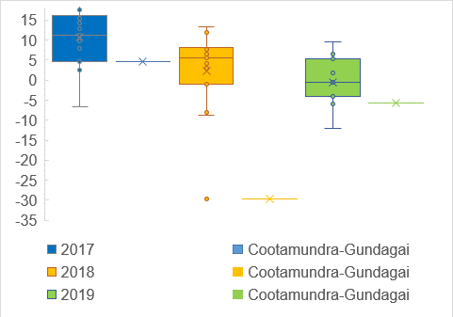

The own source ratio also featured in the amalgamation debates. Council was well below the benchmark of 60% for two of the three most recent years. However, the importance of this ratio has been well-and-truly overstated in the past by people who are apparently unacquainted with the fiscal federalism literature. Rural local governments will generally tend to have low rates of own source revenue owing to the fact that their road networks are invariably far longer than urban peers, and that living standards tend to be much lower in rural areas. The Local Government (Financial Assistance) Act (1995) has horizontal fiscal equalisation (HFE) as a core objective. HFE means that all councils ought to have similar capacity to provide core services through reasonable efforts. A HFE inspired grants system will thus result in large transfers to rural councils and economically disadvantaged areas. Thus Cootamundra-Gundagai’s performance in this area simply suggests that the FAG system of grants is working more or less as the legislators wished it to work – it would be silly to somehow suggest that Council performance is poor, simply because it is receiving the help from the federal government that it is legislatively entitled to.

Some Councils have unfortunately decided to go into various business arrangements as a way to meet the benchmark for this ratio. This is a very dangerous practice – government should govern, not distort local economies by entering into business ventures. Moreover, when governments engage in business activities it exposes residents to risk (which is the whole reason why business receives above market returns on investments) and unless residents have agreed to this risk it is hard to justify these activities in a moral sense. Given the precarious nature of Council’s financial sustainability, this is not a good time to be taking on new risks. It should also be borne in mind that government is notoriously bad at running businesses – generally, the wage structure for government is much higher, and the regulatory and social burdens also greater. In addition, running a business diverts council attention away from its’ core responsibilities, and in a council such as Cootamundra-Gundagai which is struggling to deal with a number of matters that should have been resolved four years ago, it does not seem wise to me to do anything that might distract staff attention further.

**Figure 3. Own Source Ratio**

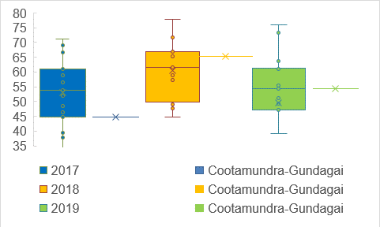

In Figure 4 I plot the road grants received by Cootamundra-Gundagai against those received by its peers. As I have written elsewhere, I am not thoroughly convinced that Cootamundra-Gundagai has been receiving its full entitlement during the four-year post-amalgamation protection period. However, it is clear from the relatively high levels of road component FAGs that Council has received far higher road grants than its peers. It would be thus reasonable to suspect that when the protection period expires, that road grants might be reduced to more typical levels. Moreover, we should be mindful that the federal government is currently heading towards a very large deficit (due to its’ coronavirus response) and previous experience suggests that future federal budget repair may well include a FAGs freeze. In addition, the NSW Local Government Grants Commission has advised me that they are phasing in a new formula that has unknowable implications for local governments (because they won’t release full details).

For all these reasons we might reasonably expect recurring grant revenues in the future to decrease. *This is problematic because the current LTFP – which is very concerning – works off the assumption that grant income will continue to grow.*

**Figure 4. Road Grant per Kilometre**

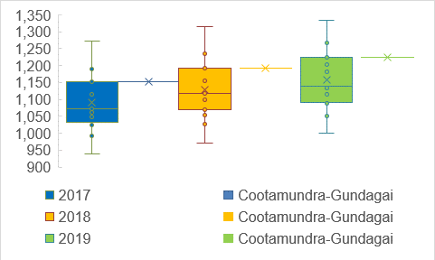

Similarly, Council currently receives slightly higher levels of the general component of FAGs (see Figure 5). I suspect that when the protection period expires that these levels might decrease slightly. As I noted earlier, the NSW LGGC is running with a new model next year, and this could have big implications for revenue for many councils, including Cootamundra-Gundagai. The financial sustainability at Cootamundra-Gundagai is at a concerning state – if grants do in fact reduce further then Council will likely experience even more pronounced stress.

**Figure 5. General Component of Financial Assistance Grant per Person**

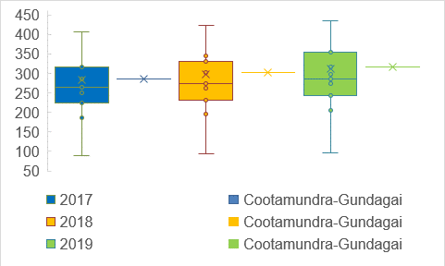

The effect of chronic operating deficits (excluding capital grants) will be a reduction in liquidity. Figure 6 clearly demonstrates waning liquidity. Cootamundra-Gundagai is still above the benchmark (1.5) for 2018-19. However, it is clear that if the recent trends continue that Council will fall short of the benchmark next year. This underlines the urgency of budget repair work.

**Figure 6. Unrestricted Current Ratio**

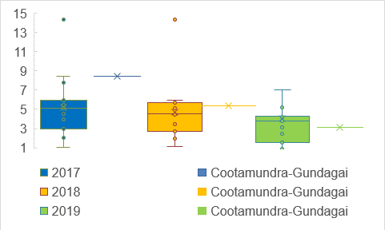

The debt service ratio is also eroded by chronic operating deficits. I understand that Cootamundra-Gundagai was recently discouraged from pursuing finance with TCorp. Given the results illustrated in Figure 7, I am not surprised.

**Figure 7. Debt Service Ratio**

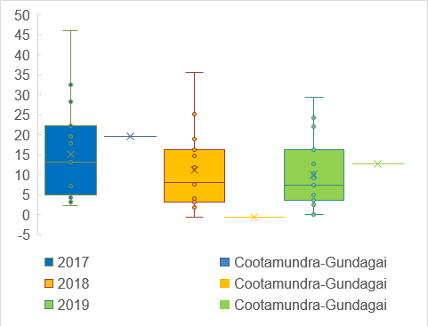

The nett financial liability ratio is not used in NSW (it is used in Queensland, South Australia and Western Australia). It is a much more inclusive picture of a council’s position because it takes account of non-current assets and liabilities. Generally, a local government will have a negative result for this ratio (the lower the better) as non-current assets usually make up a large proportion of a council’s balance sheet. Figure 8 demonstrates that when non-current assets are included then the position of the council looks good, relative to the peer group. However, the position of Council has been eroding since amalgamation as evidenced by the fact that the Cootamundra-Gundagai’s result has been moving steadily north over the last three years. What this means is that Cootamundra-Gundagai’s relative position owes much to restricted reserves, strong flows of capital grants, and the relatively good state each council was in prior to amalgamation. Since amalgamation, things have clearly deteriorated.

**Figure 8. Nett Financial Liabilities**

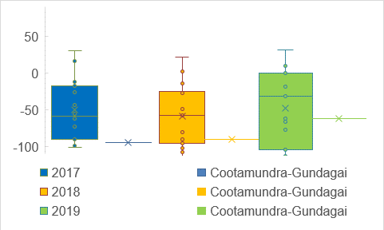

Figure 9 shows the depreciation rate employed in Cootamundra-Gundagai Regional Council relative to its peer group. The rate is relatively high (at Quartile 3, wherein only 25% of results exceed this point). However, there are a couple of points that one must be mindful of when considering these numbers. First, depreciation rates across the state are extraordinarily low and chaotic (Drew, 2018) – so higher depreciation rates might simply mean that Council is recording asset consumption appropriately (as I suspect). Failure to depreciate appropriately is, in fact, a long-term financial sustainability risk, because inevitably values have to be adjusted or plant and equipment is disposed of at a loss. Second, a lot of the metrics we have been looking at don’t have depreciation as an input at all. Therefore, whilst a ‘fast’ depreciation schedule might affect the income statement operating result, it is not affecting most of the metrics contained in this report that generally paint an unflattering picture of Council’s financial sustainability. Third, in forthcoming research I show that depreciation rates in NSW have increased across the state since the advent of Central Auditing therefore I expect ‘typical’ results to start to increase in future years across this comparison cohort.

**Figure 9. Depreciation Rate**

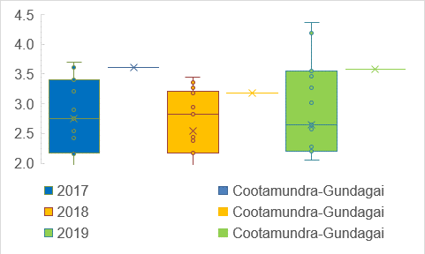

Operating deficits (excluding capital grants) can either be caused by insufficient revenue or excessive expenditures (or, most probably, both). Previously I have provided Council with rate comparison data that I re-produce below:

**Table 2. Comparative Data on Average Rates.**

|  |  |  |  |  |
| --- | --- | --- | --- | --- |
| **Category** | **Proposed** | **OLG11 Average** | **OLG 10 Average (former Cootamundra Group)** | **OLG 9 Average (former Gundagai Group)** |
| **Residential** | $699.70 | $806 | $668 | $414 |
| **Farmland** | $3,017.74 | $3,309 | $2,864 | $3,128 |
| **Business** | $1,639.39 | $2,118 | $1,540 | $842 |

Relative to other OLG 11 councils, there would seem to be scope to lift rates by a cumulative 62.6% over 5 years including the assumed rate cap.

In Figure 10 I plot the nexus ratio for Cootamundra-Gundagai and its peer councils. This ratio effectively measures the amount of operational expenditure that is funded through fees and charges. As can be seen, Cootamundra-Gundagai has a particularly low nexus ratio compared to similar councils. This means that Council is funding a lot more of its operational expenditure from the common tax pool, than does its peer group. As I have written elsewhere, cross-subsidising non-public goods and services from the common tax pool (that is, not charging sufficient fees to cover costs and overheads) is both inequitable and unsustainable. There is clearly a case for increasing Council fee and charges revenue (which is also insufficient for Council’s current expenditure profile), to take some of the pressure off the tax pool As I have noted before, correct trade waste charging, on-site sewer administration charges, and correct business stormwater charges are obvious avenues to increase the nexus ratio. However, it also seems there is a case to adjust other charges to better capture full costs, including overheads. From both ethical and capacity to pay perspectives it is much preferable to get discretionary fee charging correct than to subsidise non-public goods and services through increases to non-discretionary local government taxation.

**Figure 10. Nexus (adjusted for extraordinary RMS)**

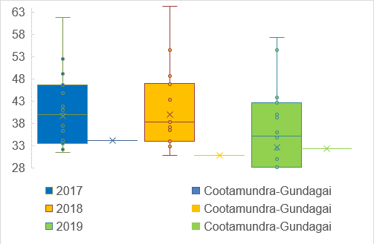

In Figure 11 I plot rates, fees and charges revenue per assessment against time and the peer group (I adjusted the 2019 charges for RMS down to reflect the extraordinary situation this last financial year). As will be noted this ratio is jumping around a fair bit which suggests Council has a higher than normal reliance on charges revenue from non-standard sources (such as RMS, but maybe also discretionary services). Mostly, Cootamundra-Gundagai’s result is lower than its typical peer which provides further evidence for my contention that increases to rates and charges must be part of the budget repair plan.

**Please Note (14/12/20):** since the time of this report Council has reviewed all of its fees and charges and is now consistent with supply-side methodology (see Drew, 2020).

**Figure 11. Rates, Fees and Charges per Assessment (adjusted for extraordinary RMS)**

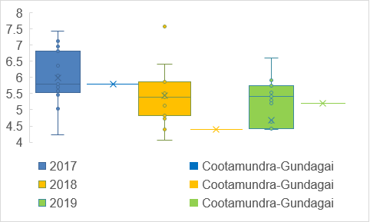

The other critical part of budget repair will be to reduce the expenditure profile of Council. In Figures 12-15 I examine the broad components of spending to try to help Council to identify where it should prioritise cost-cutting exercises. Figure 12 plots operational expenditure on roads on a per kilometre basis (this data is not available for 2019). Expenditure for this item jumps about a fair bit, but averaging the two years’ data together suggests to me that Council is pretty typical of its peer group in this area.

**Figure 12. Road Operational Expenditure per Kilometre (2019 data unavailable)**

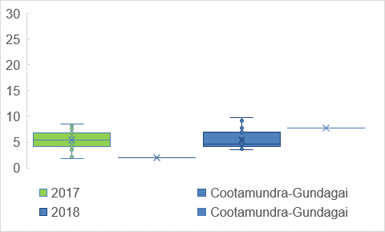

Similarly, there are no obvious problems for operational expenditure in the area of water provision.

**Figure 13. Water Operational Expenditure per Assessment**

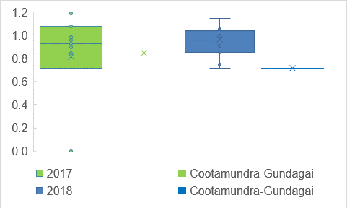

Sewer operational expenditure has been skewed a little, however the 2018 result suggests to me that this is not an area of concern either.

**Figure 14. Sewer Operational Expenditure per Connection**

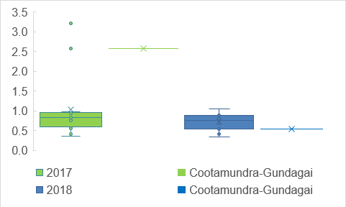

The problem is clearly with the residual activities of Council as illustrated in Figure 15. Otherwise stated Cootamundra-Gundagai is doing an acceptable job on roads, water and sewer, but costs seem excessive relative to peers in the remainder of functions. For both standard financial years since amalgamation Council has been hovering around Quartile 3 (top 25% of results) for residual operational expenditure when expressed in per assessment terms. This is clearly a problem given that, as we saw earlier, rates revenue on an average per assessment basis is well below peers.

**Figure 15. Non-Road, Non-Water and Non-Sewer Operational Expenditure per Assessment**

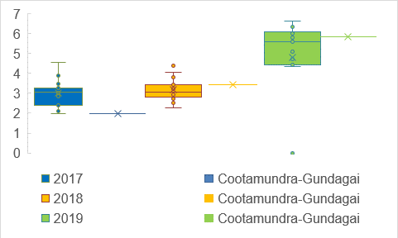

Figure 16 plots deviation from budgeted expenditure for the two standard financial years since amalgamation and casts further light on the problems with spending at Cootamundra-Gundagai. Relative to its peer group, Cootamundra-Gundagai has incredibly high unexpected blowouts in expenditure. Elsewhere I have shown that poor budget accuracy is closely linked to poor relative technical efficiency (McQuestin, Noguchi, and Drew, 2020). It is therefore imperative that unbudgeted spending be abruptly curtailed. Part of the problems in this area can be unexpected grants, unplanned RMS work, and natural disaster responses. I suspect that unplanned requests for help with community projects may also be one source of this budgeting error. Elsewhere I have proposed a much stricter approach to the provision of community grants and subsidies.

**Figure 16. Deviation from Budgeted Expenditure (2017 unavailable)**

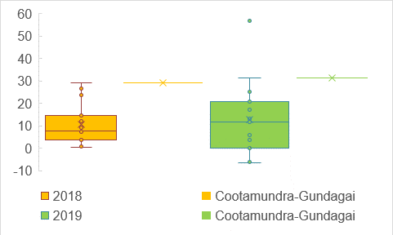

It also appears that Council has had difficulty predicting revenue. However, a positive result in this side of the ledger does not have the same deleterious effects as it represents unexpected flows of revenue.

**Figure 17. Deviation from Budgeted Revenue (2017 unavailable)**

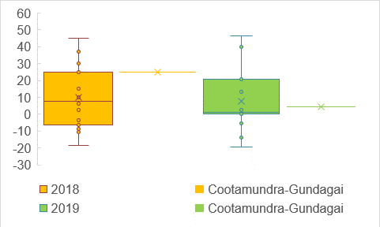

The proportion of expenditure on staff for Cootamundra-Gundagai is below typical for the local government peer group. This suggests that there are only limited opportunities available to reduce staff expenditure as part of the budget repair effort. However, matters are sufficiently serious that each vacant position must now be carefully considered *before* a decision is made to fill it. In particular, the presumption should be that outdoor staff won’t be immediately replaced when they resign or retire. Savings in this area will offset some of the pain of fee and tax increases. I am well aware that this will result in reduced outdoor service levels, but can see little alternative. Indoor positions will also need to be considered carefully, but few indoor jobs can go long undone, and it is clear to me that Council has been missing out on revenue over the last four years simply because it hasn’t had sufficient office staff in the right places to get essential work done. Therefore, we will have to be careful not to make matters worse by leaving key indoor staff positions unfilled.

**Note (14/12/20):** staff attention has now been turned to matters such as trade waste and revenue is now being collected where appropriate.

**Figure 18. Proportion of Expenditure on Staff**

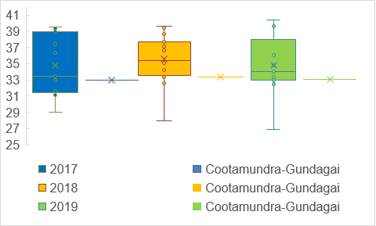

When we look at the level of staff expenditure on a per assessment basis, Cootamundra-Gundagai is pretty typical of the cohort. One must be mindful of Figure 11 when interpreting this present graph – staff expenditure may be typical, but rates, fees and charges are below typical and the compounding effect of this disparity over four years explains much of the Council’s present difficulties. Merely being typical, with respect to staff expenditure will not repair the budget or save rate payers from significant increase to fees and taxes. Therefore, Cootamundra-Gundagai Council would be well-advised to look at ways to reduce employee costs – along the lines I stated above – even further and hopefully improve relative performance to Quartile 1, or below.

**Figure 19. Staff Expenditure per Assessment**

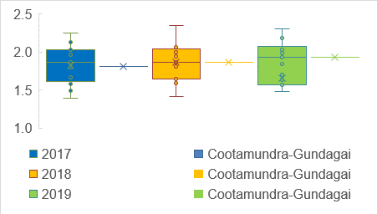

Given my comments above, the relatively poor operating cash flow for Council will not come as a surprise. The 2017 result was affected by the additional six weeks that was included for amalgamated councils and isn’t a reliable comparison. For the two standard financial years since amalgamation it is clear that Council has some of the poorest results of the peer group. The situation cannot be allowed to continue for long before there are serious ramifications. The solution will probably be to both reduce operating expenditure *and* increase operating revenue substantially.

**Figure 20. Nett Operating Cash Flows (deflated by revenue)**

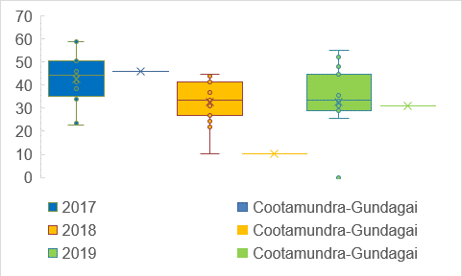

Figure 21 illustrates the relative position of Council with respect to investment cash flows. Cootamundra-Gundagai Council has been delivering extensive infrastructure projects which have so far been mainly funded through grants, running down of reserves, and debt. In a relative sense Council performance doesn’t look particularly bad. However, the LTFP and various conversations I have had of late suggests to me that reserves have been depleted (or are about to be) and this is very concerning. Fees will have to go up significantly for water and sewer (less so for waste) to re-build reserves back to a safe level.

**Figure 21. Nett Investing Cash Flows (deflated by revenue)**

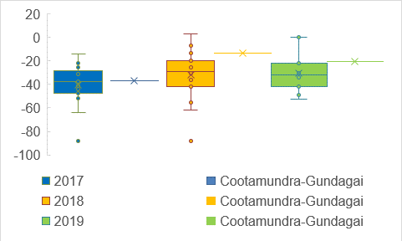

Cash flows for finance activities suggest to me that Council’s repayments and borrowings are typical for the peer group. However, we need to be mindful of the impact of the proposed new borrowings, as well as the fact that revenue is clearly insufficient for the current expenditure profile.

**Figure 22. Nett Finance Cash Flows (deflated by revenue)**

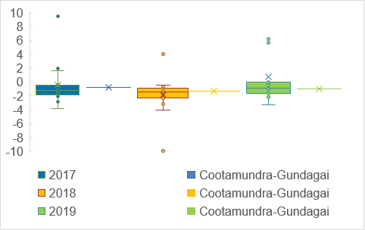

The next three charts examine various measures of infrastructure condition and backlog. Caution needs to be exercised when considering these charts because many of the inputs to the ratios rely on subjective judgements. Since the Fit for the Future programme many Councils have adopted an optimistic approach to recording their asset conditions, because these ratios were used in 2016 to justify forced amalgamations. Also, as at the time of writing Cootamundra-Gundagai did not have infrastructure metrics prepared for the 2019 financial year.

Figure 23 charts Council’s relative position on the renewals ratio which measures funds spent on renewals relative to depreciation expenditure (see the Table in the appendix for ratio definitions). As I noted earlier, Council does have a relatively high depreciation rate which will tend to lower its relative performance on this ratio, all other things held constant. Notwithstanding this relatively high depreciation rate Cootamundra-Gundagai recorded a typical result with respect to its peer group in 2018. I imagine this will also be the case in 2019 given the significant work being undertaken on water assets.

**Figure 23. Buildings and Infrastructure Renewal Ratio (2019 data unavailable)**

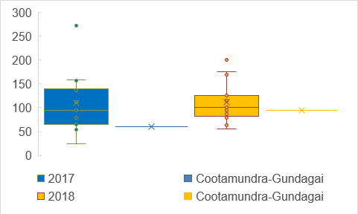

Figure 24 charts the backlog ratio which measures funds that are required to be spent on assets in order to bring them to a satisfactory standard as a proportion of total assets. The chart suggests that Council has a very high backlog relative to its peer group. This, of course, is why Cootamundra-Gundagai has been spending (or is planning to spend) considerable funds on water and sewer assets (and to a lesser extent waste). Unfortunately, this means that reserves will soon be at concerning low levels for water and sewer and fees therefore will need to go up substantially to ensure Council has sufficient funds to cover contingencies.

**Note (14/12/20):** Water and sewer fees were adjusted up to ensure that full costs and overheads were collected from the 2020/21 financial year onwards.

**Figure 24. Infrastructure Backlog Ratio (2019 unavailable)**

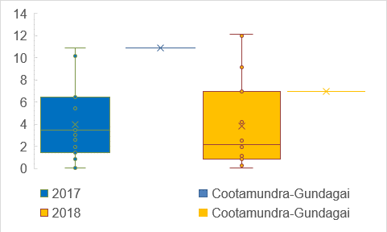

For the previous two years Council has claimed that it has no required maintenance to conduct on its assets (I set it at 200, just so Council would appear in the graph – if I left it at infinity CGRC wouldn’t have been marked in at all). This does not seem correct and should be redressed in future financial statements.

**Figure 25. Asset Maintenance Ratio (2019 unavailable)**

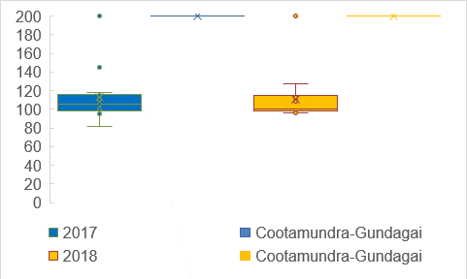

The final financial ratio that I examined is the rates and annual charges outstanding ratio. This ratio fluctuates a little from year to year, but I think it is fair to say the Cootamundra-Gundagai’s performance here is pretty typical of the peer group. This is an important point to consider because I cannot see any other alternative to significantly higher fees and taxes for the next five years or more. The ratio suggests that residents have ‘typical’ capacity to pay what must be paid and this suggests to me that budget repair – although unfortunately painful – will be possible. Careful attention should be paid to this ratio for the next few years to monitor the capacity of ratepayers to meet the higher demands that will have to be placed on them.

**Figure 26. Rates and Annual Charges Outstanding**

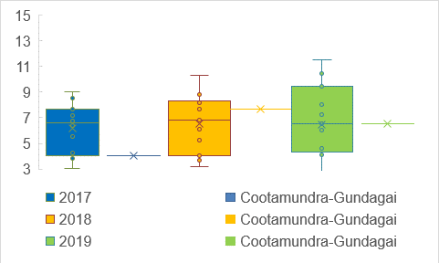

**Long Term Financial Plan Analysis**

The Long Term Financial Plan (LTFP) makes for sobering reading. Of particular concern are projections of negative balances in unrestricted general funds commencing 2021/22. Subsequent to this time Council would likely be placed into financial administration. Moreover, the sewer and water reserves are about to be emptied and there simply will be no money to deal with unexpected problems or budget blowouts on the sewer and water works.

When examining these figures, we should be mindful that LTFPs are always based on assumptions. Some of the assumptions in the LTFP that underlie the figures that I chart below are quite optimistic. For instance, it is assumed that RMS work will continue apace. It is also assumed that FAG grants will continue at current levels – and this seems a rather optimistic assumption (first because CGRC is now out of the protection period, second because a new FAG model is being introduced in NSW, and third because the parlous state of federal finances means that a FAG freeze is a strong possibility). Similarly, it has been assumed that R2R funding will continue at current rates (which is also unlikely given the federal budget position). Moreover, there is already an assumption built in of 8.5% p.a. SRVs commencing 2021/22 – which clearly won’t be sufficient if we are still expecting to end up with negative $1 million by the end of 2021/22.

The following four charts tell us most of what we need to know about the problems facing Council. Figure A looks at Total Income compared to the peer group. As will be quickly noted Cootamundra-Gundagai has total income below the typical level of the peer group (measured by either the mean (average) or median (half-way mark when results are placed in ascending order)). Notably this is inclusive of large flows of capital grants this year, and the planned SRVs that I discussed from 2020/21. Clearly Council is not receiving sufficient revenue for a local government of its size.

**Figure A. Total Income Compared to Peer Group**

The problem of insufficient revenue is thrown into stark relief by the total expenditure data which shows that Council is slightly higher than typical in this respect. Otherwise stated, Council has lower revenue than typical, but higher expenditure than typical. It is thus hardly surprising that after four years of this unbalanced revenue/expenditure profile that Council has reach its current budget crisis.

**Figure B. Total Expenditure Compared to Peer Group**

It is also not surprising that the projected nett operating result for Council is the worst in the peer group (which includes Hilltops; see Figure C below). This is clearly not sustainable.

**Figure C. Nett Operating Result (Including Capital Grants)**

In Figure D the picture becomes even grimmer, when we exclude capital grants.

**Figure D. Nett Operating Result Without Capital Grants**

At present the plan seems to be for Council to fail sometime during the 2021/22 financial year. This cannot be allowed to happen and anyone who doesn’t understand the gravity of this situation needs to look at the scholarly paper I wrote regarding the financial administration of Central Darling Shire (Drew and Campbell, 2015).

So, what does need to happen? We need to reduce our costs and increase our revenue. We also need to ensure that our senior staff and ratepayers are made aware of the measures we must take and the budget emergency we face. Blame for this situation goes way back to the amalgamation – either directly or indirectly. Early Administrators saddled Council with expenditure and structures which still weigh Council down. The costs for amalgamation were larger than expected. The politically motivated four year rate cap meant that we couldn’t put in a SRV much earlier, which would have minimised the pain (due to compounding effects) and might have been expected to have made it easier for ratepayers to manage the transition to higher fees and charges.

Shortly Council will receive a report on new waste fees, changes to the waste strategy, and a plan to put Elouera’s work out to competitive tender. I also make recommendations for changes to stormwater, on-site septic fees, water charges, sewer access charges, trade waste fees, other non-regulated fees, and a new strategy for providing community grant funds. Council needs to consider these matters quickly and make appropriate resolutions as soon as practical.

**Note (14/12/20):** CGRC adopted all of these proposed measures in full.

Council also needs to commit itself to strict austerity for a period of at least five years – there cannot be any new discretionary programs or discretionary expenditure. Staff need to focus on dealing with the situation at hand, and the community needs to have its fiscal illusions dispelled as a matter of some urgency.

Unfortunately, we are locked out of a SRV for this financial year, which will only increase the pain that must be inflicted next financial year. I have gone back through the last four years’ IPART SRV determinations and the largest one I found was:

Dungog Shire**e** 508A: 15.00%, 15.00%, 10.00%, 10.00%, 10.00%

Cumulative rise =76.02%

Cumulative rise above rate peg = 62.66%

SV purpose: Fund operations such as infrastructure maintenance and renewal, reduce infrastructure backlog, maintain existing enhance financial sustainability (IPART, 2019).

Unfortunately, this would *not* be sufficient, in and of itself, to keep Council’s unrestricted general fund in the black, given current LTFP projections.

As I stated earlier the situation at Council is extraordinarily fluid, so things may well change by the end of the year. However, what won’t change is that a large SRV is absolutely necessary and Council should resolve shortly to commit to indicating to IPART that it will be lodging a SRV application when the next round opens.

**Demographic Ratios**

The following suite of metrics are important because they provide us with a detailed picture of the operating environment that Cootamundra-Gundagai Regional Council faces.

Notably Council has relatively high growth in number of assessments, which will act in the medium and long-term to mitigate some of the financial sustainability concerns.

**Figure i. Growth in Number of Assessments**

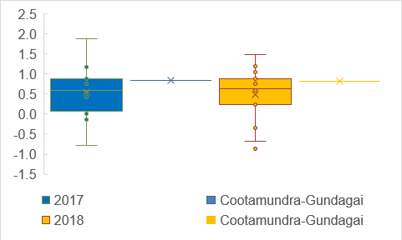

As the next two charts illustrate growth in residential assessment is pretty typical, compared to the peer group, but very promising for business. This is particularly helpful given that growth in business not only directly increases revenue for non-residential services, but might also be expected to bolster local employment and hence improve resident capacity to pay.

**Figure ii. Growth in Residential Assessments**

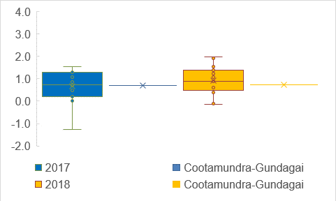

**Figure iii. Growth in Business Assessments**

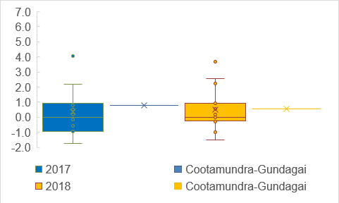

The uneven distribution in assessment growth is reflected in population growth data in Figure iv. However, it should be noted that growth in number of assessments is a much better metric to judge future revenue potential by because the data is far more accurate (inter-censal estimates in population growth may have errors up to 15.2% - see Drew and Dollery, 2014) and far more relevant to revenue considerations (because it is the unit by which waste, water and sewer access charges are levied).

**Figure iv. Population Growth**

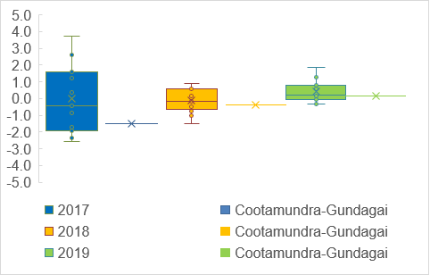

Population density provides us with a proxy measure by which to understand Council costs for servicing properties. As the distance between properties increases the cost of providing local government services also increases, all other things held constant (which is a good reason for why Council should preference infill development over greenfield sites). Figure v illustrates that population densities at Cootamundra-Gundagai are higher than typical for the peer group – which suggests that relatively higher costs incurred per assessment (see Figure 15) should be able to be addressed through careful expenditure control.

**Figure v. Population Density**

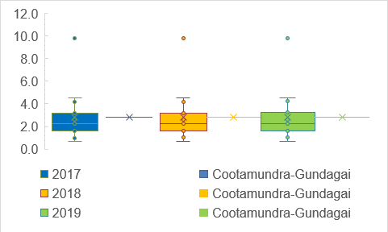

One area that Council is disadvantaged in relates to its relatively high proportion of pensioners. This has significant implications for revenue owing to pensioner discounts and the like. Ultimately the high number of discounts which Council is required by legislation to provide means that the remaining body of taxpayers and fee-payers will need to have even greater imposts placed on them than would be expected to occur at peer councils. Welfare is not a function assigned to local government in the tax assignment literature for a very good reason and it is regrettable that successive state governments have forced councils to effectively do so. However, it would be unrealistic to expect that pensioner discounts might be discontinued, so it is an additional burden Cootamundra-Gundagai is likely to be forced to bear indefinitely.

**Figure vi. Aged Pension**

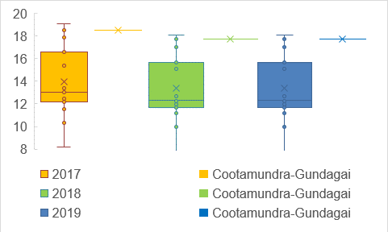

Other welfare statistics (disability pension, Newstart, and single parent pension) provide us with a further glimpse into the challenging socio-demographic environment in which Council operates.

**Figure vii. Disability Pension**

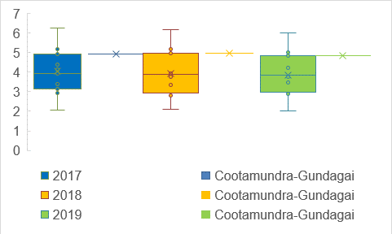

**Figure viii. Newstart**

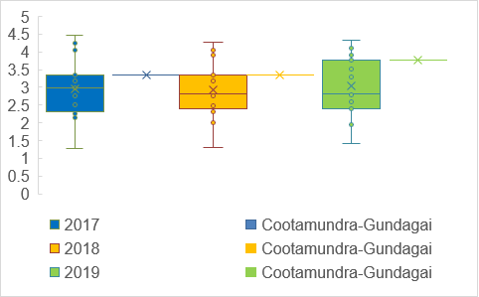

**Figure ix. Single Parent Pension**

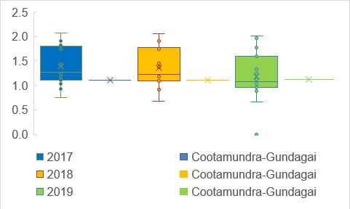

This picture, of a challenging operating environment, is confirmed by the relatively low median income of Cootamundra-Gundagai residents illustrated in Figure x. This means that Council will need to be very mindful of capacity to pay as it seeks to undertake budget repair. In an ideal situation inter-governmental grants would ‘compensate’ Council for its challenging socio-demographics, however it has long been demonstrated that the Financial Assistance Grants are not allocated in a manner completely consistent with the horizontal fiscal equalisation goals set out in the enabling legislation (see Grant and Drew, 2017).

**Figure x. Median Income**

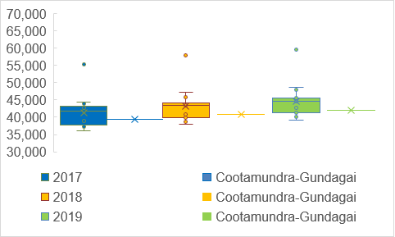

**Appendices**

**Definitions, Benchmarks, and Weightings of TCorp Financial Sustainability Ratios**

|  |  |  |  |  |
| --- | --- | --- | --- | --- |
| **Variable** | **Weighting** | **Benchmark** |  | **Definition** |
| Operating ratio | 17.5% | *>*–4% |  | (Operating revenuea – operating expenses)/operating revenuea |
| Own-source Revenue ratio | 17.5% | *>*60% |  | Rates, utilities, and charges/total operating revenueb |
| Unrestricted Current ratio | 10.0% | *>*1.50× |  | Current assets less  restrictions/current liabilities less specific purpose liabilities |
| Interest Cover ratio | 2.5% | *>*4.00× |  | EBITDA/interest expense |
| Infrastructure Backlog ratio | 10.0% | *<*0.02× |  | Estimated cost to bring assets to a satisfactory condition/total infrastructure assets |
| Debt Service Cover ratio | 7.5% | *>*2.00× |  | EBITDA/(principal repayments +  borrowing costs) |
| Capital Expenditure ratio | 10.0% | *>*1.10× |  | Annual capital expenditure/annual depreciation |
| Cash Expense ratio | 10.0% | *>*3.0 months |  | (Current cash and equivalents/(total expenses – depreciation – interest costs)) × 12 |
| Buildings and Infrastructure Renewal ratio | 7.5% | *>*1.00× |  | Asset renewals/depreciation of  building and infrastructure assets |
| Asset Maintenance ratio | 7.5% | *>*1.00× |  | Actual asset maintenance/required asset maintenance |

aRevenue excludes capital grants and contributions. bRevenue includes capital grants and contributions.

The cash expense cover ratio was not reported in the main body of this report as it provides a misleading picture of Council’s true cash position. Most of Council’s cash is in restricted funds and the general fund is in a rather parlous state. The cash expense ratio doesn’t make distinctions between restricted funds and general funds, and thus suggests that Council’s position is pretty typical of the peer group. It is, unfortunately, anything but typical. Drastic action must be taken as soon as possible to build up General Fund balances – this will include postponing projects, reducing staff expenditure, increasing fees and increasing rates.

**Cash Expense Ratio**

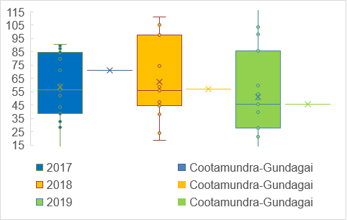

**References**

Drew, J. (2017). Playing for Keeps: Local Government Distortion of Depreciation Accruals in Response to High Stakes Public Policy-Making. *Public Money & Management*, 38(1): 57-64.

Drew, J. (2020). *Reforming Local Government*. Springer Palgrave: Singapore.

Drew, J. and Campbell, N. (2016). Autopsy of Municipal Failure: The Case of Central Darling Shire. *Australasian Journal of Regional Science*, 22(1): 81-104.

Drew, J. and B. Dollery. (2014). Keeping It In-House – Households as an Alternative Proxy for Local Government Output. *Australian Journal of Public Administration*, 73(2): 235-246.

Drew, J. and Grant, B. (2017). Means, Motive and Opportunity: Distortion of Public Policy Making Performance Management Data. *Australian Journal of Public Administration*, 75(1): 237-250.

Drew, J. and Grant, B. (2017). Multiple Agents, Blame Games and Public Policy-Making: The Case of Local Government Reform in New South Wales. *Australian Journal of Political Science*, 52(1), 37-52.

Grant, B. and Drew, J. (2017). *Local Government in Australia: History, Theory and Public Policy.* Springer Palgrave, Singapore.

McQuestin, D., Noguchi, M., and Drew, J. (2020). The Association between Budget Inaccuracy and Technical Efficiency in Australian Local Government. *Public Money & Management,* In print.

Independent Pricing and Regulatory Tribunal (IPART). (2019). *NSW Councils’ Special Variation and Minimum Rate Applications for 2019-20*. IPART: Sydney.