**Fact Sheet: Proposed Special Rate Variation**

Cootamundra-Gundagai Regional Council has indicated that it will apply to the Independent Pricing and Regulatory Tribunal (IPART) for a Special Rate Variation (SRV) for the 2021-22 year. A special rate variation allows Council to increase rates by more than the annual IPART rate cap. Ratepayers can find more information about the SRV process at: <https://www.ipart.nsw.gov.au/Home/Industries/Local-Government/Special-Variations>

The purpose of the SRV *is to try to assure financial sustainability, with a view to maintaining service levels wherever possible, including planned asset renewals, in response to very significant cost pressures imposed by the May 2016 forced amalgamation and subsequent rate path freeze.*

The cumulative impact of the Special Rate Variation is substantial and sits at 62.6 percent over five years, including the assumed rate peg. This will be a permanent increase to the rate base[1]. At the end of this Fact Sheet we provide tables to show the average impact (in both percent and dollar terms) for each of the three rating categories – residential, farm, and business – although we stress that the precise outcome for each ratepayer is dependent on the particular land valuation for the property.

Residents might note that this application is indeed a variation to the existing temporary SRV granted to Gundagai for its main street upgrade by the IPART commencing 2014/15 and currently scheduled to end before the 2024/25 financial year. If IPART doesn’t approve this current proposal to vary the SRV, then rates would otherwise decrease a little in 2024/25 in response to the expiration of the existing SRV instrument[2].

Prior to determining the size of the SRV requested of IPART, Cootamundra-Gundagai Regional Council considered other options, as outlined in the addendum to the Operational Plan. For example, during preparation for the 2020/21 budget, Council did significant work to improve efficiency and is on target to realise savings in excess of $2 million. These savings will continue in the later years. We also plan to reduce capital expenditure on transport infrastructure in 2021/22 and reduce employee costs by a further $500,000 per year from 2022/23.

In early 2020 Council had Professor Drew conduct a financial sustainability review of Cootamundra-Gundagai Regional Council. He concluded that without a substantial SRV Council solvency was at risk and that Council was likely to be placed into financial administration (Deloittes, in their work for the Boundaries Commission, also confirmed that Council’s financial position was grave). This would mean that the current serving, democratically elected, Councillors would be dismissed and the affairs of the Council would be determined by an Administrator. The Administrator would be appointed by the State government. Moreover, an Administrator would still have to balance the budget. This would likely result in significant cost cutting, as well as new revenue raising measures, such as an SRV.

The need for an SRV responds to a structural imbalance in the operating budget that has emerged since the 2016 amalgamation. Quite simply, Council’s required expenditure for staff, materials, and contracts exceeds its revenue (see Table 5 below). Indeed, in their work for the Boundaries Commission, Deloittes (2020, p. 4) claimed that ‘CGRC’s cost base has grown to be approximately 22% higher than the aggregate cost base of the former Gundagai and Cootamundra Councils (adjusting for inflation impacts)’. Council has made considerable cost savings recently and plans to do more in the future. However, the consensus of both external reviews is that an SRV is absolutely essential.

If we don’t get the SRV approved then to ensure solvency we would either have to cut employee costs by 25%, capital expenditure by 30%, or a combination of the two. We believe that the community would not find the resulting significant decline in infrastructure and services, which would occur under these scenarios, acceptable.

Council is very conscious of the hardship that the Special Rate Variation might cause and has recently reviewed its Hardship Policy, on which it invites the community to provide feedback. The Hardship Policy is available at [https://www.cgrc.nsw.gov.au/connect-with-us/have-your-say/documents-on-public-exhibition/](https://protect-au.mimecast.com/s/8TwOCL7EPlFL1gryiBohb3?domain=cgrc.nsw.gov.au/) or at either Council office. We want to hear from the community and will incorporate your feedback.

Accordingly we have arranged for a number of different kinds of community engagement events:

1. The community is requested to fill in the attached survey and return it to Council in person or by mail to PO Box 420 Cootamundra NSW 2590.
2. Council will soon be posting short videos to its website to further elaborate on this Fact Sheet.
3. Council will conduct two citizen juries:

Monday 18th January, 2021 Alby Schultz Meeting Centre, Cootamundra 10am till 2pm.

Tuesday 19th January, 2021 Gundagai Council Meeting Room, 10am till 2pm.

We seek expressions of interest from the community to participate in these juries. Please see the attached Expression of Interest form for details.

1. Council will hold two public meetings to present the case for an SRV and receive community feedback:

Monday 18th January, 2021 Gundagai Services Club, 7pm till 8.30pm.

Tuesday 19th January, 2021 Cootamundra Ex-Services Club, 7pm till 8.30pm.

1. Council will conduct two listening posts at the following sites:

Cootamundra: Thursday 21st January, 2021 outside IGA Supermarket, 9am till 5 pm.

Gundagai: Wednesday 20th January, 2021 outside Foodworks Supermarket, 9 am till 5 pm.

*How will the SRV Impact on Rates?*

The following tables outline the average annual changes for each rating category, as well as the overall impact for Council, in both percentage and dollar terms. Cumulative increase is presented for the five years in percentage and dollar terms (note figures are rounded to the nearest dollar).

**Table 1. Impact on Average Farmland Rate of an Expiring Special Rate Variation and a s508A Special Variation of 19%, 18%, 5%, 5%, 5%**



**Table 2. Impact on Average Residential Rate of an Expiring Special Rate Variation and a s508A Special Variation of 19%, 18%, 5%, 5%, 5%**



**Table 3. Impact on Average Business Rate of an Expiring Special Rate Variation and a s508A Special Variation of 19%, 18%, 5%, 5%, 5%**



**Table 4. Impact on Total Rate Revenue of an Expiring Special Rate Variation and a s508A Special Variation of 19%, 18%, 5%, 5%, 5%**



**Table 5. Cootamundra-Gundagai Operating Results ($’000)**

|  |  |  |  |  |
| --- | --- | --- | --- | --- |
| **Financial Year** | **2016/17** | **2017/18** | **2018/19** | **2019/20** |
| Revenue | 48,635 | 31,777 | 42,835 | 41,196 |
| Expenses | 43,578 | 38,856 | 38,488 | 39,783 |
| Operating Result Including Capital Grants | 5,057 | -7,079 | 4,347 | 1,413 |
| Operating Result Excluding Capital Grants | -4,882 | -9,376 | -2,910 | -6,248 |

**Table 6. Comparison of Average Rate Levels for Other Similar (OLG 11) Councils, 2020-21**

|  |  |  |  |
| --- | --- | --- | --- |
| **2020-21** | **Residential** | **Farm** | **Business** |
| Mean (average) OLG11 | 981.64 | 3,466.63 | 2,245.98 |
| Standard deviation[3] OLG11 | 505.19 | 2,070.97 | 1,469.98 |
| Median[4] OLG11 | 897.75 | 2,900.00 | 1,672.71 |
| **Cootamundra-Gundagai Post Harmonisation** | **$675.00** | **$2,900.00** | **$1,560.00** |

Source: Office of Local Government 2018-19 data inflated for the two rate caps over the intervening period.

**Figure 1. Cootamundra-Gundagai Revenue and Expenditure by Type and Destination.**

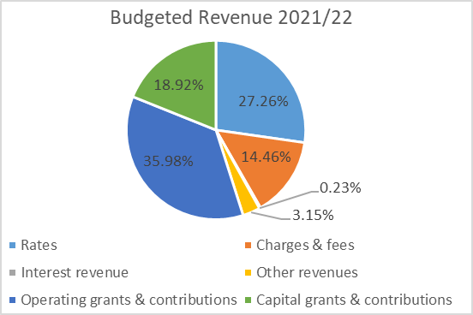 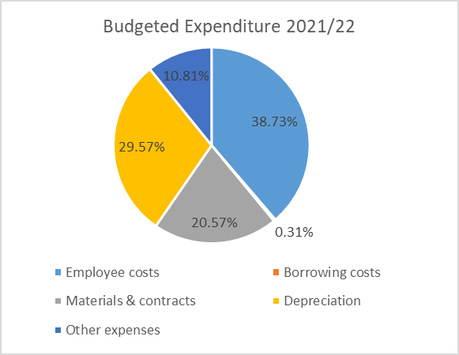

1. This means that after 2025/26 rates will not go down again, but instead be increased by the rate peg set by IPART which Councils are advised to assume to be 2.5% per annum.
2. As a consequence of forgoing the expiry of the current SRV at the end of 2023/24 the 5% SRV included in our tables really represents a 9% increase against the status quo outcome for 2024/25.
3. The standard deviation is the average spread of results in OLG11 from the mean.
4. The median is the middle number when all OLG11 council rates are put into ascending order. It is sometimes used as an alternative to the mean for measuring central tendency.