Special Variation Application Form – Part B
For 2016-17

Issued January 2016
Insert Name of Council: Greater Taree City Council
Date Submitted to IPART: 12 February 2016
Council Contact Person: Ron Posselt
Council Contact Phone: 6592 5300
Council Contact Email: tareecouncil@gtcc.nsw.gov.au

© Independent Pricattachment i
ng and Regulatory Tribunal of New South Wales 2016
This work is copyright. The Copyright Act 1968 permits fair dealing for study, research, news reporting, criticism and review. Selected passages, tables or diagrams may be reproduced for such purposes provided acknowledgement of the source is included.
The Tribunal members for this review are:
Dr Peter J. Boxall AO, Chairman
Ms Catherine Jones
Mr Ed Willett
Inquiries regarding this document should be directed to a staff member:
Dennis Mahoney (02) 9290 8494
Tony Camenzuli (02) 9113 7706
Independent Pricing and Regulatory Tribunal of New South Wales
PO Box K35, Haymarket Post Shop NSW 1240
Level 16, 2-24 Rawson Place, Sydney NSW 2000
T (02) 9290 8400 F (02) 9290 2061
www.ipart.nsw.gov.au

Contents
1 Introduction 1
1.1 Completing the application form 1
1.2 Notification and submission of the special variation application 2
2 Preliminaries 4
2.1 Focus on Integrated Planning and Reporting 4
2.2 Key purpose of special variation 4
2.3 Capital expenditure review 6
3 Assessment Criterion 1: Need for the variation 7
3.1 Case for special variation - community need 7
3.2 Financial sustainability 12
3.3 Financial indicators 16
3.4 Contribution plan costs above the cap 20
4 Assessment criterion 2: Community awareness and engagement 20
4.1 The consultation strategy 22
4.2 Feedback from the community consultations 24
5 Assessment criterion 3: Impact on ratepayers 25
5.1 Impact on rates 28
5.2 Consideration of affordability and the community’s capacity and willingness to pay 32
5.3 Addressing hardship 34
6 Assessment criterion 4: Public exhibition of relevant IP&R documents 36
7 Assessment criterion 5: Productivity improvements and cost containment strategies 37
8 List of attachments 46
9 Certification Error! Bookmark not defined.

Introduction
IPART will assess each application against the criteria set out in the Office of Local Government’s (OLG) Guidelines for the preparation of an application for a special variation to general income for 2016/2017 (the Guidelines). Councils should refer to these guidelines before completing this application form.
Each council must complete this Part B application form when applying for a special variation to general income either under section 508A or under section 508(2) of the Local Government Act 1993.
In addition, councils must complete the Part B form with the Part A (spreadsheet) form for both s508(2) and s508A applications. The Guidelines also require the council to have resolved to apply for a special variation. You must attach a copy of the council’s resolution. IPART’s assessment of the application cannot commence without it.
If the proposed special variation includes increasing minimum rates above the statutory limit, or is to apply a higher rate of increase to an existing minimum rate than to its other rates, it is not necessary for the council to also complete the separate Minimum Rates Application form. However, this must be clearly identified and addressed in the special variation application. In such circumstances, councils are encouraged to discuss their proposed application with IPART as soon as possible.
As outlined in the OLG’s Guidelines, councils that are the subject of merger proposals will not be eligible for a special variation for the 2016-17 rating year.

Completing the application form
This form is structured to provide guidance on the information we consider is necessary for us to assess a special variation application. To complete the form, the council will need to respond to questions and insert text in the boxed area following each section or sub-section.
The amount of information that a council provides will be a matter of judgement for the council, but it should be sufficient for us to make an evidence-based assessment of the application. Generally, the extent of the evidence should reflect the size of the variation sought. More complex applications or requests for a high cumulative percentage increase should be supported by stronger, more extensive evidence.
Councils may submit additional supporting documents as attachments to the application (refer to section 8). These attachments should be clearly cross-referenced in Part B. We prefer to receive relevant extracts rather than complete publications, unless the complete publication is relevant to the criteria. If you provide complete documents when only an extract is relevant, we may ask you to resubmit the extract only. (You should provide details of how we can access the complete publication should this be necessary.)
We publish videos and Fact Sheets on how IPART assesses special variations and on the nature of community engagement for special variation applications. These will assist in preparing the application. The latest videos and Fact Sheets on these topics are available on IPART’s website.
We may ask for additional information to assist us in making our assessment. If this is necessary, we will contact the nominated council officer.
This application form consists of:
- Section 2 – Preliminaries
- Section 3 – Assessment criterion 1
- Section 4 – Assessment criterion 2
- Section 5 – Assessment criterion 3
- Section 6 – Assessment criterion 4
- Section 7 – Assessment criterion 5
- Section 8 – List of attachments
- Section 9 – Certification.

Notification and submission of the special variation application

Notification of intention to apply
Councils intending to submit an application under either section 508(2) or section 508A should have notified us of their intention to apply, via the Council Portal, by Friday, 11 December 2015.
Any councils that did not notify but intend to apply for a special variation for 2016-17 should contact us as soon as possible.

On-line submission of applications
All councils intending to apply for a special variation must use the Council Portal on IPART’s website to register as an applicant council and to submit an application.
The Portal is at http://www.ipart.nsw.gov.au/Home/Industries/Local_Govt. The User Guide for the Portal will assist you with the registration and online submission process. If you experience difficulties please contact Himali Ranasinghe on (02) 9113 7710 or by email himali_ranasinghe@ipart.nsw.gov.au
File size limits apply on the Council Portal to each part of the application. For this Part B application form the limit is 10MB. The limit for supporting documents is 50MB for public documents and 50MB for confidential documents. These file limits should be sufficient for your application. Please contact us if they are not.
We will post all applications (excluding confidential content) on the IPART website. Confidential content may include part of a document that discloses the personal identity or other personal information pertaining to a member of the public or whole documents such as a council working document and/or a document that includes commercial-in-confidence content. Councils should ensure that documents provided to IPART are redacted so that they do not expose confidential content.
Councils should also post their application on their own website for the community to access.

Hardcopy of application
We ask that councils also submit one hardcopy of their application to us (with a table of contents and appropriate cross-referencing of attachments) at the following address:
Local Government Team
Independent Pricing and Regulatory Tribunal
PO Box K35
Haymarket Post Shop NSW 1240
or
Level 15, 2-24 Rawson Place, Sydney NSW 2000.
We must receive your application via the Council Portal no later than COB Monday, 15 February 2016.

Preliminaries

Focus on Integrated Planning and Reporting
Councils must identify the need for a proposed special variation to their General Fund’s rates revenue as part of their Integrated Planning and Reporting (IP&R) process. The IP&R documents will need to be publicly exhibited and adopted by the council prior to it submitting its application to us. Also refer to section 6 for a more detailed explanation.
The key IP&R documents are the Community Strategic Plan, Delivery Program, Long Term Financial Plan and, where applicable, the Asset Management Plan. A council’s application may also include supplementary and/or background publications used within its IP&R processes. You should refer to these documents to support your application for a special variation where appropriate.

Key purpose of special variation
At the highest level, indicate the key purpose(s) of the proposed special variation by marking one or more of the boxes below with an “x”.

Maintain existing services
Enhance financial sustainability
Environmental services or works
Infrastructure maintenance / renewal
Reduce infrastructure backlogs
New infrastructure investment
Other (specify)
You should summarise below the key aspects of the council’s application, including the purpose and the steps undertaken in reaching a decision to make an application.
Community dissatisfaction with the state of our infrastructure has a long history, commencing with quantification of a backlog in the vicinity of $150M (Percy Allen) in 2008 (attachment i) and then confirmed during consultation relating to the preparation of our Community Plan in 2009. In 2010, Council was successful in its application for a road and bridge infrastructure special rate variation (SRV), that remains permanently in the rate base and which continues to be restricted for capital infrastructure to this day. However, generating income of $4,870,118 in 2015/2016, this amount does little to halt a deteriorating road network of 1,725 kms. Despite spending approximately 40% of our annual rate income on our failing infrastructure, the backlog continues to grow at a rate of $20M each year. We believe an affordable solution lies in a mixture of renewal activities and increased maintenance activities to provide a safer network for users. The solution involves a commitment to improve levels of service by increasing the quantum and frequency of the following renewal and maintenance activities:
- Heavy patching - 225,000m² of heavy patching per annum, 5 times the current level of service.
- Surface reseal - 40kms of road reseal per annum, 5 times the current level of service.
- Gravel resheeting - 20km of gravel resheeting per annum, an increase of 75% the current level of service.
- Rehabilitation and reconstruction - A minimum 3km per annum, 3 times the current level of service. More when grant funds are also secured.
- Linemarking - Doubling the frequency from 10 to 5 years. Ensuring all sub arterial and collector roads have clearly defined traffic lines, road widths and alignment.
- Roadside vegetation management - Tripling the roadside vegetation clearing frequency. Sealed roads – quarterly, unsealed roads – annually and unsealed local/minor roads – every 3 years. Ensuring improved line of sight on rural roads and low roadside vegetation on sealed roads.
- Drainage management - Doubling the number of drains cleaned to 10 per week. Ensuring efficient water run off, which reduces pavement damage and increases safety conditions.
- Pothole response - Doubling the intervention rate: Regional roads – weekly, Collector roads – fortnightly, Local/minor roads – monthly. Ensuring potholes on highly trafficable roads a filled more regularly.
- Gravel patching - Unsealed road network patched every 3 months. Ensuring monthly patrols for unsealed road network.
- Safety barriers – 500 linear metres of safety barriers replaced annually, removing backlog in 5 years. Ensuring clear delineation between roadway and hazardous locations and reduced severity of accidents.
- Shoulder grading - 100km of shoulder grading per annum, 12 times the current rate. Ensuring adequate run off and safe area to pull over.
The current SRV application supports this solution and is underpinned by an Strategic Asset Management Plan for Transport and Drainage (attachment ii).
Greater Taree City Council (GTCC) commenced consideration of the current SRV to increase expenditure on infrastructure in June 2014 when it adopted a Long Term Financial Plan (LTFP) 2014 (attachment iii) scenario that included a 5% (excl rate peg) SRV to commence in 2016/2017. With adoption of the LTFP (attachment iv) in June 2015, this was revised to 6% (excl rate peg), over two years in one scenario and over 6 years in another. In June 2015, the latter formed the basis of the Council endorsed submission of its ‘Fit for the Future’ (attachment v) proposal, to the NSW State Government.
Council’s draft 2015/2016 budget proposes a Long Term Financial Plan scenario 3 that indicates a rate variation of 6% in addition to the IPART rate peg for 6 years, with the additional rating income to remain in the budget following this period. By 2022/2023, this increase would realise an approximately $10M in additional rating income per annum all of which it is proposed be quarantined for expenditure on infrastructure maintenance and renewal. The aim of this being to decelerate deterioration of the road and bridge infrastructure.
Fit for the Future Submission report endorsed by Council – June 17 2015.
Specifically, these resolutions led to the preparation of an SRV community engagement plan (attachment vi) and a report to Council’s 15 October 2015 Ordinary meeting, at which it was resolved that a community consultation process be undertaken to ascertain response to an 6% variation above the rate peg, which at the time was assumed to be 2.4% (total 8.4%), over 6 years.
Based on the feedback from surveys, face to face, and via other mechanisms such as social media and correspondence, a revised SRV proposal was discussed at the 2 December Councillor workshop and considered at the 9 December Ordinary meeting of Council. Council’s current proposal of 6.9% (incl rate peg) was advised to the Independent Pricing and Regulatory Tribunal (IPART) by the due date of 11 December 2015.

You should complete this section if the council intends to undertake major capital projects that are required to comply with the OLG’s Capital Expenditure Guidelines, as outlined in OLG Circular 10-34. A capital expenditure review is required for projects that are not exempt and cost in excess of 10% of council’s annual ordinary rates revenue or $1 million (GST exclusive), whichever is the greater.
A capital expenditure review is a necessary part of a council’s capital budgeting process and should have been undertaken as part of the Integrated Planning and Reporting requirements in the preparation of the Community Strategic Plan and Resourcing Strategy.

Does the proposed special variation require council to do a capital expenditure review in accordance with OLG Circular to Councils, Circular No 10-34 dated 20 December 2010 | Yes | No
If Yes, has a review been done and submitted to OLG? | Yes | No

Assessment Criterion 1: Need for the variation
Criterion 1 within the OLG Guidelines is:
The need for, and purpose of, a different revenue path for the council’s General Fund (as requested through the special variation) is clearly articulated and identified in the council’s IP&R documents, in particular its Delivery Program, Long Term Financial Plan and Asset Management Plan where appropriate. In establishing need for the special variation, the relevant IP&R documents should canvass alternatives to the rate rise. In demonstrating this need councils must indicate the financial impact in their Long Term Financial Plan applying the following two scenarios:
- Baseline scenario – General Fund revenue and expenditure forecasts which reflect the business as usual model, and exclude the special variation, and
- Special variation scenario – the result of implementing the special variation in full is shown and reflected in the General Fund revenue forecast with the additional expenditure levels intended to be funded by the special variation.
Evidence to establish this criterion could include evidence of community need /desire for service levels/projects and limited council resourcing alternatives.
Evidence could also include the assessment of the council’s financial sustainability conducted by the NSW Treasury Corporation.
The response to this criterion should summarise the council’s case for the proposed special variation. It is necessary to show how the council has identified and considered its community’s needs, alternative funding options (to a rates rise).
The criterion states that the need for the proposed special variation must be identified and clearly articulated in the council’s IP&R documents especially the Long Term Financial Plan (LTFP) and the Delivery Program, and, where appropriate, the Asset Management Plan (AMP). The purpose of the proposed special variation should also be consistent with the priorities of the Community Strategic Plan (CSP).

Case for special variation - community need
Summarise and explain below:
- How the council identified and considered the community’s needs and desires in relation to matters such as levels of service delivery and asset maintenance and provision.
- How the decision to seek higher revenues above the rate peg was made and which other options were examined, such as changing expenditure priorities or using alternative modes of service delivery.
- Why the proposed special variation is the most appropriate option: for example, typically other options would include introducing new or higher user charges and/or an increase in council loan borrowings, or private public partnerships or joint ventures.
- How the proposed special variation impacts the LTFP forecasts for the General Fund and how this relates to the need the council identified. Our assessment will also consider the assumptions which underpin the council’s LTFP forecasts.
In addressing this criterion, you should include extracts from, or references to, the IP&R document(s) that demonstrate how the council meets this criterion.

In 2010, Council adopted the Manning Valley Community Plan 2010/2030 (attachment vii). The Plan follows an extensive community consultation period and represents the combined efforts of over 7,000 individuals through written submissions, comments and contributions. It captures the community’s priorities and aspirations for the next 20 years and includes a series of objectives and strategies for achieving these goals. The Plan is divided into five Key Directions as follows:
- Looking after what we’ve got – focusing on maintaining community assets;
- Respecting the environment – addressing issues such as care of the Manning River;
- A strong economy – including opportunities for business, education and employment;
- A great lifestyle – covering a range of community wellbeing issues, such as housing, health, culture and recreation;
- Getting things done – focusing on opportunities for partnerships and community involvement in delivering the Plan.
There were two surveys conducted during the community engagement program for the Community Plan. The first survey (April 2009) aimed at capturing the key issues for the future and identifying what was important to the community. The second survey (December 2009) was a random telephone sample of 402 community members. It looked more specifically at areas of concern and the financing of those concerns.
Survey One – Top 10 Key Issues:
- Social Facilities;
- Transport;
- Roads & Bridges;
- Recreational facilities;
- The natural environment;
- The Manning River;
- Community Safety;
- Public Health;
- Employment;
- Education.
Key messages to emerge from Survey One were as follows:
- The natural environment is important;
- The state of the roads is a significant issue;
- Employment and a broad-based economy is essential;
- People want to be proud of where they live.
Survey Two - Key Issues:
As referred to above, whilst the first survey aimed at capturing the key issues for the future and identifying what was important to the community, the second survey was a random telephone sample that looked more specifically at areas of concern and how we could finance the objectives of the Community Plan. The key messages to emerge from this survey were as follows:
- Residents place high importance on infrastructure such as roads and bridges;
- Libraries, parks and reserves were also highly valued facilities and there was a strong focus on the general appearance and cleanliness of the area;
- Respondents found it difficult to identify the key environmental issues for the area;
- Community members felt they could contribute towards the social, environmental or economic improvement of the Manning Valley through activities such as supporting local business, volunteering, keeping areas clean and tidy, increasing awareness of issues, conserving water and energy and participating in recycling programs and being involved in community fundraising and projects.
On the issue of resourcing options, the second survey considered three options for addressing the Manning Valley’s infrastructure backlog. The results were:
- Option One: maintain the status quo (i.e. no new funding initiatives): 6%
- Option Two: steady rating increase (between 10% - 15%): 47%
- Option Three: higher rating increase: 6%
- Other: i.e. increased State and or Federal Govt. funding 20%
- Unsure: 11%
This information formed the basis of the 2010 SRV, but more significantly a review of options to increase funding of our infrastructure backlog. These initiatives include:
- Following an organisational restructure in early 2010, Council announced an extensive review of services to meet the ballooning operational budget. In May 2011, the draft 2011/2012 budget indicated an operational deficit of almost $3M. In response, the Council set a target of $3M in operational savings as a result of service reviews aimed at gaining efficiencies. In June 2015, Council adopted a budget with and operational surplus of $30,000 and a quarter 2, Quarterly Budget Review Statement adopted at the January 2015 meeting of Council indicates further improvement. This is a direct result of service reviews and has resulting in increase in the allocation of 40% of rate income to infrastructure, in an effort to address the key concern of the community – the state of the road and bridge infrastructure.
- Since 2010, we have developed our capacity to attract grants, having secured $65M in infrastructure grants, which has resulted in a $120M investment across a combination of infrastructure renewal projects since 2010. Including 22.2kms of renewal and replacement of six bridges. Often, as was the case with the 2015 Fixing Country Roads grant, we are the only Council on the NSW Mid North Coast to secure funds.
- Since 2011, we have actively managed our loans through the establishment of a Finance and Investment Advisory Committee, which meets quarterly to review the borrowing and investment strategy. Since June 2012, the Committee has recommended restructure of loans that has generated savings in the vicinity of $500,000.
- Another key objective of GTCC has been our continued advocacy for allocation of federal funds for road and infrastructure based on road length and not population including review of the distribution of the Federal Assistance Grants Scheme (FAGS), to ensure a more sustainable base for regional and rural councils. This matter has been progressed through related Motions to both the ALGA National General Assembly and the LGNSW Conference in 2015 and is identified as a continuing focus in our 2015 Fit for the Future submission.
- While Council adopted an outstanding rates and annual charges debt ratio of 6-7.5% for the 2015/2016 financial year. Defying the state trend, which has seen the increase in rates and annual charges outstanding by 15% in recent years, significant work has been done to reduce ours this year. Council’s preferred position being that rate payers are on payment plans over retaining outstanding debt. At January 2016, our outstanding debt ratio stood at 5.86%, the State benchmark for metropolitan and coastal councils being 5%.
Despite these improvements in financial management, and the continued quarantine of funds raised through the permanent increase established with the 2010/2014 SRV, for capital infrastructure programs, a shortfall remains for critical asset renewal and maintenance.
Because of the fragmented nature of settlement, the Manning Valley has a large amount of infrastructure per head of population. Our current network of roads, bridges, footpaths, kerb and gutter, sports fields, parks and buildings represents an investment of more than $15,000 worth of infrastructure for each man, woman and child in our Valley. There has been a history of under-investment in the care and maintenance of our local infrastructure, with the result that some 25% of the network has passed its serviceable life and requires major repair or reconstruction. Our geography of large flood plains requiring many bridges with an increased susceptibility to flood damage, deep escarpment valleys with long dead end roads servicing small populations and susceptibility to landslip add to the cost and risks of our infrastructure. With 23 towns and villages our population is dispersed and a lack of public transport across our large local government area of 3,753km², makes our transport network critical to daily life.
Through the consultation undertaken in November/December 2015, it has been established that over 80% of the community is dissatisfied with the condition of local road infrastructure. The independent survey undertaken in December also identified that the majority of respondents agree council should spend more money on roads. On a sliding scale respondents reported a preference for expenditure on roads (47%) compared to lower rates (11%). This appears to indicate a willingness to pay more if outcomes are visible.
The relationship between funding and condition of Council’s assets is crucial, particularly when considered over the long term. Council’s draft Asset Management Plan for road infrastructure identifies the impact of two scenarios for investment - the status quo and the proposed 6.9% over 6 years SRV-funded capital works program.
An SRV is considered the most sustainable source of funding for infrastructure in the long term. If approved, it is a guaranteed source of funds that supports forward planning of renewal and maintenance to arrest the continuing decline in our infrastructure. Overall this enables Council to better manage its infrastructure sustainably rather than reactively. Addressing these long term issues now is fiscally responsible and has regard for the principles of intergenerational equity. It also provides for the continued economic growth of the LGA. As stated by a member of the public who addressed the January 2016 Council meeting in support of the SRV “We can’t sit back, over the last 10 years our roads have just deteriorated …. a lot of people come into the area for playing sport or tourism and we want those people to buy houses here to boom the town and to get the town moving.”
The Long Term Financial Plan adopted in June 2015, considered three scenarios:
Scenario 1: 2015/2016 Budget including projected population increase of an average 1.46% pa and a second Environmental Levy Special Rate Variation commencing 2019/2020.
Scenario 2: Scenario 1 plus an Infrastructure Maintenance Special Rate Variation (SRV) of 12% (in addition to an assumed 2.4% rate peg), increased over two years, at a rate of 6%pa (in addition to an assumed 2.4% rate peg) for 2015/2016 and 2016/2017. This SRV was modelled in perpetuity and aimed to achieve $3.4m after 2016/2017. The amount of $3.4m represented the annual cost to improve road safety on the existing road network. Road safety activities include guideline work, line marking, road reserve clearing, guideposts, guardrails, signage – street, regulatory and warning, road reserve clearing, patching, grading and resheeting.
Scenario 3: Scenario 1 plus an Infrastructure Maintenance Special Rate Variation (SRV) of 36% (in addition to an assumed 2.4% rate peg), increased over 6 years at a rate of 6% pa (in addition to an assumed 2.4% rate peg). This SRV was also modelled in perpetuity and aimed to achieve an additional $13.0m per annum after 2021/2022. The additional income of $13.0m per annum is required to address maintenance issues on the current road network to eliminate continued deterioration, including the increased safety activities of Scenario 2.
Scenario 1, assumed no change and continued deterioration of the road network.
Scenario 2, assumed increased rates to address safety issues relating to the road network, but does not stop deterioration of the road network.
Scenario 3, assumed increased rates to address the continued deterioration of the road network.
None of the scenarios proposed to reduce the infrastructure backlog and none assumed increased operational services unrelated to infrastructure maintenance. However, any SRV does improve capacity to borrow and to leverage off grant funds for specific SRV related purposes.
Following community consultation about affordability of Scenario 3, the current SRV proposal is modelled in the draft 2016/2026 Long Term Financial Plan as a 6.9% (incl rate peg) increase over 6 years, which is currently being prepared to support the annual budget process under the Integrated Planning and Reporting Framework. The impact of this is addressed in response to 3.3.

Financial sustainability
The proposed special variation may be intended to improve the council’s underlying financial position for the General Fund, or to fund specific projects or programs of expenditure, or a combination of the two. We will consider evidence about the council’s current and future financial sustainability and the assumptions it has made in coming to a view on its financial sustainability.
You should explain below:
- The council’s understanding of its current state of financial sustainability, its long-term projections based on alternative scenarios and assumptions about revenue and expenditure.
- Any external assessment of the council’s financial sustainability, eg, by auditors, Treasury Corporation. Indicate how such assessments of the council’s financial sustainability is relevant to supporting the decision to apply for a special variation.
- The council’s view of the impact of the proposed special variation on its financial sustainability.

We currently fail to meet the ‘Fit for the Future’ benchmarks. but our failure to meet the Operating Performance Ratio (-0.1223 2016/2017 forecast) and the Building and Infrastructure Asset Renewal Ratio (73.03% 2016/2017 forecast) as indicated in our 2015 ‘Fit for the Future’ submission is primarily related to the population density and disproportionate amount of essential transport infrastructure that Council is obliged to maintain compared to the rates base.
Contributing factors to this primary issue are:
- The social structure of the community. Based on ABS SEIFA data GTCC is the 12th most socially disadvantaged LGA in NSW. Just under 30% our ratepayers receive a pensioner discount, which costs the budget $460,000 pa after the State Government rebate is applied.
- 30% of our population is aged 60 and above, which is 6% higher than regional NSW and 10% greater than the State average.
- The LGA is susceptible to natural disaster from flooding with the Manning River having a catchment of 8,400 km2. The river delta is extensive from Taree downstream leaving hundreds of square kilometres subject to inundation that not only damages roads and bridges, but also provides geology that is difficult and more costly for road construction and maintenance.
- In various studies Council’s infrastructure backlog has been estimated to be between $250 and $400 million. While new approaches to this issue are being explored there is a common view that the GTCC road network is poor in many areas.

Council has relentlessly pursued opportunities to improve sustainability including:
- Implementing an infrastructure-based Special Rate Variation in 2011 of 10% per annum for 3 years to be retained in the base. This has allowed borrowing, including via the LIRS to fast track renewal projects. This has improved the backlog situation slightly.
- Judiciously managing our finances including investments and loans through a formal Finance and Investment Committee.
- Carrying out a major staff restructure in 2009/10 and has undertaken extensive service reviews since that period. Our structure is lean with 245 FTE which is 21% less than the average FTE for our LGA Group.
We recognise the need to increase actual asset maintenance despite spending some $7m per annum on this function currently. As our network has deteriorated the need for more maintenance to address risk and levels of service has become very apparent. While we would prefer to remove additional maintenance from our operating budget and reconstruct assets instead, our income simply does not allow this to happen in a sustainable manner. We have a responsibility to maintain a safe transport network at all times.
We strongly believe that there is value in sector wide research and development into road maintenance and construction design, and construction techniques. MidROC councils currently spend around $90m annually on asset maintenance and report the required maintenance spend to be $143m annually. Efficiencies in this area across the sector could make a big difference. We are pursuing an SRV that increases our commitment to maintenance, but this will also have a one-off negative affect of our efficiency benchmark result.
We will optimise our asset management approach to ensure depreciation is an accurate reflection of the real life experience and we will work with like councils in making this a consistent approach. This will improve the Operating Performance Ratio and the Building and Asset Renewal Ratio.
We will lobby the State and Federal Government to allocate Financial Assistance Grants to councils in the most need and to move the grants from a per capita basis to an infrastructure basis.
We will move our business online in as many ways as possible in this period. The NBN has been rolled out in Taree and there are many ways we can improve our efficiency and service delivery through automation and new approaches.
We will continue to place downward pressure on staffing levels. We have already progressed to 1 level one (GM), 2 level 2 (Director) and 10 level 3 (Manager) positions. We are a lean council in comparison to the sector. Our remuneration as a percentage of expenditure is 29% compared to a sector average of 35%.
We will continue to optimise our operational expenditure through efficiency reviews. Since 2010, over $3M in reductions have been achieved through efficiencies with some of these savings being reinvested in infrastructure related activities.
In 2012, TCORP (attachment viii) observed Council to have an extremely large backlog compared to other NSW councils and in particular, when compared to Councils of similar size. Other observations included:
- An upward trending infrastructure backlog of such a large scale, it is unrealistic to expect that it can be significantly reduced through Council’s own resources.
- An inability for Council to fund the required maintenance amount on the backlog in two of three years prior to the assessment.
- That a significant portion of the backlog (92%) is related to roads.
- Council has insufficient financial resources to meet its future capital expenditure requirements or to address its infrastructure backlog.

“The forecast shows deficit positions are expected in all 10 years when capital grants and contributions are excluded. This is Council’s weakest forecast ratio and highlights that over the longer term Council faces financial sustainability issues. Council’s current SRV expires in 2013, and while revenues remain flat from that point onwards, expenditure is forecast to fall, resulting in a slightly improving, but still below benchmark operating deficits. Our discussions with Council officers confirm that they have recognised the unsustainability of their current financial forecasts over the long term, and accept that they will have to be adjusted, either through increased revenue or expenditure cuts. Strategies to resolve this forecast position need to be developed and actioned in the short to medium term.” Excerpt from TCORP Financial Assessment and Benchmarking Report, October 2012 (page 5).
In 2013, Council participated in John Comrie’s Review of TCorp’s Report ‘Financial Sustainability of the NSW Local Government Sector’ in which it was noted (page 19) (attachment ix).
“In fact considerable work had already been commenced by the council well before the TCorp review to resolve the issues of asset renewal needs and service level affordability. TCorp’s assessments were not a surprise to the council.
Greater Taree’s work to refine its projections and determine appropriate responses is continuing and has been assisted by the introduction in NSW of the local government Integrated Planning and Reporting framework. It is noteworthy that for the year ending 30 June 2013 Council’s depreciation expense was $26 million compared with $32 million for the previous two years. Council is anticipating a further reduction of about $4 million in its recorded depreciation expense for 2013/14. Council is currently preparing for a conversation with its community regarding affordable service levels and asset renewal expenditure.”
Active management of our loans has also resulted in a conscientious decision by the Finance and Investment Advisory Committee to maintain borrowing capacity for infrastructure projects in coming years. This has meant that as loans have been retired in recent years, we have been selective in our choice around further borrowings ensuring that we are in a position to contribute to 50/50 funding schemes. This action is evidenced by the increased unrestricted current ratio detailed in both the base scenario and the 6.9% SRV scenarios documented in our draft 2016/2026 LTFP (attachment x).
The SRV increases opportunity for us, through increased unrestricted current ratio to almost 7% and it is our intention to continue to use this to create opportunity to increase our capacity to deliver upgrade and replacement of infrastructure assets to our community.
The SRV also increases our capacity to maintain our infrastructure sustainably as is indicated by the Broad Liabilities Ratio which trends downwards over the life of the LTFP. Without an SRV our Broad Liabilities Ratio grows significantly by approximately 50% over the life of the LTFP.

Financial indicators
How will the proposed special variation affect the council’s key financial indicators (General Fund) over the 10-year planning period? Please provide, as an addendum to the LTFP, an analysis of council’s performance based on key indicators (current and forecast) which may include:
- Operating balance ratio excluding capital items (ie, net operating result before capital grants and contributions as percentage of operating revenue before capital grants and contributions).
- Unrestricted current ratio (the unrestricted current assets divided by unrestricted current liabilities).
- Rates and annual charges ratio (rates and annual charges divided by operating revenue).
- Debt service ratio (principal and interest debt service costs divided by operating revenue excluding capital grants and contributions).
- Broad liabilities ratio (total debt plus cost to clear infrastructure backlogs as per Special Schedule 7 divided by operating revenue).
- Asset renewal ratio (asset renewals expenditure divided by depreciation, amortisation and impairment expenses).

Without borrowings factored in, for example Council intends to take advantage of state low interest loans should they be made available, the financial indicators are affected as follows.
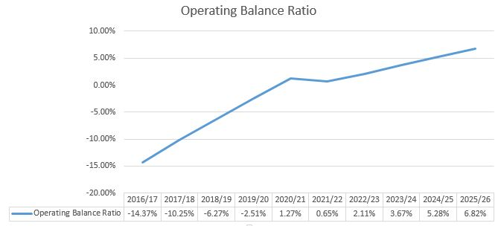
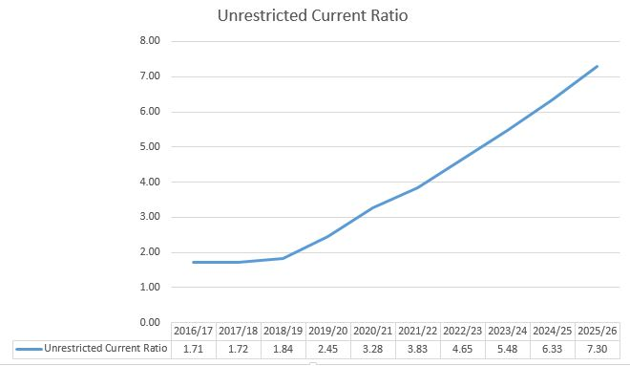

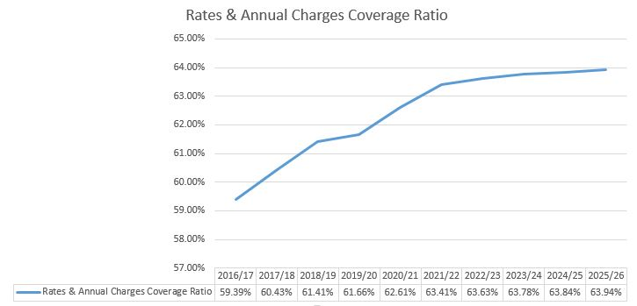

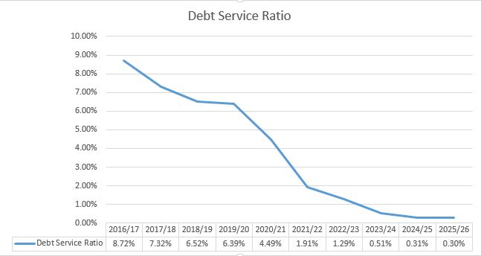

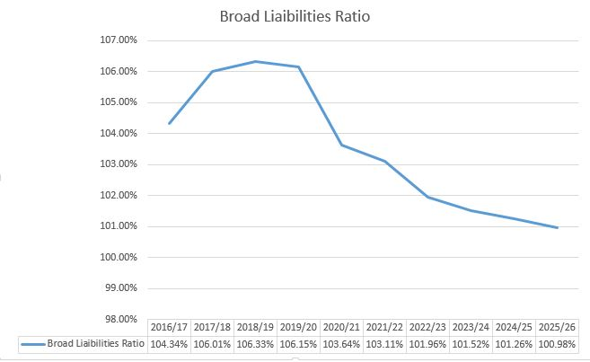

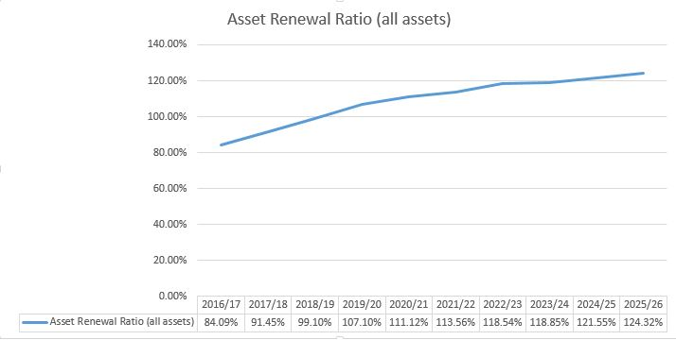

Contribution plan costs above the cap
You should complete this section if the proposed special variation seeks funding for contributions plan costs above the development contributions cap. Otherwise, leave this section blank.
Please explain how the council has established the need for a special variation to meet the shortfall in development contributions.
For costs above the cap in contributions plans, a council must provide:
- a copy of the council’s section 94 contributions plan
- a copy of the Minister for Planning’s response to IPART’s review and details of how the council has subsequently amended the contributions plan
- details of any other funding sources that the council is proposing to use, and
- any reference to the proposed contributions (which were previously to be funded by developers) in the council’s planning documents (eg, LTFP and Asset Management Plan (AMP).

Not applicable

Assessment criterion 2: Community awareness and engagement
Criterion 2 within the OLG Guidelines is:
Evidence that the community is aware of the need for and extent of a rate rise. The Delivery Program and Long Term Financial Plan should clearly set out the extent of the General Fund rate rise under the special variation. The council’s community engagement strategy for the special variation must demonstrate an appropriate variety of engagement methods to ensure community awareness and input occur. IPART’s fact sheet includes guidance to councils on the community awareness and engagement criterion for special variations.
Our fact sheet on the requirements for community awareness and engagement are available on the IPART website.
In responding to this criterion, the council must provide evidence that:
- it has consulted and engaged the community about the proposed special variation using a variety of engagement methods and that the community is aware of the need for, and extent of, the requested rate increases
- it provided opportunities for input and gathered input/feedback from the community about the proposal, and
- the IP&R documents clearly set out the extent of the requested rate increases.
In assessing the evidence, we will consider how transparent the engagement with the community has been, especially in relation to explaining:
- the proposed cumulative special variation rate increases including the rate peg for each major rating category (in both percentage and dollar terms)
- the annual increase in rates that will result if the proposed special variation is approved in full (and not just the increase in daily or weekly terms)
- the size and impact of any expiring special variation (see Box 4.1 below for further detail), and
- the rate levels that would apply without the proposed special variation.
More information about how the council may engage the community is to be found in the OLG Guidelines, the IP&R manual, and IPART’s Fact Sheet Community Awareness and Engagement for special variation applications, January 2016.

Box 4.11 Where a council is renewing or replacing an expiring special variation
The council’s application should show how you have explained to its community:
- There is a special variation due to expire at the end of the current financial year or during the period covered by the proposed special variation. This needs to include when the expiring special variation was originally approved, for what purpose and the percentage of (General Fund) general income originally approved.
- The corresponding percentage of general income that the expiring special variation represents for the relevant year.
- Whether the temporary expiring special variation is being replaced with another temporary or a permanent increase to the rate base.
- The percentage value of any additional variation amount, above the rate peg, for which the council is applying through a special variation.
- If the proposed special variation was not approved ie, only the rate peg applies, the year-on-year change in rates would be lower, or that rates may fall.
The council also must attach, to its application to IPART, a copy of the Instrument of Approval that has been signed by the Minister or IPART Chairman.

The consultation strategy
The council is required to provide details of the consultation strategy undertaken, including the range of methods used to inform and engage with the community about the proposed special variation and to obtain community input and feedback. The engagement activities could include media releases, mail outs, focus groups, statistically valid random or opt-in surveys, online discussions, public meetings, newspaper advertisements and public exhibition of documents.
The council is to provide relevant extracts of the IP&R documents that explain the rate rises under the proposed special variation and attach relevant samples of the council’s consultation material.
At its Ordinary meeting held 15 October 2015, Council resolved to conduct a community consultation process in accordance with the prepared community engagement plan adopted by the council.
1 SPECIAL RATE VARIATION CONSULTATION (S1433)
MOVED Cr Hogan/West
(i) That a community consultation process occur in accordance with the engagement plan attached to, and outlined in, this report based on a special rate variation proposal of a 6% increase in general rates above the normal cost of living increase, each year for the next 6 years to be restricted to infrastructure maintenance and renewal.
(ii) That during the consultation period, community feedback also be sought about increasing the proposed SRV a further 1% to 7%, with the extra 1% being restricted to improved maintenance of community facilities.
(iii) That a budget variation of $40,000 to facilitate the consultation process be endorsed.
(iv) That following the period of consultation and collation of the feedback received, a report be submitted to Council in January 2016, to inform a decision about a special rate variation.
CARRIED
For: Jennison, West, Keegan, Jenkins, Christensen & Hogan.
Against: Bell & Epov.
Community consultation then commenced, in accordance with the agreed community engagement plan, in early November with:
- Media releases (8), informing community the SRV proposal.
- A number of social media posts, the first of which had a reach of 3,954. With subsequent posts reaching between 208 and 1,948, but consistently around the 700-1,200 mark.
- Presentation to groups in response to invitation, informing of the SRV proposal.
- Content on the GTCC website informing the community of the proposed terms of the SRV, which saw a peak of 80,000 hits in November, 20,000 above average and two subscriber emails advising of content update.
- Opportunity to complete a self selecting survey, resulting in 503 responses.
- 227 radio slots.
- Promotion on town entrance community event signage.
- Overprint on 20,000 rates envelopes, informing of the SRV conversation.
- A pop-up shop in Manning Street Taree adjacent to the main shopping arcade, from 10-6pm Monday 16 November through Friday 20 November with an estimated 500 people accessing the facility. Staffed by senior staff, Councillors and the Mayor.
- Extensive TV news coverage on Prime and NBN.
- An independent, statistically representative survey (sample 400) conducted by Jetty Research during the week 23 – 27 November.
During this period Council’s senior staff responded to approximately 12 email and letter submissions and a number of verbal queries from ratepayers.
These activities were supported by extensive media through TV, radio and print.
Key feedback relate to affordability, particularly from pensioners, to which we listened and responded, came through the survey, face to face, and via other mechanisms such as social media and correspondence. A revised SRV proposal was discussed at the 2 December Councillor workshop and considered at the 9 December Ordinary meeting of Council.
The revised SRV proposal sought to reduce the overall burden over the six year period from the previously proposed 62% compounding impact to a total increase of 42%, and to further reduce the burden for eligible pensioners to 27%, through implementation of a GTCC imposed SRV rebate.
The current pensioner rebate is set at up to $250pa, has not been reviewed in many years since being set at this figure in 1989, and is only partially rebated by state government. The annual imposition to GTCC is $607,000.
The revised proposal, as discussed at the December Councillor workshop and the December Ordinary Meeting, formed the basis of Council’s advice to IPART regarding the intention to lodge a 2016/2017 SRV application.
Implicit in a revised SRV proposal, and identified in the December report to Council, was the need to consult further with the community. To that end, Jetty Research was engaged to undertake a further study of the 400 people surveyed previously to gauge their views on the amended proposal. The purpose of surveying the same respondents was to measure changed view to the new proposal. That survey took place in mid December and secured response from 327 of the original 400.
GTCC website content was updated to reflect the amended proposal and a short online self-selecting survey was conducted. Those who had subscribed to the GTCC website for SRV updates were informed of the updated proposal electronically. Media releases and social media alerts were issued and the new proposal was advertised in the Manning News section of MRT.
Again, these activities were supported by extensive media through TV, radio and print.

Feedback from the community consultations
Summarise the outcomes and feedback from the council’s community engagement activities. Outcomes could include the number of attendees at events and participants in online forums, as well as evidence of media reports and other indicators of public awareness of the council’s special variation intentions. Where applicable, provide evidence of responses to surveys, particularly the level of support for specific programs or projects, levels and types of services, investment in assets, as well as the options proposed for funding them by rate increases.
Where the council has received submissions from the community relevant to the proposed special variation, the application should set out the views expressed in those submissions. Please refer to Section 1.2 concerning how the council should handle confidential content in feedback received from the community. The council should also identify and document any action that it has taken, or will take, to address issues of common concern within the community.
The results of the first round of consultation undertaken by Jetty Research (attachment xi) in 23 – 27 November can be summarised as follows
- Over 80% of people surveyed are dissatisfied with the state of local roads;
- Of those surveyed, 40% supported the SRV application and 38% opposed it, while 22% were neutral or unsure;
- 55% of people surveyed believe Council should be spending more of its existing rate income on roads; and
- 47% of people surveyed are prepared to pay for better local roads to some degree while 42% are happy with the current rate level.
The survey sample of 400 is statistically representative. The sampling error of this survey is +/- 4.9% at 95% confidence level.
The results of the online survey on Council’s website, which does not have the same statistical significance due to the self-selecting nature of the sample, found:
- 86% of people surveyed are dissatisfied with the state of local roads;
- of the people surveyed 25% support the SRV application, 63% oppose and 11% are neutral or unsure; and
- 66% of people surveyed think Council should be spending more of its existing rate income on roads.
Observations by senior staff and Councillors, from the interactions at the shop front, which was visited by approximately 500 community members, were:
- there was a strong face to face message that people on pensions supported fixing the roads, but could not afford it;
- some people were confused by the SRV and Rate Peg percentages, but had this clarified at the shop front;
- many people questioned Council’s competence to address the problem;
- universally people felt informed by the shopfront process and website content.
- there was an overwhelming acceptance of the problem ie the poor condition of roads in the area; and
- there is no appetite for considering a larger increase for other infrastructure.
The December meeting of Council led to a second round of consultation in relation to the 6.9% SRV proposal with a second independent survey conducted with 327 of the 400 randomly sampled previously.
It should be noted that the survey sample of 327 remains statistically representative. The sampling error of this survey is +/- 5.4% at 95% confidence level.
A summary of key points from the second survey regarding the 6.9% SRV is as follows:
- 84% of respondents agreed with the rebate offered to eligible pensioners;
- support for the 6.9% SRV increased by 9% to 49% and opposition declined by 6%to 32%;
- those who were reportedly neutral or unsure decreased by 3%; and
- support for the 6.9% SRV proposal was highest in 60+ age group (females).
The following graph from the report indicates the change in support for an SRV between November and December 2015, as reported by Jetty Research (page 17).

Overall awareness of the SRV prior to survey contact was high. Respondents reported primarily gaining knowledge through TV and radio. The survey also found that 92% of those who had heard about the SRV sought no further information.
The majority of respondents agree council should spend more money on roads. On a sliding scale respondents reported a preference for expenditure on roads (47%) compared to lower rates (11%). This appears to indicate a willingness to pay more if outcomes are visible.
GTCC website content was also updated and an online survey available. Due to the self-selecting nature of this survey the results cannot be considered representative of the broader community view. However, results from this survey (35 responses) indicate a shift in opinion about the SRV, as follows:
- support for the SRV increased from 25% to 49% due to increased affordability; and
- opposition to the SRV decreased from 63% to 51%; and
- there was a modest difference between those who support the notion of pensioners paying less (57%) compared to those who do not support the pensioner rebate (43%).

The vast majority of respondents declared being ratepayers (97%), with only 20% currently receiving a pensioner rebate on their rates. 43% of respondents were aged 60+ and 43% were aged 40-59 years. Assessment criterion 3: Impact on ratepayers.
There were approximately 25 opinion pieces printed in the local paper, expressing a variety of sentiments, from concerns about affordability (prior to the December amendment), awareness of the SRV, State and Federal government funding contributions, the competence of council and SRV support.
The Community Engagement in Practice document (attachment xii) provides details of the engagement, interaction, feedback and exposure the community engagement created in full.
Criterion 3 within the OLG Guidelines is:
The impact on affected ratepayers must be reasonable, having regard to both the current rate levels, existing ratepayer base and the proposed purpose of the variation. The Delivery Program and Long Term Financial Plan should:
- clearly show the impact of any rises upon the community
- include the council’s consideration of the community’s capacity and willingness to pay rates and
- establish that the proposed rate increases are affordable having regard to the community’s capacity to pay.
The impact of the council’s proposed special variation on ratepayers must be reasonable. To do this, we take into account current rate levels, the existing ratepayer base and the purpose of the proposed special variation. We also review how the council has assessed whether that the proposed rate rises are affordable having regard to the community’s capacity and willingness to pay.

Impact on rates
Much of the quantitative information we need on the impact of the proposed special variation on rate levels will already be contained in Worksheet 5a and 5b of Part A of the application.
To assist us further, the application should set out the rating structure under the proposed special variation, and how this may differ from the current rating structure, or that which would apply if the special variation is not approved.
We recognise that a council may choose to apply an increase differentially among categories of ratepayers. If so, you should explain the rationale for applying the increase differentially among different categories and/or subcategories of ratepayers, and how this was communicated to the community. This will be relevant to our assessment of the reasonableness of the impact on ratepayers.
Councils should also indicate the impact of any other anticipated changes in the rating structure.
Revising the SRV from 8.4 to 6.9% has reduced the compounding effect from 62% to 42%. Implementation of an SRV rebate of 35% to eligible pensioners further reduces the compounding impact to 27% to those ratepayers. Eligible pensioners are those who currently receive the fixed concession council rate rebate.
The following graphs indicate the reduced impact of the 6.9% SRV proposal (versus 8.4%) on the average rate in each of the rating categories (residential, farmland and business) and also on the average pensioner rate:
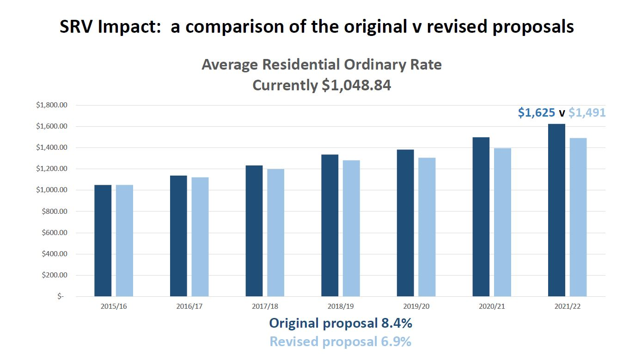
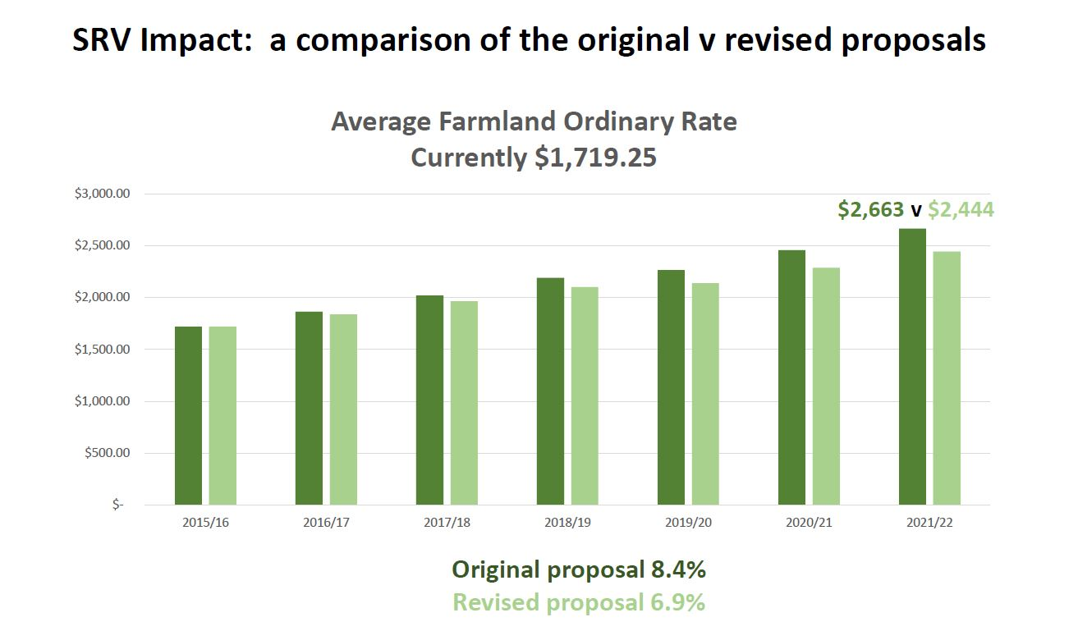
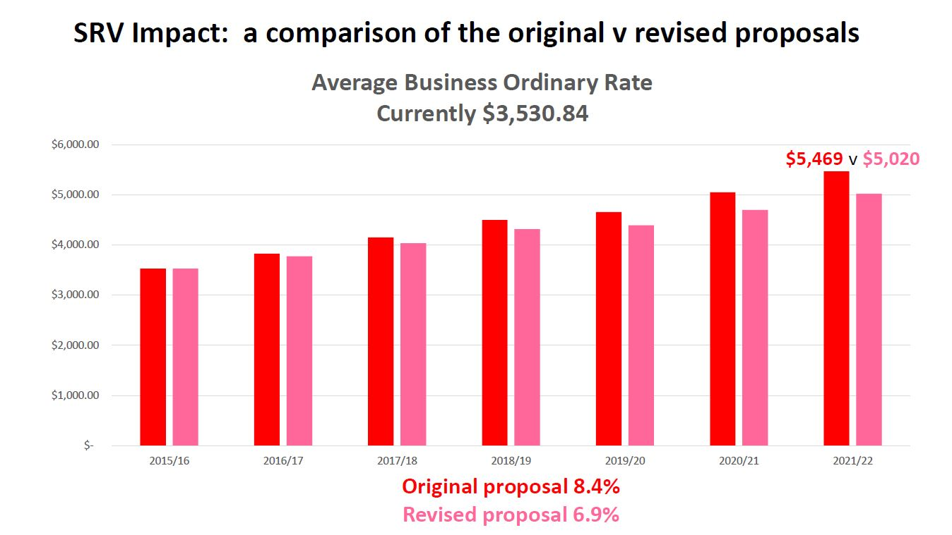
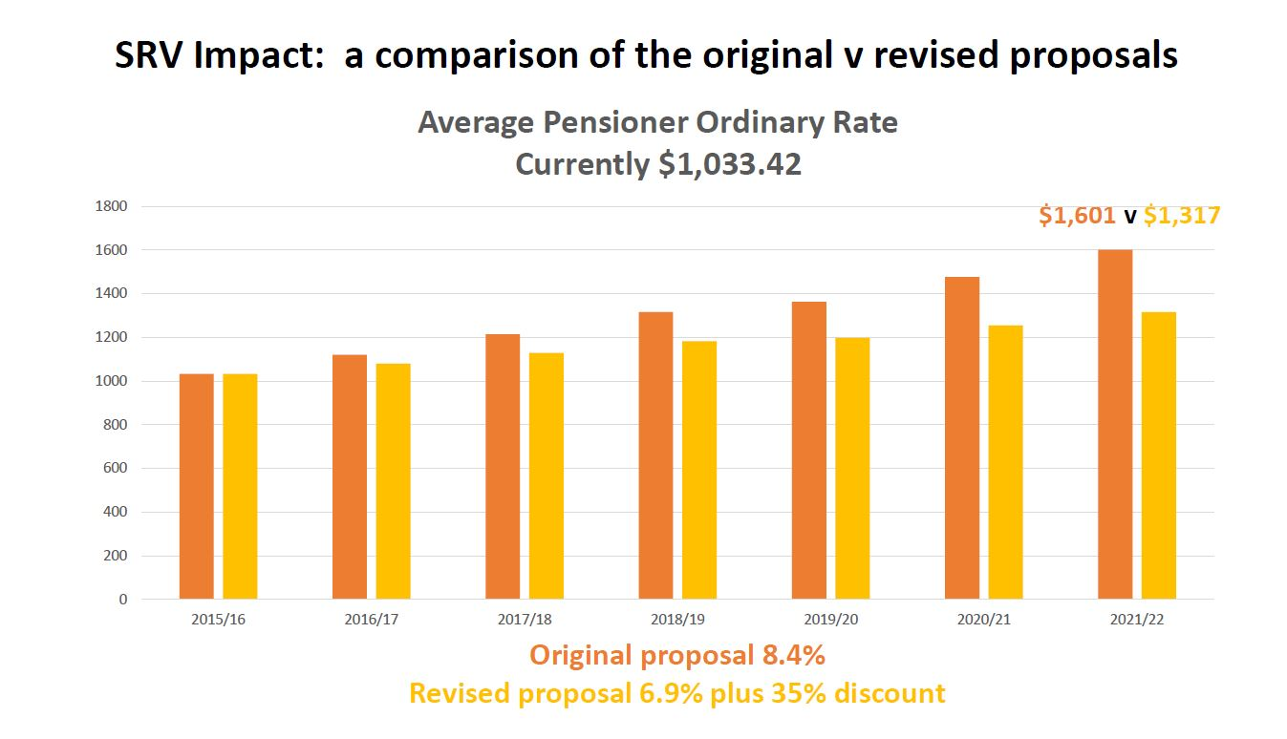
The following graphs indicate the impact of a 6.9% SRV on rates to the closest ’00. The average annual residential rate is approximately $1,050. Check this against IBIS before including.

 | ANNUAL INCREASE (represents increase on previous year)
Ordinary Rate | Year 1 | Year 2 | Year 3 | Year 4 | Year 5 | Year 6 | Cumulative increase after 6 years
$600 | $41.40 | $44.26 | $47.31 | $13.55 | $51.51 | $55.06 | $253.09
$700 | $48.30 | $51.63 | $55.20 | $15.81 | $60.09 | $64.24 | $295.27
$800 | $55.20 | $59.01 | $63.08 | $18.06 | $68.68 | $73.42 | $337.45
$900 | $62.10 | $66.38 | $70.97 | $20.32 | $77.26 | $82.60 | $379.63
$1,000 | $69.00 | $73.76 | $78.85 | $22.58 | $85.85 | $91.77 | $421.81
$1,100 | $75.90 | $81.14 | $86.74 | $24.84 | $94.43 | $100.95 | $464.00
$1,200 | $82.80 | $88.51 | $94.62 | $27.10 | $103.02 | $110.13 | $506.18
$1,300 | $89.70 | $95.89 | $102.51 | $29.35 | $111.60 | $119.30 | $548.35
$1,400 | $96.60 | $103.27 | $110.39 | $31.61 | $120.19 | $128.48 | $590.54
$1,500 | $103.50 | $110.64 | $118.28 | $33.87 | $128.77 | $137.66 | $632.72
$1,600 | $110.40 | $118.02 | $126.16 | $36.13 | $137.36 | $146.84 | $674.91

 | ANNUAL INCREASE (represents cumulative effect)
Ordinary Rate | Year 1 | Year 2 | Year 3 | Year 4 | Year 5 | Year 6
$600 | $41.40 | $85.66 | $132.97 | $146.52 | $198.03 | $253.09
$700 | $48.30 | $99.93 | $155.13 | $170.94 | $231.03 | $295.27
$800 | $55.20 | $114.21 | $177.29 | $195.35 | $264.03 | $337.45
$900 | $62.10 | $128.48 | $199.45 | $219.77 | $297.03 | $379.63
$1,000 | $69.00 | $142.76 | $221.61 | $244.19 | $330.04 | $421.81
$1,100 | $75.90 | $157.04 | $243.78 | $268.62 | $363.05 | $464.00
$1,200 | $82.80 | $171.31 | $265.93 | $293.03 | $396.05 | $506.18
$1,300 | $89.70 | $185.59 | $288.10 | $317.45 | $429.05 | $548.35
$1,400 | $96.60 | $199.87 | $310.26 | $341.87 | $462.06 | $590.54
$1,500 | $103.50 | $214.14 | $332.42 | $366.29 | $495.06 | $632.72
$1,600 | $110.40 | $228.42 | $354.58 | $390.71 | $528.07 | $674.91

 | ANNUAL ORDINARY RATE INCREASE
Ordinary Rate | Year 1 | Year 2 | Year 3 | Year 4 | Year 5 | Year 6 | Total cumulative increase after 6 years
$600 | $641.40 | $685.66 | $732.97 | $746.51 | $798.02 | $853.09 | 42.18%
$700 | $748.30 | $799.93 | $855.13 | $870.93 | $931.03 | $995.27 | 42.18%
$800 | $855.20 | $914.21 | $977.29 | $995.35 | $1,064.03 | $1,137.45 | 42.18%
$900 | $962.10 | $1,028.48 | $1,099.45 | $1,119.77 | $1,197.04 | $1,279.63 | 42.18%
$1,000 | $1,069.00 | $1,142.76 | $1,221.61 | $1,244.19 | $1,330.04 | $1,421.81 | 42.18%
$1,100 | $1,175.90 | $1,257.04 | $1,343.77 | $1,368.61 | $1,463.04 | $1,563.99 | 42.18%
$1,200 | $1,282.80 | $1,371.31 | $1,465.93 | $1,493.03 | $1,596.05 | $1,706.18 | 42.18%
$1,300 | $1,389.70 | $1,485.59 | $1,588.09 | $1,617.45 | $1,729.05 | $1,848.36 | 42.18%
$1,400 | $1,496.60 | $1,599.87 | $1,710.26 | $1,741.87 | $1,862.06 | $1,990.54 | 42.18%
$1,500 | $1,603.50 | $1,714.14 | $1,832.42 | $1,866.29 | $1,995.06 | $2,132.72 | 42.18%
$1,600 | $1,710.40 | $1,828.42 | $1,954.58 | $1,990.71 | $2,128.06 | $2,274.90 | 42.18%

Minimum Rates
The proposed special variation may affect ordinary rates, special rates and/or minimum rates.
As previously discussed, if the proposed special variation includes increasing minimum rates above the statutory limit, or is to apply a higher rate of increase to an existing minimum rate than to its other rates, it is not necessary for the council to also complete the separate Minimum Rates Application form. However, this must be clearly identified and addressed in the special variation application.

Does the council have minimum Ordinary rates? | Yes | No

If Yes, does the council propose to increase minimum Ordinary rates by:

The rate peg percentage
The special variation percentage
Another amount Indicate this amount _____________

What will minimum Ordinary rates be after the proposed increase? $430.21 in the 6th year of the SRV as indicated in the table below.

The council must explain how the proposed special variation will apply to the minimum rate of any ordinary and special rate, and any change to the proportion of ratepayers on the minimum rate for all relevant rating categories that will occur as a result.
You should also explain the types of ratepayers or properties currently paying minimum rates, and the rationale for the application of the special variation to minimum rate levels.
The minimum rate applies to 14% of business rates only and .08% of total assessments. GTCC is seeking to maintain the same relative distribution of rates across the rating burden, between minimum and other ratepayers, as has been levied in previous years. This is essential given the lower value of property in the LGA. While not anticipated, there is also potential that further advice from the Valuer Generals, throughout the life of the SRV, may impact in a way that increases the number of properties to which the minimum rate is applied.
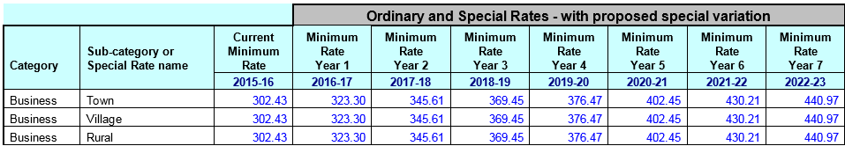

Consideration of affordability and the community’s capacity and willingness to pay
The council is required to provide evidence through its IP&R processes, and in its application, of how it assessed the community’s capacity and willingness to pay the proposed rate increases. This is to include an explanation of how the council established that the proposed rate rises are affordable for the community.
Evidence about capacity to pay could include a discussion of such indicators as SEIFA rankings, land values, average rates, disposable incomes, the outstanding rates ratio and rates as a proportion of household/business/farmland income and expenditure, and how these measures relate to those in comparable or neighbouring council areas.
As many of these measures are highly aggregated, it may also be useful to discuss other factors that could better explain the impact on ratepayers affected by the proposed rate increases, particularly if the impact varies across different categories of ratepayers.
We may also consider how the council’s hardship policy (see Section 5.3 below) might reduce the impact on socio-economically disadvantaged ratepayers.
A comparison among our closest neighbours (Great Lakes, Gloucester, Port Macquarie and Kempsey) reveals communities that are quite similar.
- Populations ageing faster than the NSW average.
- Increased reliance on a fixed income (6-10% more likely than the state average).
- Lower annual income than NSW average ($33,500 - $39,600).
However, a notable discrepancy in the annual rates levied.
GTCC’s rates continue to compare favourably against our neighbours, and on average:
- Great Lakes’ rates are currently 15.5% higher.
- Port Macquarie Hastings’ are 12% higher.
- Kempsey’s are 2.5% higher.

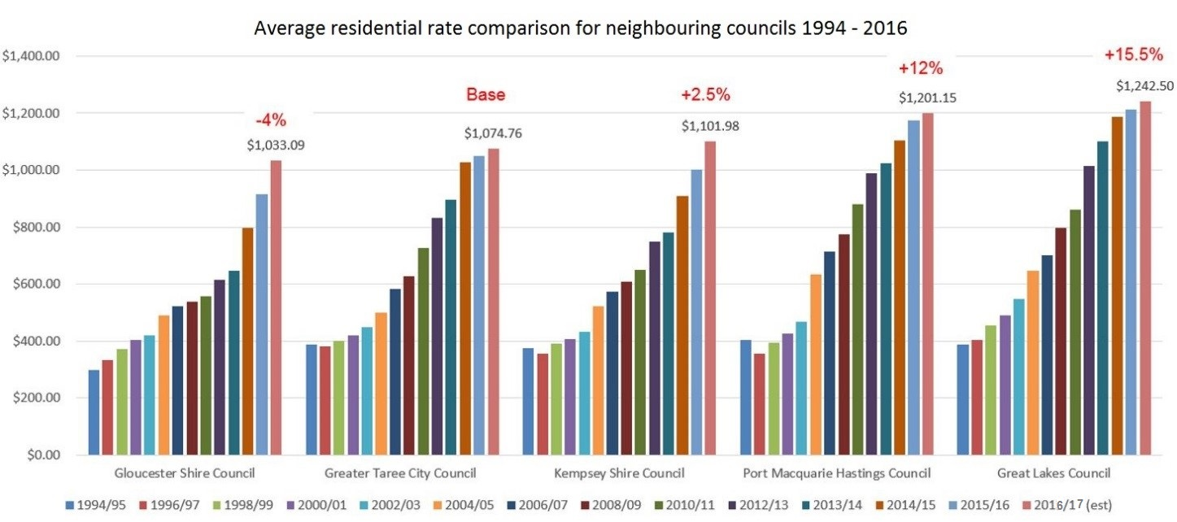

While Council adopted an outstanding rates and annual charges debt ratio of 6-7.5% for the 2015/2016 financial year. Defying the state trend, which has seen the increase in rates and annual charges outstanding by 15% in recent years, significant work has been done to reduce ours this year. Council’s preferred position being that rate payers are on payment plans over retaining outstanding debt. At January 2016, our outstanding debt ratio stood at 5.86%, the State benchmark for metropolitan and coastal councils being 5%.
In November, we consulted with the community in regard to an 8.4% increase over six years to remain permanently in the rate base. In response, the community articulated concern about affordability. This feedback led to a revised SRV proposal of 6.9% over six years, to remain permanently in the rate base.
The revised SRV proposal sought to reduce the overall burden over the six year period from the previously proposed 62% compounding impact to a total increase of 42%, and to further reduce the burden for eligible pensioners to 27%, through implementation of a GTCC imposed SRV rebate.
The second independent and statistically significant survey conducted in December 2015 found:
- 84% of respondents agreed with the rebate offered to eligible pensioners;
- support for the 6.9% SRV increased by 9% to 49% and opposition declined by 6%to 32%;
- those who were reportedly neutral or unsure decreased by 3%; and
- support for the 6.9% SRV proposal was highest in 60+ age group (females).

Addressing hardship
In addition to the statutory requirement for pensioner rebates, most councils have a policy, formal or otherwise to address issues of hardship.

Does the council have a Hardship Policy? | Yes | No
If Yes, is an interest charge applied to late rate payments? | Yes | No
Does the council propose to introduce any measures to reduce the impact of the proposed special variation on specific groups in the community? | Yes | No
You should attach a copy of the Hardship Policy and explain below who the potential beneficiaries are and how they are assisted.
Please provide details of any other measures addressing hardship to be adopted, or alternatively, explain why no measures are proposed.
The council is also to indicate whether the hardship policy or other measures are referenced in the council’s IP&R documents (with relevant page reference or extract provided).

Council’s Hardship Policy (attachment xiii) supports the preferred position that ratepayers enter into payment plans if they are unable to meet the lump sum payments required by the rates notice and instalments. The policy recognises that there are cases of genuine financial hardship requiring respect and compassion in special circumstances. The policy does not discriminate, but rather identifies ratepayer experiencing financial hardship have the intention, but not the financial capacity to make the required payments within the timeframe set out in the rates and charges notice.
In addition to applying our Hardship Policy, Council has responded to community concern about affordability of an SRV by applying a rebate of 35% of the increase, to eligible pensioners.
Council also applies a rates subsidy to the 34 community groups in the local government area that do not own commercial premises, as detailed in the Donations Policy (attachment xiv).
Public Halls
- Bobin School of Arts Hall
- Bulga Soldiers Memorial Hall
- Burrell Creek Hall
- Caffreys Flat Public Hall
- Coopernook School of Arts Hall
- Cundletown Soldiers Memorial Hall
- Hannam Vale Hall
- Harrington Memorial Hall
- Killabakh Community Hall
- Krambach School of Arts Hall
- Lansdowne School of Arts Hall
- Marlee Public Hall
- Mitchell’s Island School of Arts Hall
- Mondrook Hall
- Mooral Creek Hall
- Mount George School of Arts Hall
- Old Bar Soldiers Memorial Hall
- Oxley Island School of Arts Hall
- Tinonee Schools of Arts Hall
- Upper Lansdowne Memorial Hall
- Wherrol Flat Hall

Community Organisations
- Manning District Bowhunters
- Manning Media Coop Ltd
- Manning River Canoe Club
- Manning River Rowing Club
- Manning River Sailing Club
- Old Bar Community Pre School
- Oxley Island Pony Club
- Snugglepot Day Care Centre
- Taree Arts Council
- Taree Tennis Club
- Wingham and District Pre School

Surf Life Saving Clubs
- Black Head
- Crowdy Head
Council’s Hardship and Donations policies are contained within our Policy Framework, which is available to the public on our website. The Hardship Policy also forms part of the Financial Management Framework, the development of which was a 2015/2016 initiative identified in Council’s Operational Plan (page 31/48) (attachment xv).
Assessment criterion 4: Public exhibition of relevant IP&R documents
Criterion 4 within the OLG Guidelines is:
The relevant IP&R documents must be exhibited (where required), approved and adopted by the council before the council applies to IPART for a special variation to its general revenue.
Briefly outline the significant IP&R processes the council has undertaken to reach the decision to apply for a special variation. Include the details of and dates for key document revisions, public exhibition period(s) and the date(s) that the council adopted the relevant IP&R documents.
You should also include extracts from council minutes as evidence that the documents were adopted.
The council is reminded that the Community Strategic Plan and Delivery Program (if amended), require public exhibition for at least 28 days prior to adoption. Amendments to the Long Term Financial Plan and Asset Management Plan do not require public exhibition. However, it would be expected that the Long Term Financial Plan would be posted, in a prominent location, on the council’s website.
GTCC commenced preparation of the Manning Valley Community Plan in 2009, as a Group one council. The final Plan followed an extensive community consultation period and represents the combined efforts of over 7,000 individuals through written submissions, comments and contributions. It was placed on public exhibition for a period of 28 days at the Ordinary Meeting of Council held 14 April 2010.

104 | ITEM 6 – MANNING VALLEY COMMUNITY PLAN (GT6436-2)
 | MOVED Cr Keegan/Richardson
 | (i) That Council acknowledge the substantial contribution of community members to the development of the draft Manning Valley Community Plan.
 | (ii) That Council place the draft Community Plan on public exhibition for a period of 28 days.
 | (iii) That, following consideration of community feedback, the final Community Plan document be presented to Council’s June 16 meeting for endorsement.
 | (iv) That staff be congratulated on the production of the report, and note that it was assembled ‘in-house’ at minimal cost.
 | CARRIED
And adopted at the Ordinary Meeting of Council held 23 June 2010.
183 | F1 – MANNING VALLEY COMMUNITY PLAN (GT6436-2)
 | MOVED Cr Jennison/Keegan (as per recommendation)
 | (i) That the draft Manning Valley Community Plan 2010 – 2030 be adopted.
 | (ii) That, on adoption, the Manning Valley Community Plan be forwarded to the NSW Department of Local Government.
 | (iii) That, on adoption, the Manning Valley Community Plan be made available to the public.
 | (iv) That Council acknowledges the contribution of community members to the preparation of the Manning Valley Community Plan.
 | CARRIED
 | For: Bell, Tickle, Marks, Jennison, Keegan, Richardson, West, Loftus & Hogan.
On the 19 May 2010, Council adopted at its Ordinary Meeting to place on public exhibition, its first Integrated Planning and Reporting Framework suite of documents.

154 | G1 – DRAFT 2010/2011 BUDGET, OPERATIONAL PLAN & DELIVERY PROGRAM (GT6790)
 | MOVED Cr Keegan/Tickle
 | (i) That the following draft documents be approved for public exhibition:
- 2010/2011 Budget (including fees and charges)
- Statement of Revenue Policy
- 2010/2011 Operational Plan
- 2010-2014 Delivery Program
 | (ii) That following the public exhibition period, the above draft documents as amended as the result of consideration of public submissions, be adopted at an Ordinary Meeting of Council on the 23 June 2010.
 | (iii) That the public be encouraged to read the four documents concurrently.
 | CARRIED
 | For: Bell, Tickle, Keegan, Richardson, West, Loftus & Hogan.
 | Against: Marks

With these being adopted on 23 June 2010.

182 | G5 – 2010/2011 BUDGET, OPERATIONAL PLAN & DELIVERY PROGRAM (GT6790)
 | MOVED Cr Jennison/Keegan (as per recommendation)
 | (i) That Council adopt the following documents subject to the amendments as included in this report:
- 2010/2011 Budget (including fees and charges)
- 2010/2011 Statement of Revenue Policy
- 2010/2011 Operational Plan
- 2010-2014 Delivery Program
 | (ii) That Council undertakes internal service reviews across the organisation in an effort to identify areas where cost-savings can be found, revenues can be increased and where services can be delivered in alternate ways or potentially reduced with a view to improving Council’s bottom line by $3 million.
 | CARRIED
 | For: Bell, Tickle, Jennison, Keegan, Richardson, West, Loftus & Hogan.
 | Against: Marks.
Since adoption of this framework, we have reported our progress against the Operational Plan on a quarterly basis, while the requirement is every six months. We do this as a measure of transparency to our community.
In 2013, our Delivery Program (attachment xvi) was reviewed and placed on public exhibition:

64 | G3 – 2013/2017 DRAFT DELIVERY PROGRAM and 2013/2014 DRAFT RESOURCING STRATEGY (GT8551)
 | MOVED Cr Keegan/ Tickle (as per recommendation)
 | (i) That the following documentation be endorsed for public exhibition from Thursday 18 April 2013 until close of business on Friday 31 May 2013:
- 2013/2017 Draft Delivery Program
- 2013/2014 Draft Resourcing Strategy incorporating the Long Term Financial Plan, Workforce Plan and Asset Management Strategy.
 | (ii) That members of the community be invited to make written submissions with regard to the draft documentation, as identified in recommendation (i), while on public exhibition.
 | (iii) That, following the period of public exhibition, the draft documents, as amended as a result of consideration of public submissions, are considered for adoption at the Ordinary Meeting of Council proposed for Wednesday 19 June 2013.
 | CARRIED
 | For: Bell, Christensen, Jenkins, West, Tickle, Epov, Keegan & Hogan.

And adopted in June 2013.

103 | G2 - 2013/2017 DELIVERY PROGRAM and 2013/2014 RESOURCING STRATEGY (S86)
 | MOVED Cr Jennison/Keegan (as per recommendation)
 | (i) That, the 2013/2017 Delivery Program, attached to the report, be adopted.
 | (ii) That, the 2013/2017 Resourcing Strategy, attached to the report, be adopted.
 | (iii) That, following adoption, the 2013/2017 Delivery Program and Resourcing Strategy be made available on Council’s website in accordance with legislation.
 | (iv) That, following adoption, a copy of the 2013/2017 Delivery Program and Resourcing Strategy be forwarded to the Division of Local Government.
 | CARRIED
 | For: Bell, Christensen, Jenkins, West, Tickle, Epov, Keegan, Jennison & Hogan.

In each case the documents and business papers are available on our website at www.gtcc.nsw.gov.au.

Greater Taree City Council commenced consideration of the potential for special rate variation to increase expenditure on infrastructure in June 2014 when it adopted a Long Term Financial Plan scenario that included a 5% SRV to commence in 2016/2017.

An AMENDMENT was MOVED Cr Keegan/Epov
(i) That, the 2014/2015 Draft Operational Plan be adopted and that in doing so, the following is also adopted:
- Economic Development – a further six month extension of the Memorandum of Understanding (MOU) between the Manning Valley Business Chamber and Council.
- During that six months, Council to consider the conditions and activities related to any future MOU.
- That the Economic Development section of the Operational Plan be updated to reflect determination of the MOU prior to December 2014.
(ii) That, the 2014/2015 Draft Budget be adopted.
(iii) That, the 2014/2015 Draft Fees and Charges Schedule be adopted.
(iv) That, the 2014/2015 Draft Long Term Financial Plan be adopted.
(v) That, the 2014/2015 Draft Capital Works Program be adopted.
(vi) That, following adoption a copy of the 2014/2015 Operational Plan, Budget, Fees and Charges Schedule, Long Term Financial Plan and Capital Works Program, be placed on Council’s website in accordance with legislation.
(vii) That, following adoption, a copy of the 2014/2015 Operational Plan, Budget, Fees and Charges Schedule, Long Term Financial Plan and Capital Works Program, be forwarded to the Office of Local Government.
(viii) That should the Federal Government pause the indexation of Financial Assistance Grants, a workshop be held to explore the impact and effect of the budget on the long term financial sustainability of Council.
The AMENDMENT was CARRIED.
For: Bell, Epov, Keegan & Jenkins
Against: West, Tickle & Jennison
The AMENDMENT became the MOTION and was again CARRIED
For: West, Tickle, Keegan, Jennison & Jenkins.
Against: Bell & Epov.
Resolution of the 2014/2015 LTFP ensured focus on a significant body of work to prepare Asset Management Plans that quantify the infrastructure related work that would be completed under an SRV.
And resulted in adoption of the 2015/2025 LTFP in June 2015, in which the SRV was revised to 6%, over two years in one scenario and over 6 years in another. In June 2015, the latter formed the basis of the Council endorsed submission of its ‘Fit for the Future’ proposal, to the NSW State Government.
Council’s draft 2015/2016 budget proposes a Long Term Financial Plan scenario 3 that indicates a rate variation of 6% in addition to the IPART rate peg for 6 years, with the additional rating income to remain in the budget following this period. By 2022/2023, this increase would realise an approximately $10M in additional rating income per annum all of which it is proposed be quarantined for expenditure on infrastructure maintenance and renewal. The aim of this being to decelerate deterioration of the road and bridge infrastructure.
Fit for the Future Submission report endorsed by Council – June 17 2015.
At the Ordinary meeting of Council 17 June 2015, Council adopted both the 2015/2016 ten year Long Term Financial Plan:
114 2015/2016 DRAFT OPERATIONAL PLAN, BUDGET, FEES AND CHARGES, LONG TERM FINANCIAL PLAN AND CAPITAL WORKS PROGRAM (S1324)
MOVED Cr West/Keegan
That the 2015/2016 Draft Long Term Financial Plan be adopted.
CARRIED
For: Bell, Epov, West, Keegan, Tickle, Jenkins & Hogan.
And the Fit for the Future submission:
19 FIT FOR THE FUTURE SUBMISSION (S1089)
MOVED Cr Tickle/West (as per recommendation)
That the content of the ‘Fit for the Future’ proposal attached to this report be submitted in accordance with the requirements of IPART, prior to 30 June 2015.
CARRIED
For: Bell, Epov, West, Keegan, Tickle, Jenkins & Hogan.
Specifically, these resolutions led to preparation of a community engagement plan and a report to Council’s 15 October 2015 Ordinary meeting, at which it was resolved:
1 SPECIAL RATE VARIATION CONSULTATION (S1433)
MOVED Cr Hogan/West
(i) That a community consultation process occur in accordance with the engagement plan attached to, and outlined in, this report based on a special rate variation proposal of a 6% increase in general rates above the normal cost of living increase, each year for the next 6 years to be restricted to infrastructure maintenance and renewal.
(ii) That during the consultation period, community feedback also be sought about increasing the proposed SRV a further 1% to 7%, with the extra 1% being restricted to improved maintenance of community facilities.
(iii) That a budget variation of $40,000 to facilitate the consultation process be endorsed.
(iv) That following the period of consultation and collation of the feedback received, a report be submitted to Council in January 2016, to inform a decision about a special rate variation.
CARRIED
For: Jennison, West, Keegan, Jenkins, Christensen & Hogan.
Against: Bell & Epov.

At its Ordinary Meeting held 27 January 2016, Council resolved to make an SRV submission to IPART.

8 | 3 SPECIAL RATE VARIATION APPLICATION (S1433)
 | David Burley addressed the meeting in respect of this item.
 | MOVED Cr Hogan/Keegan
 | (i) That a Special Rate Variation application under s508 of the Local Government Act 1993 be made to IPART by the due date of 15 February 2016 indicating:
 | (a) a 6.9% rate increase each year, for 6 years that will remain permanently in the rate base;
 | (b) the special rate variation commence in 2016/2017;
 | (c) that the purpose of the special rate variation is infrastructure maintenance and renewal;
 | (d) the consultation and communication approach that has been applied to preparation of this special rate variation;
 | (e) that community support for the special rate variation, gauged through an independent statistically representative random study, outweighs opposition 49% to 32%; and
 | (f) that the General Manager be council’s contact for the application.
 | (ii) That should IPART approve the Special Rate Variation, a rebate of 35% against the increase imposed by the variation, be applied to eligible pensioners.
 | An AMENDMENT was MOVED Cr Epov/Bell
 | That this recommendation be deferred to June 2016 to allow for community consultation.
 | The AMENDMENT upon being put to the meeting was LOST
 | For: Bell & Epov.
 | Against: Jennison, West, Keegan, Tickle, Jenkins, Christensen & Hogan.
 | The MOTION was CARRIED
 | For: Jennison, West, Keegan, Tickle, Jenkins, Christensen & Hogan.
 | Against: Bell & Epov.
 | MATTER ARISING
 | MOVED Cr Jenkins/Jennison
 | That Councillors allowance be frozen for the term of the special rate variation.
 | MOTION WITHDRAWN

D. Burley address
“Thank you Mr Mayor and all other Councillors.
I just like to congratulate the Council and their staff and Councillors for this special rate variation. I believe as a business owner in the area if we need to get things improved we actually have to put our hands in our pockets. I know it’s hard but the rate variation you’ve put through with the discount for the pensioners I thinks a fair across the board deal for everyone. We can’t sit back over the last 10 years our roads have just deteriorated to an extent that a lot of people come into the area for playing sport or tourism and we want those people to buy houses here to boom the town and to get the town moving. I think with the rate variation it will give us some money in the bank to actually get the work done.”

Assessment criterion 5: Productivity improvements and cost containment strategies
Criterion 5 within the OLG Guidelines is:
The IP&R documents or the council’s application must explain the productivity improvements and cost containment strategies the council has realised in past years, and plans to realise over the proposed special variation period.
In this section, you must provide details of any productivity improvements and cost containment strategies that you have implemented during the last two years (or longer) and any plans for productivity improvements and cost containment over the duration of the proposed special variation.
These strategies, which may be capital or operational in nature, must be aimed at reducing costs and/or improving efficiency. Indicate if any initiatives are to increase revenue eg, user charges. Please include below whether the proposed initiatives (ie, cost savings) have been factored into the council’s LTFP.
Where possible, the council is to quantify in dollar terms the past and future productivity improvements and cost savings.
The council may also provide indicators of efficiency, either over time or in comparison to other relevant councils. We will make similar comparisons using various indicators and OLG data provided to us.
Following an organisational restructure in early 2010, Council announced an extensive review of services to meet the ballooning operational budget. In May 2011, the draft 2011/2012 budget indicated an operational deficit of almost $3M. In response, the Council set a target of $3M in operational savings as a result of service reviews aimed at gaining efficiencies. In June 2015, Council adopted a budget with and operational surplus of $30,000 and a quarter 2, Quarterly Budget Review Statement adopted at the January 2015 meeting of Council indicates further improvement. This is a direct result of service reviews and has resulting in increase in the allocation of 40% of rate income to infrastructure, in an effort to address the key concern of the community – the state of the road and bridge infrastructure.

We have been of a journey of improvement and renewal since 2009 and we have modernised the organisation and maximised efficiency. Attached to this submission is the NSW local government operational and management effectiveness report – FY14 (attachment xvii), a comparison of GTCC with 77 other NSW council undertaken by PriceWaterhouse Coopers and LG Professionals NSW. This document provides quantitative data that shows GTCC as a lean, efficient organisation performing well against the majority of benchmarks for 2012/13 and 2013/14.
We will continue with a dedicated program of operational service and process reviews aimed at efficiency gains, with two distinct objectives identified in our Fit for the Future submission currently being progressed.

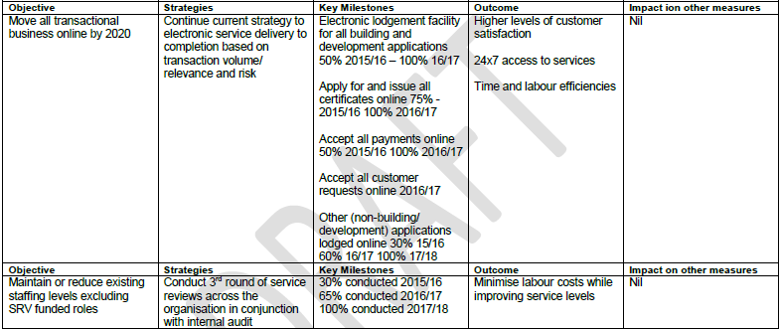

Fit for the Future submission page 14

List of attachments
The following is a list of the supporting documents to include with your application.
Some of these attachments will be mandatory to all special variation applications eg, extracts from the Community Strategic Plan.
Other attachments will be required from some, but not all, councils. For example, extracts from the Asset Management Plan would be required from a council seeking approval of a special variation to fund infrastructure.
Councils should submit their application forms and attachments online through the Council Portal in the following order. Councils may number the attachments as they see fit.

Item | Included?
Mandatory forms and Attachments
Part A Section 508A and Section 508(2) Application form (Excel spreadsheet)
Part B Application form (Word document) – this document
Relevant extracts from the Community Strategic Plan
Delivery Program
Long Term Financial Plan with projected (General Fund) financial statements (Income, Cash Flow and Financial Position) in Excel format
NSW Treasury Corporation report on financial sustainability
Media releases, public meeting notices, newspaper articles, fact sheets relating to the rate increase and proposed special variation
Community feedback (including surveys and results if applicable)
Hardship Policy
Resolution to apply for the proposed special variation
Certification (see Section 9)
Other Attachments
Relevant extracts from the Asset Management Plan
Past Instruments of Approval (if applicable)
Resolution to adopt the revised Community Strategic Plan (if necessary) and/or Delivery Program
Other (please specify)
Review Today Percy Allan Report
Draft GTCC Transport and Drainage Strategy 2015
LTFP adopted June 2014
LTFP adopted June 2015
J Comrie review of TCORP assessment
SRV Community Engagement Plan
Manning Valley Community Plan
Donations Policy
Operational Plan adopted 2015
NSW LG Operational and Management Effectiveness Report

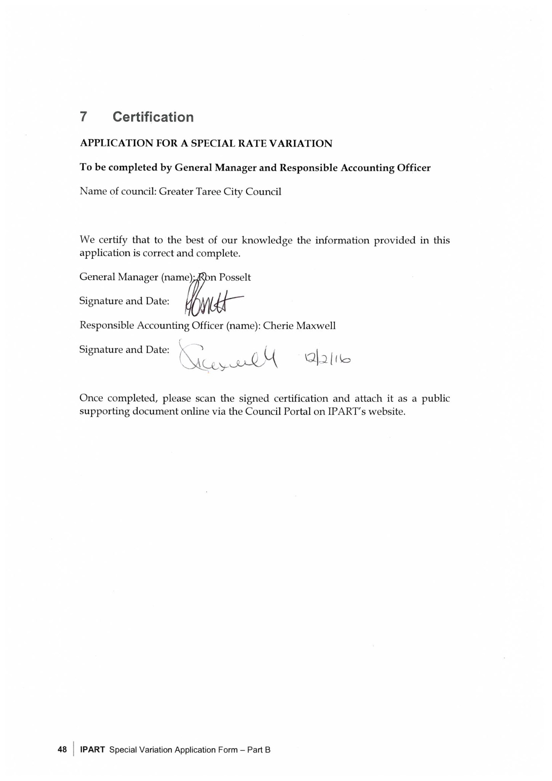

The Guidelines are available at www.olg.nsw.gov.au
See www.ipart.nsw.gov.au.
See Planning Circular 10-025 dated 24 November 2010 at www.planning.nsw.gov.au and for the most recent Direction issued under section 94E of the Environmental Planning and Assessment Act 1979. See also Planning Circular PS 10-022 dated 16 September 2010.
http://www.ipart.nsw.gov.au/Home/Industries/Local_Govt/Special_Variations_and_ Minimum_Rates
The IP&R documents are the Community Strategic Plan, Delivery Program, Long Term Financial Plan and where applicable, the Asset Management Plan.
Office of Local Government (then Division of Local Government), Integrated Planning and Reporting Manual for local government in NSW, March 2013, pp 5-6.

