|  |
| --- |
| Special Variation Application Form – Part B  For 2016-17  Issued January 2016 |
| Insert Name of Council: Clarence Valley Council  Date Submitted to IPART: 12 February 2016  Council Contact Person: Matthew Sykes  Council Contact Phone: (02) 6643 0830  Council Contact Email: matthew.sykes@clarence.nsw.gov.au |
|  |

© Independent Pricing and Regulatory Tribunal of New South Wales 2016

This work is copyright. The *Copyright Act 1968* permits fair dealing for study, research, news reporting, criticism and review. Selected passages, tables or diagrams may be reproduced for such purposes provided acknowledgement of the source is included.

The Tribunal members for this review are:

Dr Peter J. Boxall AO, Chairman

Ms Catherine Jones

Mr Ed Willett

Inquiries regarding this document should be directed to a staff member:

Dennis Mahoney (02) 9290 8494

Tony Camenzuli (02) 9113 7706

Independent Pricing and Regulatory Tribunal of New South Wales

PO Box K35, Haymarket Post Shop NSW 1240

Level 16, 2-24 Rawson Place, Sydney NSW 2000

T (02) 9290 8400 F (02) 9290 2061

[www.ipart.nsw.gov.au](http://www.ipart.nsw.gov.au/)

Contents

1 Introduction 1

1.1 Completing the application form 1

1.2 Notification and submission of the special variation application 2

2 Preliminaries 4

2.1 Focus on Integrated Planning and Reporting 4

2.2 Key purpose of special variation 4

2.3 Capital expenditure review 8

3 Assessment Criterion 1: Need for the variation 8

3.1 Case for special variation - community need 9

3.2 Financial sustainability 15

3.3 Financial indicators 30

3.4 Contribution plan costs above the cap 35

4 Assessment criterion 2: Community awareness and engagement 35

4.1 The consultation strategy 37

4.2 Feedback from the community consultations 49

5 Assessment criterion 3: Impact on ratepayers 54

5.1 Impact on rates 55

5.2 Consideration of affordability and the community’s capacity and willingness to pay 59

5.3 Addressing hardship 68

6 Assessment criterion 4: Public exhibition of relevant IP&R documents 69

7 Assessment criterion 5: Productivity improvements and cost containment strategies 79

8 List of attachments 90

9 Certification 93

# Introduction

IPART will assess each application against the criteria set out in the Office of Local Government’s (OLG) *Guidelines for the preparation of an application for a special variation to general income for 2016/2017* (the Guidelines). Councils should refer to these guidelines before completing this application form.[1]

Each council must complete this Part B application form when applying for a special variation to general income either under section 508A or under section 508(2) of the *Local Government Act 1993*.

In addition, councils must complete the Part B form with the Part A (spreadsheet) form for both s508(2) and s508A applications. The Guidelines also require the council to have resolved to apply for a special variation. You must attach a copy of the council’s resolution. IPART’s assessment of the application cannot commence without it.

If the proposed special variation includes increasing minimum rates above the statutory limit, or is to apply a higher rate of increase to an existing minimum rate than to its other rates, it is not necessary for the council to also complete the separate Minimum Rates Application form. However, this must be clearly identified and addressed in the special variation application. In such circumstances, councils are encouraged to discuss their proposed application with IPART as soon as possible.

As outlined in the OLG’s Guidelines, councils that are the subject of merger proposals will not be eligible for a special variation for the 2016-17 rating year.

## Completing the application form

This form is structured to provide guidance on the information we consider is necessary for us to assess a special variation application. To complete the form, the council will need to respond to questions and insert text in the boxed area following each section or sub-section.

The amount of information that a council provides will be a matter of judgement for the council, but it should be sufficient for us to make an evidence-based assessment of the application. Generally, the extent of the evidence should reflect the size of the variation sought. More complex applications or requests for a high cumulative percentage increase should be supported by stronger, more extensive evidence.

Councils may submit additional supporting documents as attachments to the application (refer to section 8). These attachments should be clearly cross-referenced in Part B. We prefer to receive relevant extracts rather than complete publications, unless the complete publication is relevant to the criteria. If you provide complete documents when only an extract is relevant, we may ask you to resubmit the extract only. (You should provide details of how we can access the complete publication should this be necessary.)

We publish videos and Fact Sheets on how IPART assesses special variations and on the nature of community engagement for special variation applications. These will assist in preparing the application. The latest videos and Fact Sheets on these topics are available on IPART’s website.[2]

We may ask for additional information to assist us in making our assessment. If this is necessary, we will contact the nominated council officer.

This application form consists of:

* Section 2 – Preliminaries
* Section 3 – Assessment criterion 1
* Section 4 – Assessment criterion 2
* Section 5 – Assessment criterion 3
* Section 6 – Assessment criterion 4
* Section 7 – Assessment criterion 5
* Section 8 – List of attachments
* Section 9 – Certification.

## Notification and submission of the special variation application

Notification of intention to apply

Councils intending to submit an application under either section 508(2) or section 508A should have notified us of their intention to apply, via the Council Portal, by Friday, 11 December 2015.

**Any councils that did not notify but intend to apply for a special variation for 2016-17 should contact us as soon as possible.**

On-line submission of applications

All councils intending to apply for a special variation must use the Council Portal on IPART’s website to register as an applicant council and to submit an application.

The Portal is at <http://www.ipart.nsw.gov.au/Home/Industries/Local_Govt>. The [User Guide](http://www.ipart.nsw.gov.au/files/948b8fb1-2e6e-4647-b9d3-a10000a2552a/Local_Government_-_Council_Portal_User_Guide_-_November_2012.pdf) for the Portal will assist you with the registration and online submission process. If you experience difficulties please contact Himali Ranasinghe on (02) 9113 7710 or by email [himali_ranasinghe@ipart.nsw.gov.au](mailto:himali_ranasinghe@ipart.nsw.gov.au)

File size limits apply on the Council Portal to each part of the application. For this Part B application form the limit is 10MB. The limit for supporting documents is 50MB for public documents and 50MB for confidential documents. These file limits should be sufficient for your application. Please contact us if they are not.

We will post all applications (excluding confidential content) on the IPART website. Confidential content may include part of a document that discloses the personal identity or other personal information pertaining to a member of the public or whole documents such as a council working document and/or a document that includes commercial-in-confidence content. Councils should ensure that documents provided to IPART are redacted so that they do not expose confidential content.

Councils should also post their application on their own website for the community to access.

Hardcopy of application

We ask that councils also submit one hardcopy of their application to us (with a table of contents and appropriate cross-referencing of attachments) at the following address:

**Local Government Team**Independent Pricing and Regulatory Tribunal  
PO Box K35  
Haymarket Post Shop NSW 1240

or

Level 15, 2-24 Rawson Place, Sydney NSW 2000.

We must receive your application via the Council Portal no later than **COB Monday, 15 February 2016.**

# Preliminaries

## Focus on Integrated Planning and Reporting

Councils must identify the need for a proposed special variation to their General Fund’s rates revenue as part of their Integrated Planning and Reporting (IP&R) process. The IP&R documents will need to be publicly exhibited and adopted by the council prior to it submitting its application to us. Also refer to section 6 for a more detailed explanation.

The key IP&R documents are the Community Strategic Plan, Delivery Program, Long Term Financial Plan and, where applicable, the Asset Management Plan. A council’s application may also include supplementary and/or background publications used within its IP&R processes. You should refer to these documents to support your application for a special variation where appropriate.

## Key purpose of special variation

At the highest level, indicate the key purpose(s) of the proposed special variation by marking one or more of the boxes below with an “x”.

|  |  |
| --- | --- |
| Maintain existing services |  |
| Enhance financial sustainability |  |
| Environmental services or works |  |
| Infrastructure maintenance / renewal |  |
| Reduce infrastructure backlogs |  |
| New infrastructure investment |  |
| Other (specify) |  |

You should summarise below the key aspects of the council’s application, including the purpose and the steps undertaken in reaching a decision to make an application.

**Council’s Response:**

The Governor of NSW proclaimed Clarence Valley Council (Council) on 25 February 2004. This proclamation co-joined the former general purpose councils of Copmanhurst, Grafton, Maclean and Pristine Waters and the activities of North Coast Water and Clarence River County Council.

The Council area is predominantly rural, with expanding residential areas and some industrial and commercial land uses. The Council area encompasses a total land area of 10,440 square kilometres, of which a significant proportion is National Park, State Forest and nature reserves, including beaches, rainforests, mountains and rivers. Settlement is based around the regional centre of Grafton and the townships of Iluka, Maclean, and Yamba and some 44 small villages and localities along the coast and inland. The population of Clarence Valley in 2012 was 51,346 persons. Projections to the year 2031 show the population is expected to increase by 2,554 persons, or 0.3% per annum, to a level of approximately 53,900.

Council owns and is responsible for a total of $2.074 billion (as at 30 June 2015) of assets. Comprising the following:

• 1,301ha of parks, sports fields and reserves

• 3 indoor sports centres

• 6 public swimming pools and 1 rock pool

• 2 community centres and 37 community halls

• 4 public libraries

• 2,067 km of local roads (sealed and unsealed)

• 283 bridges (134 timber & 149 concrete)

• 378 km of regional roads (sealed and unsealed)

• 1 regional art gallery

• 1 regional airport

• 5 administration buildings

• 8 works depots

Clarence Valley Council is faced with the fact our costs are increasing faster than our revenue. This funding shortfall is evident in Council’s 2014-15 Annual Financial Statements ‘Special Schedule 7 - Report on Infrastructure Assets’ which indicates that, as at 30 June 2015, Council has a road and road-related infrastructure (including bridges, culverts and drains) backlog of $49.855 million and annual maintenance gap for these assets of $4.292 million, the largest amounts for asset classes listed in Council’s Special Schedule 7. If Council does not address the road and road-related infrastructure backlog and increase its annual maintenance on these assets it is expected our community will experience a steady decline in the condition of its road and road-related infrastructure over time, leading to reduced levels of service to the community, reduced public safety, higher risks of infrastructure failure and higher maintenance costs.

Coupled with the challenge of maintaining some $2.074 billion worth of assets, council has reviewed how it can deliver services in an even more efficient and effective manner. Further strategies to achieve financial sustainability in addition to the review of Council services included a debt management review and asset rationalisation program.

In adopting the original 2015-16 Delivery Program and Operational Plan at the 23 June 2015 Ordinary Council Meeting (Item 12.020/15), Council instructed the General Manager to start public consultation on a proposal to increase Council’s general rate revenue via a Special Rate Variation (SRV) of 8% p.a. (including the rate peg limit) for five years, starting 2016-17, in accordance with Section 508A of the Local Government Act 1993. From 21 August 2015 through to 25 September 2015 Council undertook public consultation on the proposed 8% p.a. SRV by implementing the Community Engagement Strategy for its ‘Financial Sustainability – the Road Ahead’ process, which included applying for an 8% p.a. SRV for 5 years and reviewing Council’s discretionary services.

Methods of community engagement included shopping centre displays at Grafton and Yamba, a main street display at Maclean, community meetings in Grafton and Maclean, and community surveys. The outcomes of the community surveys were presented at the 20 October 2015 Ordinary Council meeting (Item 05.011/15). The survey results demonstrated that when asked about the importance of a list of specific types of infrastructure, residents ranked sealed and unsealed roads as being the most important (see Attachment 1 ‘IRIS Consulting Presentation 20 October 2015 Council meeting’).

At the 24 November 2015 Extraordinary Council meeting (Item 12.060/15), Council resolved to apply for a Section 508A SRV of 6.5% p.a. (including the rate peg limit) for 5 years commencing 1 July 2016, which is a cumulative increase in ordinary rates of 37% by year 5 (2020-21) of the SRV (with the cumulative increase permanently built into the general rate after the 5 year SRV period has ceased) – (see Attachment 2 ‘Council Resolution to apply for SRV 24.11.15 Council Meeting’). Council notified IPART on 25 November 2015 of its intent to make an SRV application of that nature.

The additional income generated above the rate peg over the 5 years from the SRV increase in ordinary rates is $19,559,812 (per Part A {worksheet 6} of Council’s SRV application, which has been based on current land values and the IPART announced rate peg of 1.8% for 2016-17 and 2.5% assumed rate peg thereafter). These additional funds will be specifically used to repair Council roads and road-related infrastructure to enable us to address our infrastructure renewal backlog to bring and maintain community assets to the expected level of service as identified and expressed by the community. The following table is a summary of where the additional income above the announced rate peg for 2016-17 of 1.8% in the first year of the SRV and the assumed rate peg of 2.5% p.a. from 2017-18 to 2020-21 of $19.5 million is to be spent:

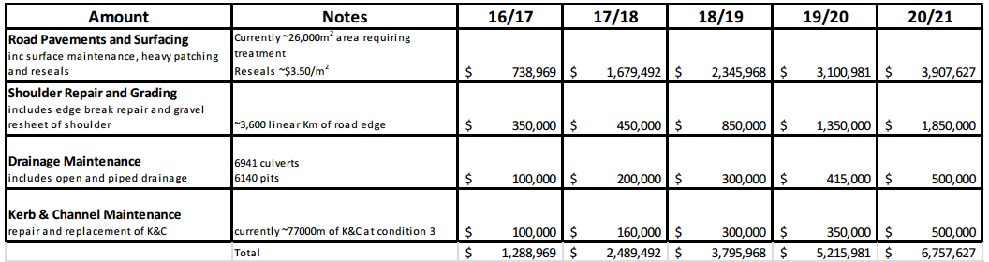

Also at the 24 November 2015 Extraordinary Council meeting, Council resolved that the General Manager find efficiency savings totalling $7.465 million (the gap between 8% p.a. and 6.5% p.a. SRV) as a minimum within the annual budget over the 5 year term of the SRV, and sewage and water fund increases on charges be capped to a maximum of 1.5% per year for five years from 2016-17 (which has been reflected in the revised 2015-16 Revenue Policy) to lessen the impact on the total rates bill. To achieve the $7.465 million annual efficiency savings by 2020-21 Council has commenced asset rationalisation and service reviews. Asset rationalisation action undertaken to date has included;

• At the 17 November 2015 Ordinary Council meeting (Item 12.058/15) Council resolved to list various Council properties for sale by auction as part of an asset rationalisation program (see Attachment 3 ‘Council Resolution Item 12.058-15 Property Sales 17.11.15 Council Meeting’).

• At the 8 December 2015 Ordinary Council meeting (Item 14.220/15) Council received and noted a review of Council’s current light fleet and heavy plant operations regarding ownership, optimum size and other efficiency strategies and resolved that recommendations relating to the review will be brought to the 15 March 2016 Council meeting (see Attachment 4 – ‘Council Resolution Item 14.220-15 Review of Light Fleet & Heavy Plant 8.12.15 Council Meeting’).

To decrease operating costs further Council also plans to review “pocket parks” in urban areas that may be surplus to our needs and is currently undertaking a strategic review of all services and service levels with reduction or elimination of services wherever possible, and devising programs and strategies to improve efficiencies.

## Capital expenditure review

You should complete this section if the council intends to undertake major capital projects that are required to comply with the OLG’s Capital Expenditure Guidelines, as outlined in OLG Circular 10-34. A capital expenditure review is required for projects that are not exempt and cost in excess of 10% of council’s annual ordinary rates revenue or $1 million (GST exclusive), whichever is the greater.

A capital expenditure review is a necessary part of a council’s capital budgeting process and should have been undertaken as part of the Integrated Planning and Reporting requirements in the preparation of the Community Strategic Plan and Resourcing Strategy.

|  |  |  |
| --- | --- | --- |
| Does the proposed special variation require council to do a capital expenditure review in accordance with OLG Circular to Councils, Circular No 10-34 dated 20 December 2010 | Yes | No |
| If *Yes*, has a review been done and submitted to OLG? | Yes | No |

# Assessment Criterion 1: Need for the variation

Criterion 1 within the OLG Guidelines is:

*The need for, and purpose of, a different revenue path for the council’s General Fund (as requested through the special variation) is clearly articulated and identified in the council’s IP&R documents, in particular its Delivery Program, Long Term Financial Plan and Asset Management Plan where appropriate. In establishing need for the special variation, the relevant IP&R documents should canvass alternatives to the rate rise. In demonstrating this need councils must indicate the financial impact in their Long Term Financial Plan applying the following two scenarios:*

* *Baseline scenario – General Fund revenue and expenditure forecasts which reflect the business as usual model, and exclude the special variation, and*
* *Special variation scenario – the result of implementing the special variation in full is shown and reflected in the General Fund revenue forecast with the additional expenditure levels intended to be funded by the special variation.*

*Evidence to establish this criterion could include evidence of community need /desire for service levels/projects and limited council resourcing alternatives.*

*Evidence could also include the assessment of the council’s financial sustainability conducted by the NSW Treasury Corporation.*

The response to this criterion should summarise the council’s case for the proposed special variation. It is necessary to show how the council has identified and considered its community’s needs, alternative funding options (to a rates rise).

The criterion states that the need for the proposed special variation must be identified and clearly articulated in the council’s IP&R documents especially the Long Term Financial Plan (LTFP) and the Delivery Program, and, where appropriate, the Asset Management Plan (AMP). The purpose of the proposed special variation should also be consistent with the priorities of the Community Strategic Plan (CSP).

## Case for special variation - community need

Summarise and explain below:

* How the council identified and considered the community’s needs and desires in relation to matters such as levels of service delivery and asset maintenance and provision.
* How the decision to seek higher revenues above the rate peg was made and which other options were examined, such as changing expenditure priorities or using alternative modes of service delivery.
* Why the proposed special variation is the most appropriate option: for example, typically other options would include introducing new or higher user charges and/or an increase in council loan borrowings, or private public partnerships or joint ventures.
* How the proposed special variation impacts the LTFP forecasts for the General Fund and how this relates to the need the council identified. Our assessment will also consider the assumptions which underpin the council’s LTFP forecasts.

In addressing this criterion, you should include extracts from, or references to, the IP&R document(s) that demonstrate how the council meets this criterion.

**Council’s Response:**

**Why the variation is needed**

The case for the variation is structured around three key themes:

• The deteriorating condition of Council’s roads and road-related infrastructure;

• The shortfall in Council’s financial capacity to fund adequate roads and road-related infrastructure maintenance and renewals as evidenced by the Long Term Financial Plan;

• The community’s desire to see improvements to the local road network as reflected in the Community Strategic Plan and Community Survey.

The following provides commentary on each of these key issues.

**Infrastructure Condition**

As at 30 June 2015 Council has $2.074 billion in assets under its control ($715.285 million is roads and road-related infrastructure). As discussed throughout this document, Council is facing a funding gap in relation to its capacity to maintain its roads and road-related infrastructure assets at a satisfactory level.

An independent assessment of Council’s sealed road network is scheduled to take place in early 2016, however inspections undertaken by council staff indicate the condition of our roads has deteriorated and has been severely impacted by major rainfalls in the area over the past several years.

The SRV funds would allow short-lived infrastructure to be renewed at a more sustainable frequency. These renewal works are critical to ensuring the longer-lived components of assets are protected so they do not fail prematurely. By way of example, ensuring road pavements are resurfaced regularly significantly improves waterproofing and is a cost effective strategy to help maximise the life of the underlying road pavement. Addressing the infrastructure gap for short-lived assets is also an effective risk based strategy to reducing the backlog of works in the medium term through the ongoing cycle of works across our network. This is reflected in the medium term noting the reduction in the asset backlog ratio (Buildings & Infrastructure Renewals ratio) as highlighted in the 10 year long term financial plan (the three year average of a ratio greater than 100% as required by Fit for the Future criteria for Regional Councils is achieved under Scenario 3 (with SRV and increased renewals and maintenance) by 2019-20, as opposed to Scenario 1 (no SRV) where the benchmark is never met).

**Infrastructure Backlog and maintenance shortfall**

The table below from Council’s 2014-15 Annual Financial Statements (see <http://www.clarence.nsw.gov.au/cp_themes/metro/page.asp?p=DOC-SYU-25-10-81> ), indicates there is a significant shortfall in Council’s capacity to fund its road and road-related (sealed roads, unsealed roads, bridges, and stormwater drainage) infrastructure renewal backlog and provide adequate maintenance.

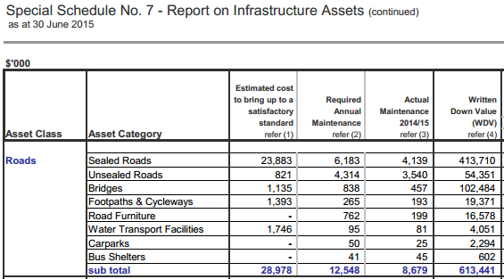

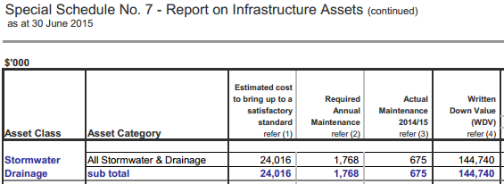

Source of data: Special Schedule 7 (2014-15 Annual Financial Statements)

Amounts contained in Special Schedule 7 of the 2014-15 Annual Financial Statements for Bring To Satisfactory (Renewal Backlog) and Required Maintenance (used to determine the Asset Maintenance Gap) were calculated based on methodology approved by Council at 23 June 2015 Council meeting in the report ‘Special Schedule 7 of the Annual Financial Statements – Backlog Works, Costs to Bring to a Satisfactory Standard and Required Annual Maintenance June 2015’ (Item 12.022/15) (see <http://www.clarence.nsw.gov.au/page.asp?f=RES-AVV-48-32-04>).

Council’s revised Asset Management Strategy **(**Item 12.001/16**)** adopted at the 9 February 2016 Extraordinary Council meeting outlines the condition, funding shortfall, performance measures, and critical risk/risk management matters associated with roads and road-related infrastructure thereby demonstrating the need for additional income to be allocated to these essential infrastructure assets

(see Attachment 5 ‘Extracted Revised Asset Management Strategy’, for full document see <https://www.clarence.nsw.gov.au/cp_themes/metro/page.asp?p=DOC-CFK-74-67-61>)

**Alternative Sources of funding for infrastructure renewal.**

To address the significant shortfall in Council’s capacity to fund its roads and road-related infrastructure renewal backlog Council explored the option of additional loan borrowings, as it has traditionally funded most of its capital works (i.e. construction works) through borrowings rather than applying for an SRV. However, NSW Treasury Corporation (T-Corp) expressed, as part of its Local Infrastructure Renewal Scheme Financial Assessment and Benchmarking Report (see Attachment 9), concern over Council’s liquidity and ability to service debt over the long term, and has even gone as far as to suggest Council consider foregoing future forecast borrowings in order to improve its liquidity position and achieve long-term financial sustainability. Consultants Ernst & Young have confirmed this view in a review of Council’s current debt portfolio in early 2015 in which they advised the sustainable debt target for Council is $110 million (as at 30 June 2015 Council’s debt portfolio was $135.855 million) (full version of the review located at <https://www.clarence.nsw.gov.au/page.asp?f=RES-FGV-70-54-35> ).

Evidence of Council seeking alternative funding sources for infrastructure renewal is also found in Section 4 - Financial Management of Council’s Strategic Organisational Action Plan 2015-2020 (Attachment 6 ‘SOAP_2015_2020_adopted_19_May_2015’**)** Objective 3, which is the formulation of the new Debt Management Policy that incorporates the sustainable debt target for Council of $110 million, and Objective 4 aligning ‘revenue-raising through fees and charges to reflect the service provided and maximise revenue raising opportunities in addition to rating’. As part of setting Council’s annual fees & charges, management seeks full cost recovery in pricing its services, cognisant of market forces and capacity to pay of the community.

Council has also conducted service reviews to free up funding to address the infrastructure renewal backlog and maintenance gap. Council has left no stone unturned. In the first 6 months of 2015 Council went through the exhaustive process of examining every service it provides, assumed it was starting the service from scratch and find the most efficient way of delivering it using zero based budgeting methodologies. However, while such service reviews have improved Council’s financial performance the roads and road-related infrastructure renewal backlog and maintenance gap still remains significant.

**The Long Term Financial Plan**

In terms of Council’s Long Term Financial Plan, the revenue provided by the proposed variation totals some $44.265 million (from Worksheet 7 of part A of the SRV application, based on a 2016-17 rate peg of 2.5%) over the 10 year period covered by the Plan. The works delivered by these funds over the SRV period from 2016-17 to 2020-21 are as follows:

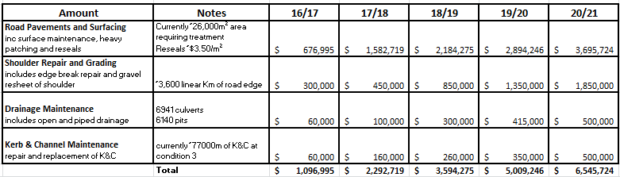

The amounts allocated in this table totalling $18,538,958 are based on a Rate Peg of 2.5% for 2016-17. This differs from the previously mentioned $19,548,037 as that figure included the announcement by IPART on Friday 4 December 2015 of a 1.8% rate peg for 2016-17, which was too late for inclusion in Council’s Revised 2015-16 to 2024-25 Long Term Financial Plan.

Council considers the program of works funded by the proposed 6.5% p.a. SRV (inclusive of rate peg) over 5 years commencing 2016-17 as critical to address the renewal and maintenance shortfall described for roads and road-related infrastructure earlier. The impact on Council’s Net Operating Result before Grants & Contributions provided for Capital Purposes of proceeding with business as usual without the SRV (Scenario 1), with the SRV showing additional income only (Scenario 2), and with the SRV additional income allocated to road and road-related infrastructure and efficiency savings (Scenario 3), is as follows:

**2015-16 to 2024-25 Long Term Financial Plan – General Fund Net Operating Result before Grants & Contributions provided for Capital Purposes:**



The Revised 2015-16 to 2024-25 Long Term Financial Plan can be located at <https://www.clarence.nsw.gov.au/cp_themes/metro/page.asp?p=DOC-CFK-74-67-61>, and the General Fund only Income Statement, Balance Sheet, and Cash Flow Statement for each Scenario of the Long Term Financial Plan in Excel format has been included in this application as Attachment 7.

**The Community Strategic Plan and Delivery Program**

The ‘Our Community Plan 2015-2024’ (see Attachment 8 ‘Extract on Infrastructure from Community Strategic Plan’) is structured around five focus areas, one of which is ‘Infrastructure – providing quality essential infrastructure throughout the Clarence Valley’. Through the plan the community articulated in Objective 2.1 that it wanted: “A safe and efficient network of arterial roads and supporting infrastructure that provides an effective road network that balances asset conditions with available resources and asset utilisation, that improves road safety, including the widening of regional roads, and maintains, renews and replaces Council bridges and culverts.”

The community also expressed to Council it wanted “town streets.., that are adequate, interconnected and maintained (Objective 2.2) while providing a network of town and village streets that balances asset conditions with available resources and asset utilisation, …and ensuring adequate stormwater, kerb and gutter infrastructure is provided, maintained and renewed.” The ‘Our Community Plan 2015-2024’, was adopted by Council at the 24 June 2014 Ordinary Council meeting (Item 12.008/14). Link to ‘Our Community Plan 2015-2024’ is as follows: <https://www.clarence.nsw.gov.au/page.asp?f=RES-NAH-13-07-78>

The 2014-2017 Delivery Program summarises some of the major issues facing Council in terms of ‘providing quality essential infrastructure throughout the Clarence Valley as’:

• Ageing transport assets in need of significant maintenance, replacement & renewal;

• Roads associated with naturally-occurring asbestos that require sealing.

• Failing stormwater drainage segments, that requires renewal.

• The challenges of funding programs to maintain the transport network over such a large geographical area.

**Community Survey – SRV Consultation.**

As disclosed in Council’s Long Term Financial Plan, Delivery Program and Asset Management Strategy, the results of the community survey demonstrated that when asked about the importance of a list of specific types of infrastructure, residents ranked sealed and unsealed roads as being the most important. In the same survey when residents were asked about funding options to address financial sustainability issues such as the maintenance gap and infrastructure renewal backlog, most residents favoured a combination of a special rate rise of 8% a year for 5 years commencing 1 July 2016 and a reduction in a range of discretionary services and amenities.

## Financial sustainability

The proposed special variation may be intended to improve the council’s underlying financial position for the General Fund, or to fund specific projects or programs of expenditure, or a combination of the two. We will consider evidence about the council’s current and future financial sustainability and the assumptions it has made in coming to a view on its financial sustainability.

You should explain below:

* The council’s understanding of its current state of financial sustainability, its long-term projections based on alternative scenarios and assumptions about revenue and expenditure.
* Any external assessment of the council’s financial sustainability, eg, by auditors, Treasury Corporation. Indicate how such assessments of the council’s financial sustainability is relevant to supporting the decision to apply for a special variation.
* The council’s view of the impact of the proposed special variation on its financial sustainability.

**Council’s Response:**

**Financially unsustainable.**

Council’s Long Term Financial Plan and Asset Management Strategy have been driven by the need to address Council’s unsustainable position relating to the infrastructure renewal backlog and asset maintenance gap.

As noted in Council’s Revised 2015-16 to 2024-25 Long term Financial Plan, two key factors, not uncommon to local government authorities, were the main contributors to this unsustainable position:

• The fact annual expenditure has been rising at a faster rate than income means it has become increasingly difficult to continue to maintain the activities and service levels the community has become accustomed to. In order to continue with historical activities and service levels council has had to utilise its existing financial reserves. This strategy cannot continue indefinitely, and

• The deterioration of community infrastructure.

The ‘widening gap’ between expenditure and revenues arises from:

• State Government ‘Rate Pegging’: legislation that has, for more than 30 years, meant increases in revenue have not always kept pace with inflation or costs for construction. The impact on Clarence Valley Council of the “Rate Pegging” policy is shown in the graph below which clearly shows that Council’s income from rate revenue has not kept pace with Council’s rising costs.

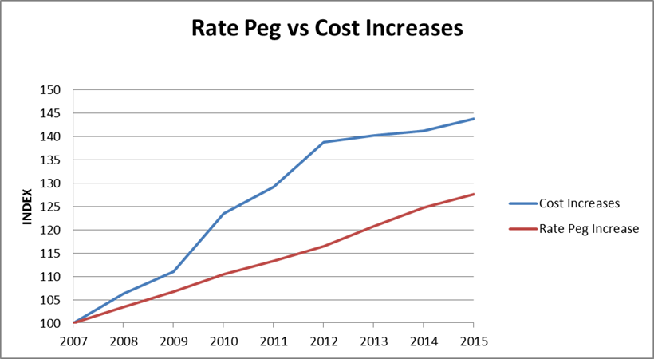

• Cost Shifting: the latest report commissioned by LGNSW found that as at 2013-14 Council was responsible for a number of extra services that were previously the responsibility of State or Federal Government and that these cost Clarence Valley Council approximately over $7.03 million each year to deliver, which is 6.55% of Total Income from Operations before Capital Amounts.

• Community Expectations: Council now delivers a wider range of services than it did in the past.

The competing financial pressures noted above have led to a gradual reduction in funding for roads and road-related infrastructure maintenance and renewal over a number of years, to the point where Council cannot continue to deliver the services it currently does to the current standards, let alone achieve new objectives over and above these.

**Council’s Long Term Financial Plan (LTFP)**

Council’s 10-year ‘Base-Line’ LTFP budget projections show ongoing and substantial General Fund deficit positions. Without the proposed SRV, Council does not have the funding capacity to undertake the required renewal and maintenance works to stop the further deterioration of roads and road-related infrastructure.

In simple terms, if the proposed SRV is approved, Council will be able to reduce further roads and road-related asset deterioration through a significant increase in its annual asset maintenance and renewal expenditure.

***The Financial Position of General Fund***

Council’s ‘General Fund’ continues to be in a poor financial position, having minimal untied revenues to allocate to new or expanded operational programs and to capital works.

Council’s more recent revenue and expenditure trends (Operating Result) for the General Fund are summarised in the following table:

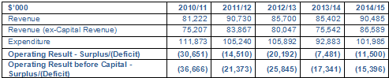

Source: Note 21 of Annual Financial Statements.

***The Financial Position of Water and Sewer Funds***

Water supply and sewerage infrastructure makes up approximately $702 million (around 34%) of the carrying value of Council assets. Under the NSW Local Government legislation these services are funded by specific charges and accounted for distinct from “general” activities funded by ordinary rates.

Over the past decade, Council has made substantial investments in the provision of new water and sewerage infrastructure including the construction of a $15 million Sewer Treatment Plant at Yamba, the $45 million Iluka Sewerage Scheme, the $77.5 million North Grafton, Clarenza, and Woodford Island Sewerage Scheme, and a $158 million on Shannon Creek Dam.

These investment decisions will underpin the social, environmental and economic future of the Clarence Valley Council Local Government Area (LGA), ensuring the expected level of service can be delivered. The decisions were supported by 30 year financial plans demonstrating that Council could repay the substantial loans required via water and sewerage charges.

The same approach is clearly required for General Fund to address the two thirds of Council’s infrastructure portfolio – transport, drainage, buildings, floodplain and recreation assets together valued at around $1.4 billion – which similarly underpin the future of the Clarence Valley Council LGA, ensuring current services can be provided into the future.

The Sewerage Fund for 2014-15 had an operating surplus of $1.204 million and the Water Fund had an operational deficit $1.962 million after deducting capital grants and contributions.

The Water and Sewer funds, in-line with the Council’s Long Term Financial Plans, are expected in general to incur surpluses over the next 10 years (Water Fund experiences a small deficit in 2017-18), primarily due to reduced operating costs from new and upgraded infrastructure. The improving financial position of the Water and Sewer Funds has enabled the annual water and sewer charge increases to be held at reasonable levels.

**Assessment of Council’s Financial Sustainability by T-Corp**

In support of the previous Independent Review of Local Government, NSW Treasury Corporation (T-Corp) was engaged by the State Government to undertake a financial assessment of NSW councils to evaluate:

• The financial capacity of the Council to undertake additional borrowings, and

• The financial performance of the Council in comparison to a range of similar councils and measured against prudent benchmarks.

An external assessment of Clarence Valley Council’s financial position was undertaken by the T-Corp in 2012.

T-Corp assessed Clarence Valley Council as follows:

• Financial Sustainability Rating (FSR): Weak

• Outlook: Negative

A ‘Weak’ FSR rating was given to councils with the following characteristics:

• A local government with an acceptable capacity to meet its financial commitments in the short to medium term and a limited capacity in the long term.

• It has a record of reporting moderate to significant operating deficits with a recent operating deficit being significant. It is unlikely to be able to address its operating deficits, manage unforeseen financial shocks and any adverse changes in its business, without the need for significant revenue and/or expense adjustments.

• The expense adjustments would result in significant changes to the range of and/or quality of services offered.

• It may experience difficulty in managing core business risks.

This assessment further highlights the inability of Council’s ‘General Fund’ to afford any new capital works. Council is undertaking a number of measures to improve the sustainably of the General Fund (see Section 7 - Productivity Improvements and Cost Containment Strategies).

The following statement is from Council’s ‘Financial Assessment Report’ produced by T-Corp in October 2012 (Executive Summary – pages 4 to 5):

“The key observations from our review of Council’s 10 year forecasts for its General Fund are:

- The forecast shows deficit positions are expected in all 10 years when capital grants and contributions are excluded. This is Council’s weakest forecast ratio and highlights that over the longer term Council faces financial sustainability issues. Strategies to resolve this forecast position need to be developed and actioned in the short to medium term.

- Council has to balance meeting liquidity benchmarks with the poor state of its infrastructure (particularly roads), and has elected to use all available funds to improve a declining infrastructure network. However, as noted above, Council does not have sufficient resources in the foreseeable future to make any significant reduction in their Infrastructure Backlog and it is more likely that the backlog will continue to increase.

- The forecast capital expenditure program is well below benchmarks to the extent that asset quality is expected to continue to decline.”

The following statement on Benchmarking was also made by T-Corp in the same report (Executive Summary – page 5):

“In respect of the Benchmarking analysis T-Corp has compared the Council’s key ratios with other councils in DLG Group 4. The key observations are:

- Council’s financial flexibility was limited, as indicated by the Operating Ratio and the Own Source Operating Revenue Ratio which generally underperformed the group’s average and the benchmark.

- Council’s liquidity position was sound and outperformed the benchmark and the group’s average in the past three years

- While Council has a higher level of gearing than its peers, its DSCR and Interest Cover Ratio were sufficient in the past three years

- Council’s Infrastructure Backlog was generally comparable to the group’s average but above the benchmark over the review period. Council’s capital expenditure, asset maintenance and asset renewal ratios were generally below benchmark and the group’s average in the past three years, indicating insufficient funds have been invested to prevent the backlog from growing”.

See Attachment 9 ‘T-Corp Financial Assessment and Benchmarking Report’

**DLG Infrastructure Management Assessment**

One of the actions of the NSW 2021 State Plan was to undertake an Infrastructure Audit of NSW councils.

The key objectives of the audit were to:

• Provide information in relation to the infrastructure backlog in NSW

• Assess the reliability of the information provided by councils to determine the backlog

• Identify trends in infrastructure needs by area and asset type

• Identify current infrastructure risk exposure.

This audit classified Clarence Valley Council as ‘Weak’ in terms of Infrastructure Asset Management and identifies the cost to bring our infrastructure to a satisfactory standard as over $224 million.

**IPART Fit for the Future Assessment**

The NSW Government released the Independent Pricing and Regulatory Tribunal (IPART) Assessment of Council Fit for the Future Proposals report on Tuesday 20 October 2015. Council was assessed by IPART as being “Not Fit” as Council did not meet all the Sustainability and Infrastructure and Service Management benchmarks by 2019-20 (See Attachment 11 ‘Extract of Assessment of Fit for the Future Proposal October 2015’).

The financial criterion that Council was assessed against, and how it was assessed by IPART, is as follows:

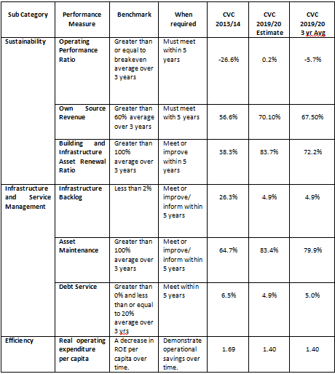

The financial indicators demonstrate Council needs to increase the level of funding it has committed to the renewal and maintenance of its building and infrastructure assets.

At the 17 November 2015 Council Meeting (Item 12.059/15) in relation to Council’s response to the Fit For the Future assessment, Council resolved to:

* Acknowledge the need for ongoing financial improvement and commit to progressively making the necessary changes to become a sustainable organisation.

* To demonstrate and assess ongoing improvement, Council will engage NSW Treasury Corporation to assess Council performance independently by June 2016.

**Long Term Financial Plan (LTFP) Scenario’s and Assumptions**

When considering the adoption of Council’s revised 2015-16 to 2024-25 Long Term Financial Plan at its 9 February 2016 extraordinary Council meeting (Item 12.001/16) Council resolved “Adopt Scenario 3 of the Revised Long Term Financial Plan to support Council’s 2016-17 Special rate Variation Application, which applies the strategies of:

a. A Special Rate Variation (SRV) of 6.5% pa (inclusive of 2.5% assumed rate peg), for five years commencing in 2016-17 to improve financial flexibility and to assist in reducing the Infrastructure Renewal Backlog and Asset Maintenance Gap by allocating funds above the rate peg limit to road-related infrastructure renewals and maintenance.

b. Utilisation of borrowing capacity when possible using external loan borrowings from 2019-20, totalling $15m by 2024-25. This is required to further reduce the Infrastructure Renewal Backlog.

c. A rigorous review of all services and service levels with reduction or elimination wherever possible and devising programs and strategies to contain rising costs and improve efficiencies resulting in a decrease in various operating costs. Such a review will generate $7.465 million in efficiency savings from 1 July 2016 to 30 June 2021, and ongoing efficiency savings of $7.465 million p.a. from 1 July 2021 to make Council financially sustainable.

d. Rationalise and review all assets.”

The utilisation of additional borrowings from 2019-20 is based on the projected loan portfolio balance in that year being below the $110 million advised sustainable debt target.

Assumptions used in the Baseline scenario (Scenario 1) of the LTFP include:

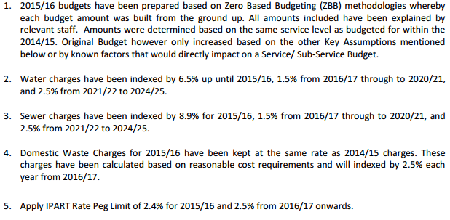

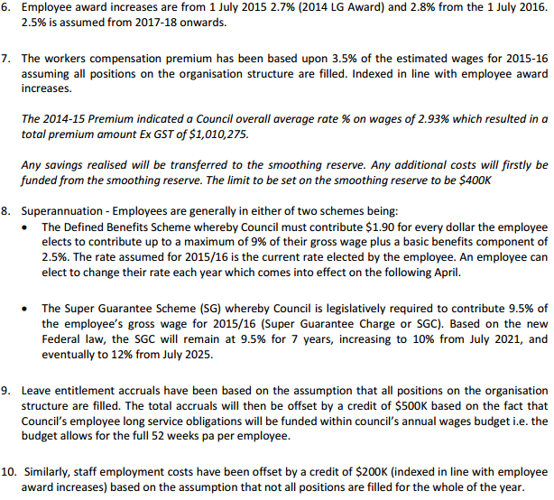

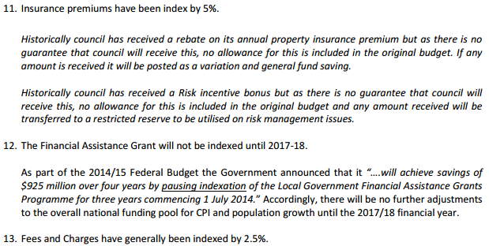

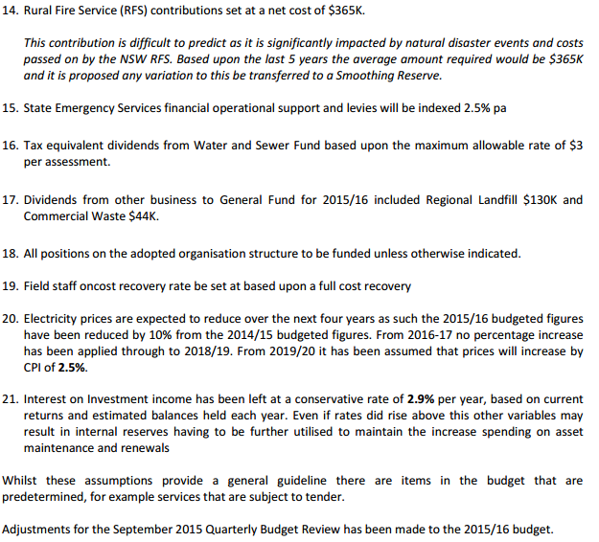

**1) Baseline Scenario**

This scenario does not include the revenue from the SRV but includes current levels of expenditure.

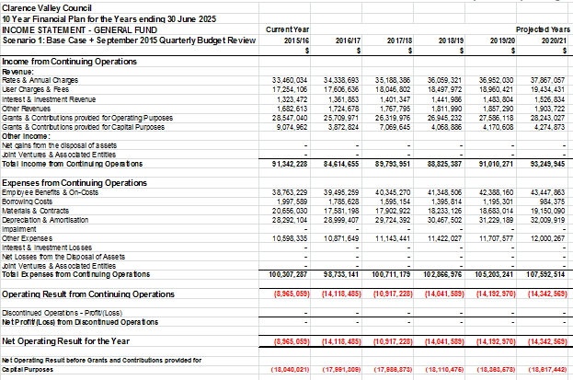

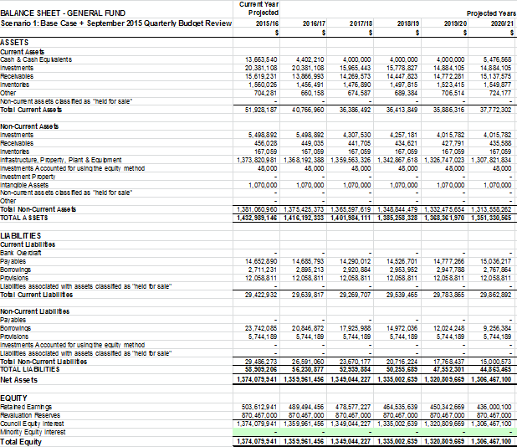

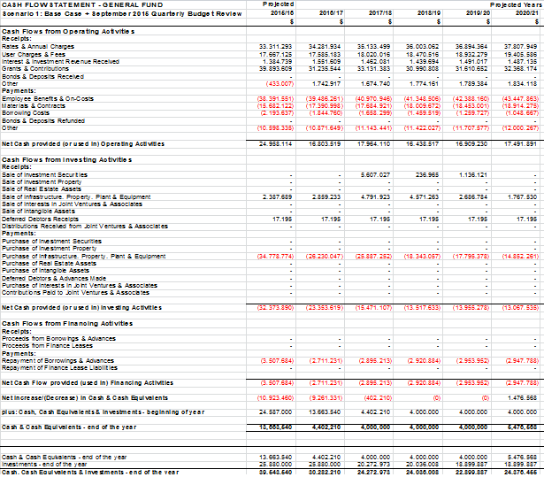

**2) Scenario 2** - includes income only from a SRV of 6.5% p.a. for the 5 year SRV period (37% cumulative increase by 2020-21 permanently built into the general rate).

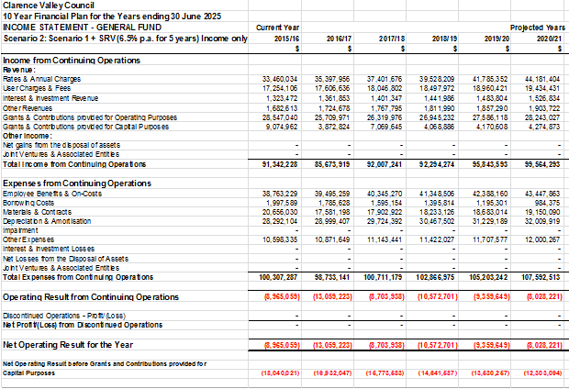

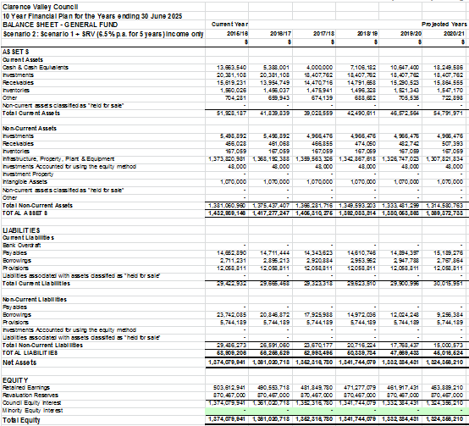

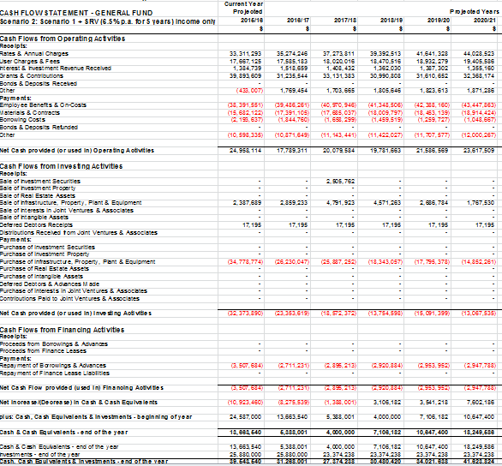

**3) Scenario 3 -** SRV income plus additional roads and road-related maintenance and renewal expenditure plus efficiency savings reaching $7.465 million by 2020-21 and ongoing savings each year of $7.465 million.

It is only under Scenario 3 of the LTFP that Council achieves Fit for the Future benchmarks for Sustainability, Infrastructure and Service Management, and Efficiency. Most importantly Scenario 3 is the only LTFP scenario that eliminates the roads and road-related infrastructure renewal backlog and maintenance gap and places council in a financially sustainable position

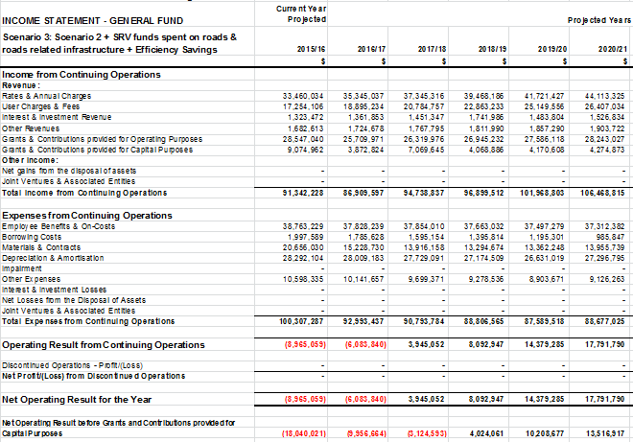

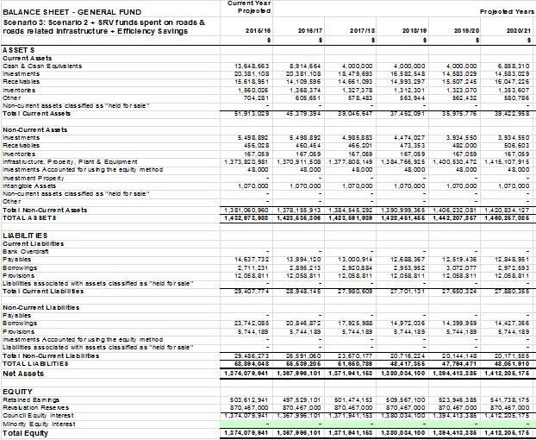

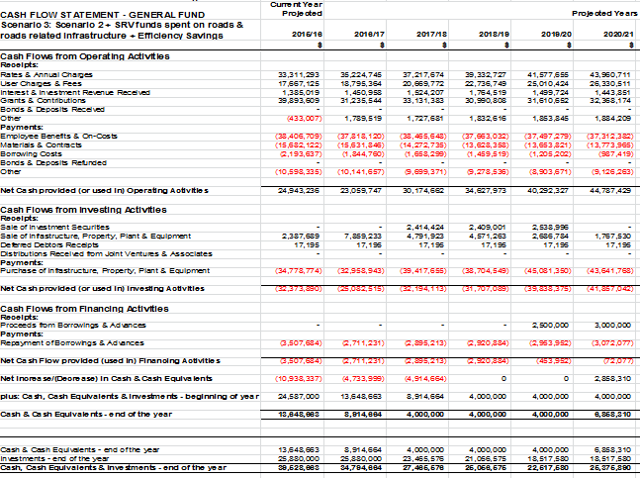

## Financial indicators

How will the proposed special variation affect the council’s key financial indicators (General Fund) over the 10-year planning period? Please provide, as an addendum to the LTFP, an analysis of council’s performance based on key indicators (current and forecast) which may include:

* Operating balance ratio excluding capital items (ie, net operating result before capital grants and contributions as percentage of operating revenue before capital grants and contributions).
* Unrestricted current ratio (the unrestricted current assets divided by unrestricted current liabilities).
* Rates and annual charges ratio (rates and annual charges divided by operating revenue).
* Debt service ratio (principal and interest debt service costs divided by operating revenue excluding capital grants and contributions).
* Broad liabilities ratio (total debt plus cost to clear infrastructure backlogs as per Special Schedule 7 divided by operating revenue).
* Asset renewal ratio (asset renewals expenditure divided by depreciation, amortisation and impairment expenses).

**Council’s Response:**

**Key Financial Indicators (KFIs) – General Fund**

Of the Key Financial Indicators mentioned above in Section 3.3 of this application, the LTFP shows the Operating Performance Ratio, Unrestricted Current Ratio, Rates and Annual Charges Coverage Ratio, Debt Service Ratio for General Fund projected for the next 10 years under both Scenario 1 the ‘Base Case’ (page 35 of Revised LTFP) and Scenario 3 ‘SRV funds spent on roads & road-related infrastructure + Efficiency Savings’ (page 52 of Revised LTFP) Financial Models.

***Operating Performance Ratio (excluding capital items)***

If the proposed SRV (Scenario 3 of the LTFP) is approved, this ratio will increase as revenue will increase by the proposed additional rate income - thereby increasing the operating revenue and net operating result. IPART’s Fit for the Future benchmark for regional councils for this ratio is that it must be greater than or equal to breakeven average over three years and that benchmark must be met within five years. Under Scenario 3 of the LTFP Council meets this requirement by 2019-20. However, in Scenario 1 (no SRV) of the LTFP the benchmark is never met.

***Unrestricted Current Ratio***

If the proposed SRV is approved, this ratio will improve slightly as cash reserves increase under Scenario 3.

***Rates and Annual Charges Coverage Ratio Percentage***

If the proposed SRV is approved, this percentage will increase as rates revenue will increase by the proposed additional rate income.

***Debt Service Ratio***

If the proposed SRV is approved, this ratio will show a favourable decrease for all years other than 2023-24 and 2024-25, as the revenue from continuing operations will increase due to the additional rate income. In 2023-24 and 2024-25 the impact of the $15 million new loan borrowings between 2019-20 and 2024-25 in General Fund to finance roads and road-related infrastructure renewals are experienced, however the ratio is still below Council’s target of less than 12%.

IPART’s Fit for the Future benchmark for Regional Councils for this ratio is that it must be greater than 0% and less than or equal to 20% average over three years and that benchmark must be met within five years. Under Scenario 3 and Scenario 1 of the LTFP Council meets this requirement in each year of the LTFP.

**Other ratios in Revised LTFP not shown above include:**

***Own Source Revenue Ratio***

If the proposed SRV is approved, this ratio will increase as rates revenue will increase by the proposed additional rate income. The three-year average of greater than 60% which must be met within five years as required by Fit for the Future criteria for Regional Councils will be achieved under Scenario 3 and Scenario 1 of the LTFP by 2017-18.

***Debt Service Cover Ratio***

This ratio measures the availability of operating cash to service debt including interest, principal and lease payments. The OLG benchmark is greater than 2x. If the proposed SRV is approved, this ratio will increase as per Scenario 3 of the LTFP as operating cash will increase due to the proposed additional rate income.

***Capital Expenditure Ratio***

If the proposed SRV is approved, this ratio will increase as a portion of the proposed additional rate income will be allocated to roads and road-related infrastructure renewals.

***Infrastructure Backlog Ratio***

If the proposed SRV is approved, this ratio will increase as a portion of the proposed additional rate income will be allocated to roads and road-related infrastructure renewals. The Fit for the Future benchmark for Regional Councils of less than 2% to meet or improve within five years will be achieved under Scenario 3 by 2019-20. In Scenario 1 (no SRV) of the LTFP the Fit for the Future benchmark for Regional Councils is never met.

***Asset Maintenance Ratio***

If the proposed SRV is approved, this ratio will increase as a portion of the proposed additional rate income will be allocated to roads and road-related maintenance. The ratio improves each year over the 10-year LTFP period under Scenario 3 and the Fit for the Future benchmark for Regional Councils of greater than 100% to meet or improve within five years will be achieved by 2016-17. In Scenario 1 (no SRV) of the LTFP the Fit for the Future benchmark for Regional Councils is never met.

***Building & Infrastructure Renewals Ratio***

If the proposed SRV is approved, this ratio will increase as a portion of the proposed additional rate income will be allocated to roads and road-related infrastructure renewals. The three-year average of greater than 100%, as required by Fit for the Future criteria for Regional Councils, will be achieved under Scenario 3 by 2019-20. In Scenario 1 (no SRV) of the LTFP the Fit for the Future benchmark for Regional Councils is never met.

***Rates, Annual Charges, Interest & Extra Charges Outstanding Percentage Ratio***

The percentage supplied in the LTFP shows little difference between Scenario 3 and Scenario 1. The ratio in the LTFP as compared against actuals for 2013-14 (6.48%) and 2014-15 (6.4%) is conservative, and payment channels and debt management procedures to be implemented in 2016 are expected to prevent any increase in the ratio from adopting the SRV.

**Other Key Financial Indicators (KFIs) Reported by Council**

Council in April 2013 adopted nine key KFIs and associated benchmarks as part of its financial strategy. These KFI’s are under review to ensure they reflect legislative requirements, industry best practice, and related council policies.

These indicators are used as financial health checks to monitor the operational liquidity (short-term focus), fiscal responsibility (elected-term focus) and financial sustainability (long-term / intergenerational focus) of the Council. The financial indicators tabled below have been referenced from Note 13 of the Local Government Code of Accounting Practice & Financial Reporting Update 21, the IPWEA Australian Infrastructure Financial Management Guidelines and the NSW IPART report Revenue Framework for Local Government – December 2009.

These ratios (detailed in the following table) are monitored on a consolidated and individual fund basis. Some of these KFIs are in addition to the Financial Indicators projected by Council’s LTFP models.

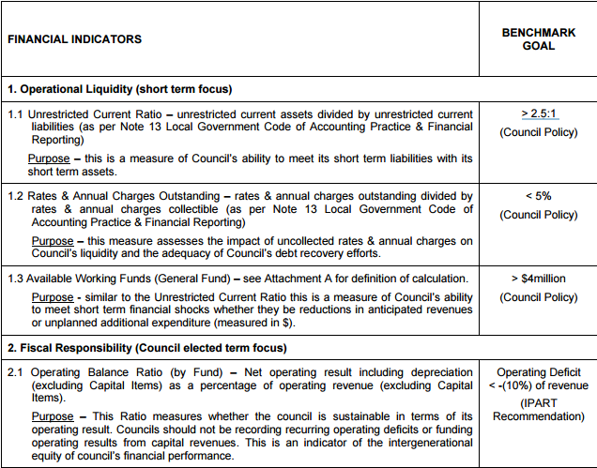

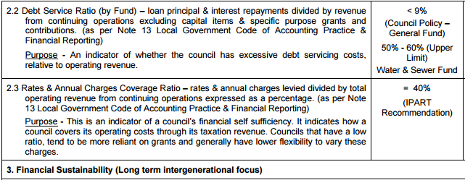

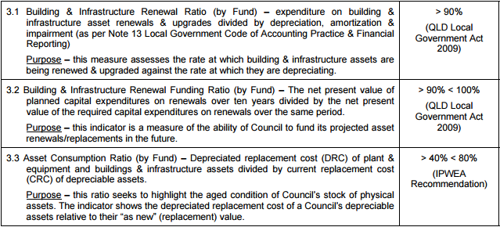

## Contribution plan costs above the cap

You should complete this section if the proposed special variation seeks funding for contributions plan costs above the development contributions cap. Otherwise, leave this section blank.

Please explain how the council has established the need for a special variation to meet the shortfall in development contributions.

For costs above the cap in contributions plans, a council must provide:[3]

* a copy of the council’s section 94 contributions plan
* a copy of the Minister for Planning’s response to IPART’s review and details of how the council has subsequently amended the contributions plan
* details of any other funding sources that the council is proposing to use, and
* any reference to the proposed contributions (which were previously to be funded by developers) in the council’s planning documents (eg, LTFP and Asset Management Plan (AMP).

|  |
| --- |
| Not Applicable |

# Assessment criterion 2: Community awareness and engagement

Criterion 2 within the OLG Guidelines is:

*Evidence that the community is aware of the need for and extent of a rate rise. The Delivery Program and Long Term Financial Plan should clearly set out the extent of the General Fund rate rise under the special variation. The council’s community engagement strategy for the special variation must demonstrate an appropriate variety of engagement methods to ensure community awareness and input occur. IPART’s fact sheet includes guidance to councils on the community awareness and engagement criterion for special variations.*

Our fact sheet on the requirements for community awareness and engagement are available on the IPART website.[4]

In responding to this criterion, the council must provide evidence that:

* it has consulted and engaged the community about the proposed special variation using a variety of engagement methods and that the community is aware of the need for, and extent of, the requested rate increases
* it provided opportunities for input and gathered input/feedback from the community about the proposal, and
* the IP&R documents clearly set out the extent of the requested rate increases.

In assessing the evidence, we will consider how transparent the engagement with the community has been, especially in relation to explaining:

* the proposed cumulative special variation rate increases including the rate peg for each major rating category (in both percentage and dollar terms)
* the annual increase in rates that will result if the proposed special variation is approved in full (and not just the increase in daily or weekly terms)
* the size and impact of any expiring special variation (see Box 4.1 below for further detail), and
* the rate levels that would apply without the proposed special variation.

More information about how the council may engage the community is to be found in the OLG *Guidelines*, the IP&R manual, and IPART’s Fact Sheet *Community Awareness and Engagement for special variation applications*, January 2016.

|  |
| --- |
| Box 4.1 Where a council is renewing or replacing an expiring special variation |
| The council’s application should show how you have explained to its community:  There is a special variation due to expire at the end of the current financial year or during the period covered by the proposed special variation. This needs to include when the expiring special variation was originally approved, for what purpose and the percentage of (General Fund) general income originally approved.  The corresponding percentage of general income that the expiring special variation represents for the relevant year.  Whether the temporary expiring special variation is being replaced with another temporary or a permanent increase to the rate base.  The percentage value of any additional variation amount, above the rate peg, for which the council is applying through a special variation.  If the proposed special variation was not approved ie, only the rate peg applies, the year-on-year change in rates would be lower, or that rates may fall.  The council also must attach, to its application to IPART, a copy of the Instrument of Approval that has been signed by the Minister or IPART Chairman. |
|  |

## The consultation strategy

The council is required to provide details of the consultation strategy undertaken, including the range of methods used to inform and engage with the community about the proposed special variation and to obtain community input and feedback. The engagement activities could include media releases, mail outs, focus groups, statistically valid random or opt-in surveys, online discussions, public meetings, newspaper advertisements and public exhibition of documents.

The council is to provide relevant extracts of the IP&R documents that explain the rate rises under the proposed special variation and attach relevant samples of the council’s consultation material.

**Council’s Response:**

At its 12 May 2015 Extraordinary Meeting (Item 14.104/15), Council resolved to instruct the General Manager to carry out public consultation on increasing the revenue via a special rate variation of 8% per year (including the rate peg limit) for a five-year term, reducing operating costs and realising capital for debt-reduction and/or funding of essential works through elimination of selected services, facilities and amenities together with the sale of excess property. At the same meeting Council also resolved to conduct a survey of all ratepayers by 30 September 2015, for a report to Council's October 2015 meeting, to ascertain the general response of respondent ratepayers to at least:

a) increasing operational revenue by way of a Special Rate Variation increase (as above) or

b) a reduction of discretionary services and amenities or

c) a combination of both as above

d) a ranking of importance for council financial capital expenditure focus giving up to 10 headings of consideration including such things as roads network, riverside amenity, public parks and gardens, land & property ownership, environmental programs, community services and,

e) other questions, if any, on financial priority and viability.

In relation to the strategies of reducing operating costs and realising capital for debt-reduction and/or funding of essential works through elimination of selected services, facilities and amenities together with the sale of excess property, the General Manager was required to undertake:

1. Ongoing identification and sale of surplus and under-utilised property assets

2. The disposal by sale of non-strategic property assets

3. The further investigation by independent professional advice, of a strategy for lease-type financing of capital items such as plant, equipment, vehicles and if feasible, large infrastructure items, and

4. Elimination of at least the following services:

• Tourism services and tourism promotion

• Economic services and economic development or promotion services

• Natural Resource Management Services

• Community Development Service

• Youth Services

• Ageing and Access Services

• Safe Communities Services

• Library facilities and services

• Community Centres

• Sponsored events and festivals

• Community Care Services not funded by other levels of government

• Public Halls

• Under-utilised, unique or unusual sporting facilities

• Aquatic Facilities

• Under-utilised public amenities

• Ulmarra Pool at end of current contract

• South Grafton Saleyards

• Mobile Library Services

• Grafton Regional Gallery

• Grafton Airport operation and/or ownership

• Cemeteries

• Quarries

• Environmental sustainability services

• Under-utilised caravan parks and camping facilities

Council staff used a suite of measures to provide information to the community about the measures under consideration and to encourage members of the public to provide their views (see Attachment 12 ‘Community Engagement Strategy’). These included:

• direct mailing all ratepayers with background material, survey form and reply-paid envelope; media releases;

• newspaper and radio advertising;

• radio and television news pieces;

• information sessions in Grafton Shoppingworld, Maclean (River Street) and Yamba Shopping Fair;

• social media posts on most Council-operated social media forums, and;

• community meetings at the Grafton Community and Function Centre and the Maclean Civic Hall;

• Letter from General Manager to all staff seeking their response to the measures being considered.

The Communication Engagement Strategy and subsequent activities related to the SRV application were viewed as a vital component of Council’s ongoing implementation of the Integrated Planning and Reporting Framework. The strategy sought to link the expectations and service priorities that the community had expressed during the extensive engagement program carried out between December 2013 and April 2014 in order to develop the Community Strategic Plan; 2015-17 Delivery Program and 2014-15 Operational Plan, with the financial modelling required to address these priorities in the future and specifically draft a revised 2015-16 to 2024-25 Long Term Financial Plan. The activities carried out in Council’s Communication Engagement Strategy are aimed to ensure that all stakeholders were able to access, participate in and provide input to the review of financial models for future service delivery.

A direct-mailed letter to all rateable properties containing a reply-paid envelope, a message from the General Manager (inviting ratepayers to complete and return a printed survey or to complete a survey online at <http://clarenceconversations.com.au/roadstosustainability> ), community survey and pamphlet explaining the background behind the need for Council’s proposed financial sustainability strategies was delivered to all rateable properties in the Clarence Valley Council local government area from the week beginning August 7, 2015 (See Attachment 13 ‘Letter to Ratepayers from General Manager’, Attachment 14 ‘Community Survey – posted’, Attachment 15 ‘Community Survey – Counter’, and Attachment 16 ‘Roads to Sustainability brochure’).

To coincide with the arrival of the letter and survey information, Council issued a media release and started radio advertising advising that ratepayers would soon get information about measures the Council was considering to improve its long-term financial position (see Attachment 17 ‘Radio Advertising Scripts’, Attachment 18 ‘media release one’). The media release received coverage in The Daily Examiner, The Clarence Valley Independent, Radio 2GF, North Coast ABC as well as Prime and NBN television. Council also used its website with a ‘slider’ image at the top of the landing page that directed people to <http://clarenceconversations.com.au/roadstosustainability> where an electronic version of the survey and comprehensive background information was provided (see Attachment 19 ‘Background information used in Clarence Conversations Website, available by request, at information sessions, and community meetings’). This website also launched in the week beginning August 7, 2015. On August 10, most of the Council’s eight Facebook pages posted links and brief information about the survey and background information. Radio advertising continued throughout.

In the week following the distribution of posted material to all ratepayers, and run over two weeks, IRIS Research conducted a random phone survey of 500 residents of the Clarence Valley local government area seeking responses to the measures outlined in Council’s resolution of 12 May 2005. A representative of IRIS Research presented the results of the survey to Council’s 20 October 2015 Council meeting (see Attachment 1). The survey conducted by IRIS Research provided statistically reliable information and provided results that reflect the views of residents and ratepayers in the Clarence Valley Council local government area. The survey was also made available at Council offices, at information meetings in shopping centres and Maclean’s main street, at community information meetings in Grafton and Maclean and by request (for content of community information meetings presentation see Attachment 20 ‘Extract of presentation to community meetings in Grafton and Maclean’). Survey responses were restricted to one per email address. The demographic information included in the survey was optional.

On August 18, 2015, The Daily Examiner published a full page advertisement providing some background to the measures under consideration, advice on how people can provide their input, a list of the discretionary services and notification of information stalls at Grafton, Maclean and Yamba and public meetings at Grafton and Maclean (see Attachment 21 ‘Daily Examiner Full Page Advertisement’). The same information was published in a full page ad in The Clarence Valley Independent on August 19 2015 (see Attachment 22 ‘Clarence Valley Independent Full Page Advertisement’).

On Thursday, August 20 2015, Council’s Corporate Director, Executive Manager of Organisational Performance and Governance, and Communications Coordinator hosted an information stall at Grafton Shoppingworld to answer questions from members of the general public. A similar information stall was hosted by Council’s Corporate Director, Works and Civil Director and Communications Coordinator in the Maclean CBD (River St, outside Maclean Variety Meats) on Friday, August 21 2015, and a third information stall hosted by the same staff operated at Yamba Shopping Fair on Monday, August 24 2015.

Two public information sessions hosted by an independent facilitator and promoted through the full-page advertising mentioned previously and in the Council’s weekly block advertising in Coastal Views (August 21, 2015) and The Daily Examiner (August 22, 2015) were conducted at the Grafton Community and Function Centre from 5:30pm on August 25, 2015 and at the Maclean Civic Hall from 5:30pm on August 26, 2015 (see Attachment 23 ‘Block advertisement Coastal Views and Daily Examiner’). On September 14 2015 Council issued a reminder for people to fill out the surveys and make comments before they closed at 4pm on September 25 (see Attachment 24 ‘media release survey reminder’).

As Council resolved to apply for a 6.5%p.a. inclusive of rate peg SRV and the original IP&R documents (i.e. Long Term Financial Plan, Asset Management Strategy and Delivery Program and Operational Plan) which were adopted on 23 June 2015 were based on an 8%p.a. SRV, council had to revise these documents and place them on exhibition (See Attachment 25 ‘Revised 2014-17 Delivery Program 2015-16 Op Plan’). Relevant extracts of the IP&R documents that explain the rate rises under the proposed special variation are per below:

***Revised Asset Management Strategy (pages 9 & 10):***

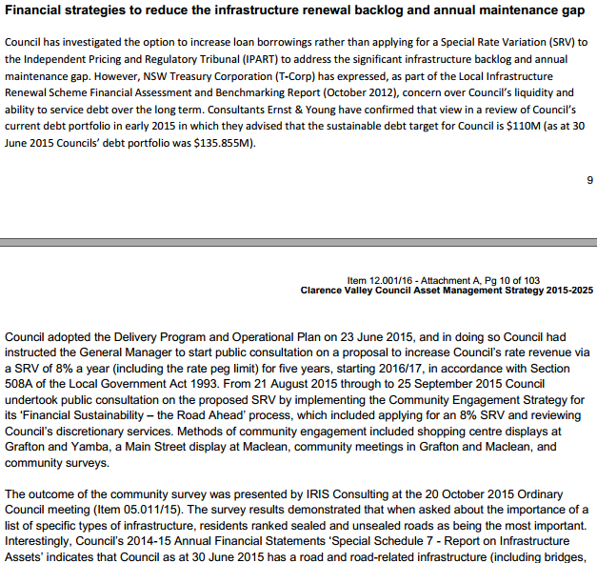

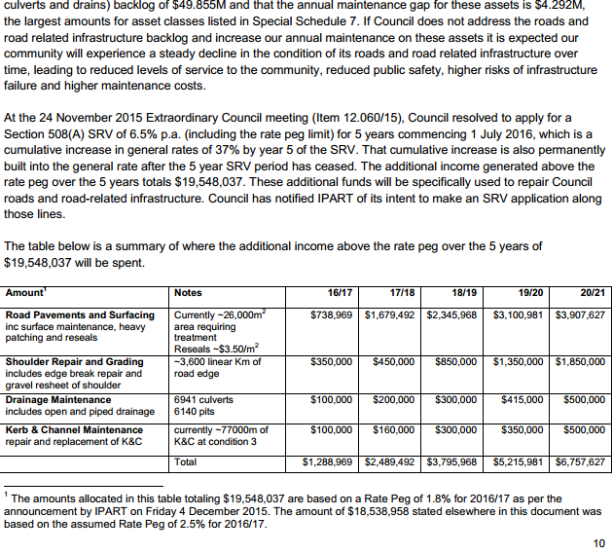

***Revised 2014-17 Delivery Program & 2015-16 Operational Plan (pages 3 to 5):***

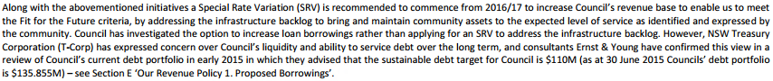

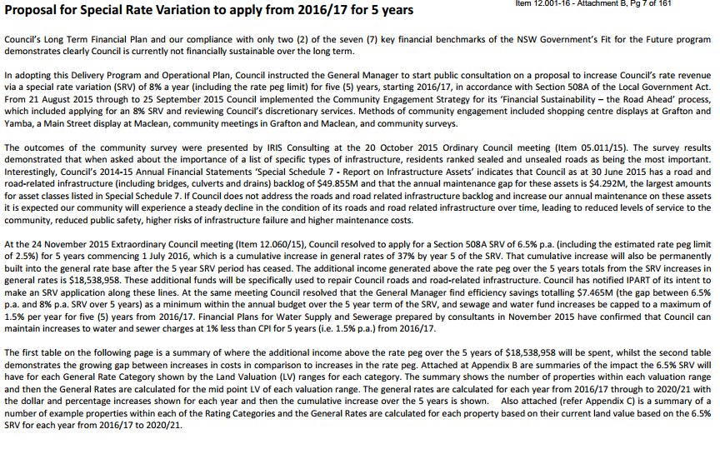

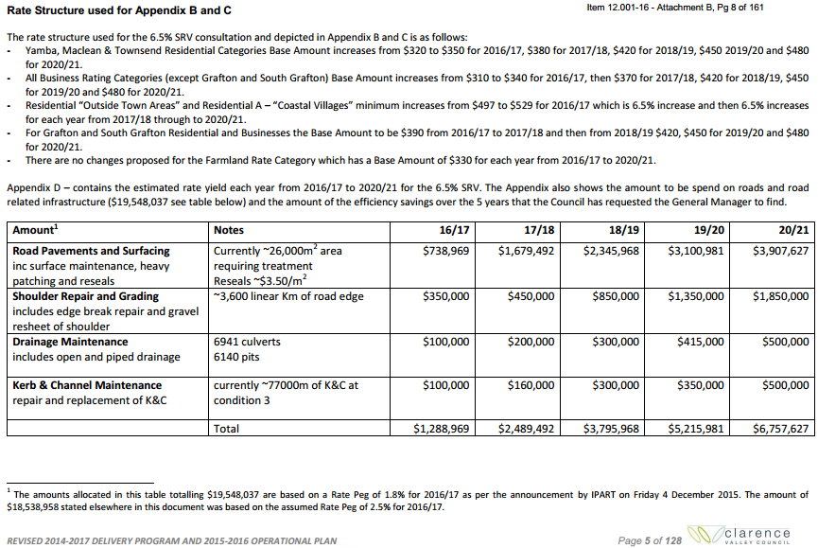

Note there are also references in the Revised Delivery Program to Appendix B– Rate Structure Options, Appendix C – Property Comparisons, and Appendix D – Estimated Rate Yield

***Revised 2015-16 to 2024-25 Long Term Financial Plan:***

***Page 3:***

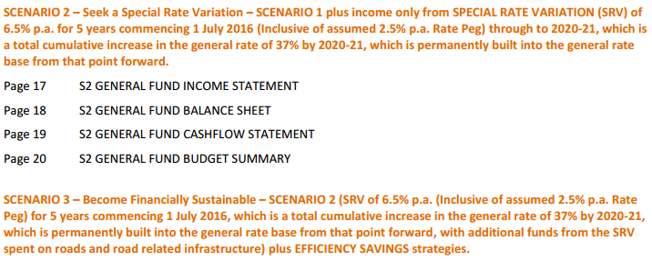

***Page 4:***

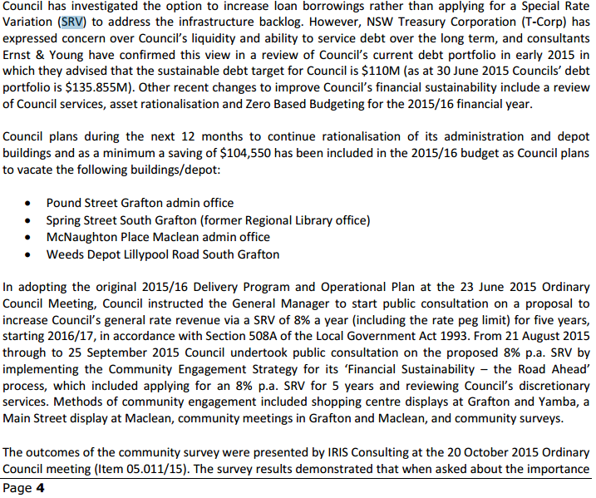

***Page 5:***

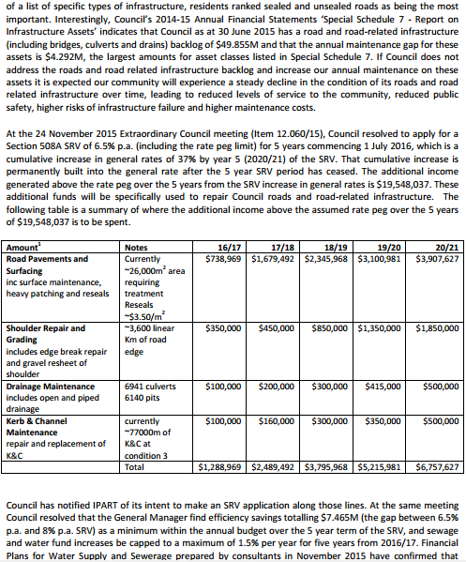

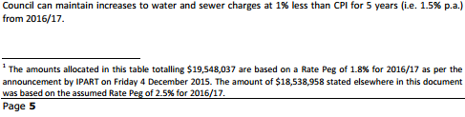

***Page 15:***

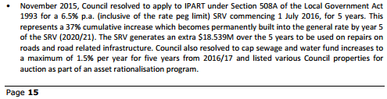

The Revised LTFP also explains the impact of the SRV on Council’s financial position under Scenario’s 2 and 3 from pages 22 to 24.

Just prior to Council placing these documents on exhibition the 2016-17 rate peg of 1.8% was announced. To keep the community informed Council issued a media release explaining the impact of the change from the assumed 2.5% rate peg in Council’s previous communications to the announced rate peg of 1.8% i.e. that the 6.5%p.a. SRV commencing in 2016-17 for 5 years was inclusive of the 1.8% rate peg amount and therefore the gap of the SRV over the rate peg increases from 4% to 4.7% for 2016-17 and this has a compounding effect for future years. In the same media release council also explained that the additional income generated from the SRV over the rate peg over the 5 year period of the SRV increases from $18,538,958 to $19,548,037 and explained how the increased income was to be allocated (see Attachment 26 ‘Media Release re 1.8% rate peg’).

***Related Media Articles:***

**Clarence Valley Considering 10% rate hike**

<http://www.dailyexaminer.com.au/news/council-touts-10-rate-hike/2633766/>

**Clarence Council Plays Down Rates Rise Plan**

<http://www.nbnnews.com.au/2015/10/11/clarence-council-plays-down-rates-rise-plan/>

**Council looks to $5 million asset sale**

<http://www.dailyexaminer.com.au/news/5-million-asset-sale-council-looks-to-asset-sell-o/2822647/>

**Mayor explains proposed rate rise**

<http://www.dailyexaminer.com.au/videos/mayor-explains-proposed-rate-rise/31919/>

**Rates rise: CV councillors decide today whether to go ahead**

<http://www.dailyexaminer.com.au/news/rates-rise-cv-councillors-decides-today-whether-to/2850775/>

**Ratepayers face 6.5% increase**

<http://www.dailyexaminer.com.au/news/tax-increase-may-sting-residents/2852231/>

For further newspaper articles on the SRV see Attachment 35 ‘Daily Examiner and Coastal Views articles on the SRV’.

## Feedback from the community consultations

Summarise the outcomes and feedback from the council’s community engagement activities. Outcomes could include the number of attendees at events and participants in online forums, as well as evidence of media reports and other indicators of public awareness of the council’s special variation intentions. Where applicable, provide evidence of responses to surveys, particularly the level of support for specific programs or projects, levels and types of services, investment in assets, as well as the options proposed for funding them by rate increases.

Where the council has received submissions from the community relevant to the proposed special variation, the application should set out the views expressed in those submissions. Please refer to Section 1.2 concerning how the council should handle confidential content in feedback received from the community. The council should also identify and document any action that it has taken, or will take, to address issues of common concern within the community.

**Council’s Response:**

The community survey was open to all Clarence Valley Council ratepayers and the wider community. It could be accessed online or through the completion of a questionnaire that was mailed out with a letter from the General Manager and mailing the completed questionnaire to Council using the reply-paid envelope provided. Council also provided in the mail out a brochure explaining the background behind the need for Council’s proposed financial sustainability strategies.

Not all respondents answered all questions in the survey, with many answering only questions one and two (question one seeking the level of support for the 3 options provided to improve Council’s operational revenue, question two seeking views on whether the 24 discretionary services currently funded by Council should be eliminated/retained/retained at a reduced level, and question three seeking a ranking of importance on items listed for future long term capital expenditure planning). The three options provided to improve Council’s operational revenue in question one were;

* **Option 1**: ‘Do you support improving Council’s operational revenue by way of a special rate rise of 8% a year for each of five years from July 1, 2016?’

* **Option 2**: ‘Do you support improving Council’s operational revenue by way of a reduction in a range of discretionary services and amenities (listed below)?’

* **Option 3**: ‘Do you support improving Council’s operational revenue by a combination of the two measures listed above?’

***Online Survey Results***

The online survey was open to the community from 7 August 2015 and closed on 25 September 2015, a period of seven weeks.

In total, 654 people completed the online survey at [www.clarenceconversations.com.au/roadstosustainability](http://www.clarenceconversations.com.au/roadstosustainability).

A total of 102 respondents (16%) said they strongly supported Option 1 and 481 respondents (74%) said they strongly opposed Option 1. A total of 314 respondents (48%) said they strongly supported Option 2 and 203 respondents (31%) said they strongly opposed Option 2. A total of 183 respondents (28%) said they strongly supported Option 3 and 356 respondents (54%) said they strongly opposed Option 3 (see Attachment 27 ‘Online Survey Results’).

***Printed Questionnaire Survey Results***

The ‘Roads to Sustainability’ community brochure sent, along with the Community Survey to all 21,298 ratepayer properties included a reply-paid envelope. Print surveys were also made available at Council offices, at information meetings, in shopping centres and Maclean’s main street, at community information meetings in Grafton and Maclean, and by request. Returned printed survey responses totalled 3,606 (or 16.9%). A total of 384 respondents (11%) said they strongly supported Option 1 and 2,803 respondents (79%) said they strongly opposed Option 1. A total of 1,696 respondents (47%) said they strongly supported Option 2 and 1,011 respondents (28%) said they strongly opposed Option 2. A total of 917 respondents (25%) said they strongly supported Option 3 and 1,905 respondents (56%) said they strongly opposed Option 3 (see Attachment 28 ‘Printed Survey Results’).

It is important to note that the online survey and printed survey results represent a ‘self-selecting’ sample – that is, the respondents have elected to seek out and complete the survey, rather than being selected at random to participate.

***Phone Questionnaire Survey Results***

The questionnaire was administered using IRIS’s Computer Assisted Telephone Interviewing (CATI) facility. CATI facilitates strategies to combat non-response using time shifted retries for non-contacts and a call-back facility for the convenience of respondents.

Research Methodology included interviews conducted from 19th August 2015 through to the 26th August 2015. From this a final sample of 500 adult decision makers was achieved. As this was a ratepayer survey and not a community survey, IRIS set out to achieve a spread of responses from male and female heads of household. A response rate of 44.5% was achieved. In response to the question asking for the level of support for the 3 options provided to improve Council’s operational revenue, seven in 10 residents (70.5%) indicated a ‘Low’ level of support (a score of 1 or 2) for Option 1 and it is the least supported option. Options 2 and 3 are statistically equally supported (Mean scores 3.06 and 3.01) although each is only given a ‘High’ support level (a score of 4 or 5) by around one in three residents (32.5% and 33.1%). When asked which of the three was their preferred option:

• 50.9% chose Option 3 with 37.1% choosing Option 2 and 12.0% Option 1.

• Of those who didn’t support Option 1, three in four residents (75.5%) said that they ‘would not support it under any circumstances’.

See Attachment 1 ‘IRIS Consulting Presentation 20 October 2015 Council meeting’.

**Additional Community Feedback**

***Written Submissions***

In addition to the feedback received via the survey, Council received 169 written submissions on the funding proposals put forward. All of these submissions included comments opposing the SRV proposal – these comments mostly focused on one or more of the following concerns:

• More focus on efficiencies required.

• Should be a reduction in services and disposal of assets.

• Inequality of the rate structure across the LGA.

• Poor condition of roads in the LGA.

• The original 8% rate rise proposed is excessive.

For a summary of submissions see Attachment 29 ‘Summary of submissions with names redacted’.

***Community Information Sessions***

The community information session held at the Grafton Community and Function Centre from 5:30pm on August 25 2015 drew six members of the public and the community information session held at the Maclean Civic Hall from 5:30pm on August 26 2015 drew 67 members of the public. At both public community information sessions Council’s Corporate Director outlined the financial challenges facing Council and took questions from the floor. Refer Attachment 20 ‘Extract of presentation to community meetings in Grafton and Maclean’.

***Ratepayer Petition***

A ratepayers’ petition was also received by Council opposing the rate rise proposal. There were 115 signatures on the petition.

The petitioners raised the following concerns with Council's SRV proposal:

• Ratepayer affordability

• Inability of Council to meet loan borrowing commitments

• Request to cut expenditure

• Changing the spread of rate burden

• Cost of Roads Maintenance within the Clarence Valley area should be borne by those who benefit from the roads.

*Responses to Concerns Raised*

The community consultation process has been extensive and the level of feedback has shown a relatively high level of engagement. Specific concerns identified from submissions, a ratepayers petition and feedback at information sessions are considered below with responses.

* Ratepayer affordability.

Affordability is a key balancing factor in Council's assessment of an SRV proposal, and this is demonstrated by Council reducing the SRV from 8% to 6.5%, and by reducing the increases in Water and Sewer charges. Affordability is discussed further in Section 5 of this application.

* Inability of Council to meet loan borrowing commitments.

The independent review by Ernst & Young of Council’s debt levels indicated that Council’s existing debt levels ($126 million as at February 2015) exceeded what is considered to be acceptable levels i.e. $110 million, and increasing debt levels particularly in Council’s General Fund was not recommended. As a result of the review $42 million of Council’s total portfolio was considered feasible for refinancing. The refinanced loan will achieve interest savings for Council of some $621,000 over 13 years and cash flow savings of $3.4 million during the first five (5) years of the refinanced loan.

Under Scenario 3 (SRV additional funds applied to roads and road-related infrastructure maintenance and renewals plus efficiency savings) of the Long Term Financial Plan, Council has considered utilisation of borrowing capacity when the total debt portfolio is below the sustainable target of $110 million, using external loan borrowings from 2019-20, totalling $15 million by 2024/25. The objective of these borrowings is to further reduce the infrastructure backlog and improve intergenerational equity.

If the proposed SRV is approved, the Debt Service Ratio will show a favourable decrease for all years other than 2023-24 and 2024-25, as the revenue from continuing operations will increase due to the additional rate income. In 2023-24 and 2024-25 the impact of the $15 million new loan borrowings are experienced, however the ratio is still below Council’s target of less than 12% for each year over the 10-year period. The Office of Local Government (OLG) ratio for debt management is known as the Debt Service Cover Ratio. It measures the availability of operating cash to service debt including interest and principal payments. Under Scenario 3 of the LTFP the ratio is greater than the OLG benchmark of greater than two each year over the 10 years of the LTFP.

Council reviews its financing needs on a continual basis to ensure compliance with the requirements of the revised Loan Borrowing Policy (Item 14.134/15 adopted at 21 July 2015 Council meeting), and along those lines a report from the Corporate Governance and Works Committee is being presented to Council’s 16 February 2016 Ordinary meeting recommending Council not draw down a proposed $6 million loan for Sewer Fund capital works, as Council’s most recent 30-year financial modelling (November 2015) demonstrates sufficient cash reserves are held within Sewer Fund (see Attachment 10 ‘Hydroscience Water & Sewer 2016-17 LTFP’).

* Request to cut expenditure.

As mentioned in Section 2.2 per Item 12.060/15 of the 24 November 2015 Extraordinary Council Meeting, $7.465 million p.a. in ongoing efficiency savings must be achieved before 30 June 2021. These savings will be identified and reported to the March 2016 Council meeting. Other cost containment and productivity improvement strategies are stated in Section 7 of this application. The view that Council's multi-million financial sustainability gap can be bridged from expenditure cuts alone is unrealistic. A full reliance on expenditure cuts would necessitate significant service reductions over a broader range of services and is therefore not considered a viable or community preferred alternative.

* Changing the spread of the rate burden.

This concern was specifically raised by the ratepayers’ petition. The signatories of the petition are residents of Angourie and surrounding areas that have an ongoing concern with the higher than average land values of these areas. The concern is about ‘subsidising Grafton property rate increases at the expense of coastal areas would likely continue’. Council's total rate revenue does not benefit from land valuation changes and Council already provides a ‘base’ ordinary general rate under legislation to limit rate burden shift from land revaluations. In relation to the proposed SRV the allocation of rate burden is not specifically relevant.

* Cost of Roads Maintenance within the Clarence Valley area should be borne by those who benefit from the roads.

The focus of the SRV proposal is on maintenance and renewal of existing roads and road-related infrastructure. The SRV is being collected for road maintenance and renewals across the Clarence Valley LGA as a whole and not located to one particular area or location.

* Should be a reduction in services and disposal of assets.

Prior to preparing the Draft 2015/16 Budget a review of Council services was undertaken. This review identified that Council currently provides 46 services comprising 109 sub-services. The services and sub-services have been identified as either being a non essential service (i.e. Discretionary) or an essential service that Council must provide (i.e. Non-Discretionary). The discretionary services are currently being reviewed for either elimination or reduction in levels of service. Regarding asset sales, as mentioned in Section 2.2 of this application, Council has passed resolutions for sales of certain properties and a review of light fleet and heavy plant asset base.

* Poor condition of roads in the LGA.

As mentioned previously in this application, the intention of the SRV is to address the roads and road-related infrastructure renewal backlog and maintenance gap.

# Assessment criterion 3: Impact on ratepayers

Criterion 3 within the OLG Guidelines is:

*The impact on affected ratepayers must be reasonable, having regard to both the current rate levels, existing ratepayer base and the proposed purpose of the variation. The Delivery Program and Long Term Financial Plan should:*

* *clearly show the impact of any rises upon the community*
* *include the council’s consideration of the community’s capacity and willingness to pay rates and*
* *establish that the proposed rate increases are affordable having regard to the community’s capacity to pay.*

The impact of the council’s proposed special variation on ratepayers must be reasonable. To do this, we take into account current rate levels, the existing ratepayer base and the purpose of the proposed special variation. We also review how the council has assessed whether that the proposed rate rises are affordable having regard to the community’s capacity and willingness to pay.

## Impact on rates

Much of the quantitative information we need on the impact of the proposed special variation on rate levels will already be contained in Worksheet 5a and 5b of Part A of the application.

To assist us further, the application should set out the rating structure under the proposed special variation, and how this may differ from the current rating structure, or that which would apply if the special variation is not approved.

We recognise that a council may choose to apply an increase differentially among categories of ratepayers. If so, you should explain the rationale for applying the increase differentially among different categories and/or subcategories of ratepayers, and how this was communicated to the community. This will be relevant to our assessment of the reasonableness of the impact on ratepayers.

Councils should also indicate the impact of any other anticipated changes in the rating structure.

**Council’s Response:**

Extensive community consultation on the impact of the SRV on Clarence Valley ratepayers has been undertaken and was the subject of a report to Council’s 20 October 2015 meeting (Item 12.052/15).

Council has listened to the concerns raised by ratepayers from the community consultations regarding affordability and have thereby resolved to reduce the SRV from the original 8% p.a. to a 6.5% p.a. increase over the five year SRV period from 2016-17 to 2020-21 and have also resolved to maintain increases for Water and Sewer Charges to a maximum of 1.5% per year for five (5) years from 2016-17, to minimise the impact of the SRV on the Total Rate Bill.

The large reduction in the increases in Water and Sewer charges (in 2015-16 Sewer charges were increased by 8.9% and Water charges by 6.5%) is now possible because all major capital works for the Water and Sewer Services have been finalised. A review of Council’s 30-year financial modelling undertaken by consultants has been completed and confirms Council can maintain increases for Water and Sewer charges 1.5% per year for five (5) years from 2016-17

The revised 2014-2017 Delivery Program, discloses the rate structure used for the 6.5% p.a. SRV consultation and depicted in Appendix B of Attachment 25 is as follows:

- Yamba, Maclean & Townsend Residential Categories Base Amount increases from $320 to $350 for 2016-17, $380 for 2017-18, $420 for 2018-19, $450 2019-20 and $480 for 2020-21.

- All Business Rating Categories (except Grafton and South Grafton) Base Amount increases from $310 to $340 for 2016-17, then $370 for 2017-18, $420 for 2018-19, $450 for 2019-20 and $480 for 2020-21.

- Residential “Outside Town Areas” and Residential A – “Coastal Villages” minimum increases from $497 to $529 for 2016-17 which is 6.5% increase and then 6.5% increases for each year from 2017-18 through to 2020-21.

- For Grafton and South Grafton Residential and Businesses the Base Amount to be $390 from 2016-17 to 2017-18 and then from 2018-19 $420, $450 for 2019-20 and $480 for 2020-21.

- There are no changes proposed for the Farmland Rate Category which has a Base Amount of $330 for each year from 2016-17 to 2020-21.

*Rating Structures with and without proposed SRV*

The following tables show Council’s rating structure (for Ordinary, Farmland and Business Rates) for the 2016-17 ‘With’ and ‘Without’ proposed SRV.





Appendix A of Attachment 25 from the 2014-17 Revised Delivery Program discloses the impact of the proposed SRV using property rate comparisons for selected properties across the local government area.

### Minimum Rates

The proposed special variation may affect ordinary rates, special rates and/or minimum rates.

As previously discussed, if the proposed special variation includes increasing minimum rates above the statutory limit, or is to apply a higher rate of increase to an existing minimum rate than to its other rates, it is not necessary for the council to also complete the separate Minimum Rates Application form. However, this must be clearly identified and addressed in the special variation application.

|  |  |  |
| --- | --- | --- |
| Does the council have minimum Ordinary rates? | Yes | No |

If *Yes*, does the council propose to increase minimum Ordinary rates by:

The rate peg percentage

The special variation percentage

Another amount  Indicate this amount _____________

What will minimum Ordinary rates be after the proposed increase? **$529 for 2016/17 which is a 6.5% increase**

The council must explain how the proposed special variation will apply to the minimum rate of any ordinary and special rate, and any change to the proportion of ratepayers on the minimum rate for all relevant rating categories that will occur as a result.

You should also explain the types of ratepayers or properties currently paying minimum rates, and the rationale for the application of the special variation to minimum rate levels.

**Council Response:**

Council will increase the rate for properties on the minimum rate by the 6.5% SRV to keep the current rate structure in place. Those minimums will increase from $497 to $529 for 2016-17 and applies to Residential “Outside Town Areas” and Residential A – “Coastal Villages”. Residential “Outside Town Areas” covers the area’s of Ashby, Chatsworth, Copmanhurst, Brushgrove, Gulmarrad, Harwood, Ilarwill, Lawrence, Palmers Island, Coutts Crossing, Woombah, Cowper, Glenreagh, Swan Creek, Tucabia, Ulmarra, plus rural residential areas. Residential A – “Coastal Villages” sub category covers the areas of Angourie, Brooms Head, Diggers Camp, Iluka, Sandon River, Minnie Water, Wooloweyah, and Wooli.

There is no impact on the number of ratepayers paying the minimum rate when the minimum rate is adjusted by the SRV from $497 to $529 in 2016-17. Of the 7,715 properties within the Residential “Outside Town Areas” sub category 1,756 (22.8%) are paying the minimum rate under both the base case and proposed SRV options. Of the 2,239 properties within the Residential A – “Coastal Villages” sub category 286 (3.7%) are paying the minimum rate under both the base case and proposed SRV options.

## Consideration of affordability and the community’s capacity and willingness to pay

The council is required to provide evidence through its IP&R processes, and in its application, of how it assessed the community’s capacity and willingness to pay the proposed rate increases. This is to include an explanation of how the council established that the proposed rate rises are affordable for the community.

Evidence about capacity to pay could include a discussion of such indicators as SEIFA rankings, land values, average rates, disposable incomes, the outstanding rates ratio and rates as a proportion of household/business/farmland income and expenditure, and how these measures relate to those in comparable or neighbouring council areas.

As many of these measures are highly aggregated, it may also be useful to discuss other factors that could better explain the impact on ratepayers affected by the proposed rate increases, particularly if the impact varies across different categories of ratepayers.

We may also consider how the council’s hardship policy (see Section 5.3 below) might reduce the impact on socio-economically disadvantaged ratepayers.

**Council’s Response:**

In summary, Council has used comparative data from other LGAs and, after assessment of this data and other comparative information, the following evidence suggests Clarence Valley Council’s ratepayers have the capacity to pay the rate levels proposed by the SRV:

• Average rates comparison confirms Clarence Valley Council’s residential average rates, farmland average rates, and business average rates are lower than the average of Group 4 Councils, as presented to the community online at <http://www.clarenceconversations.com.au/roadstosustainability> and at community information sessions – see Attachments 30 to 32.

• Council’s outstanding rates and annual charges ratio displays over the past 4 years a downwards trend - see below:

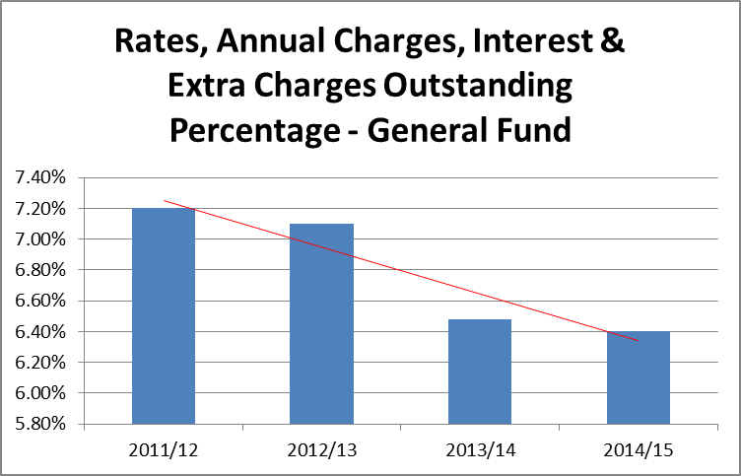

• Monthly mortgage repayments for the Clarence Valley ($1,438) are lower than NSW ($2,132) average and Northern Rivers average ($1,693) –see table below

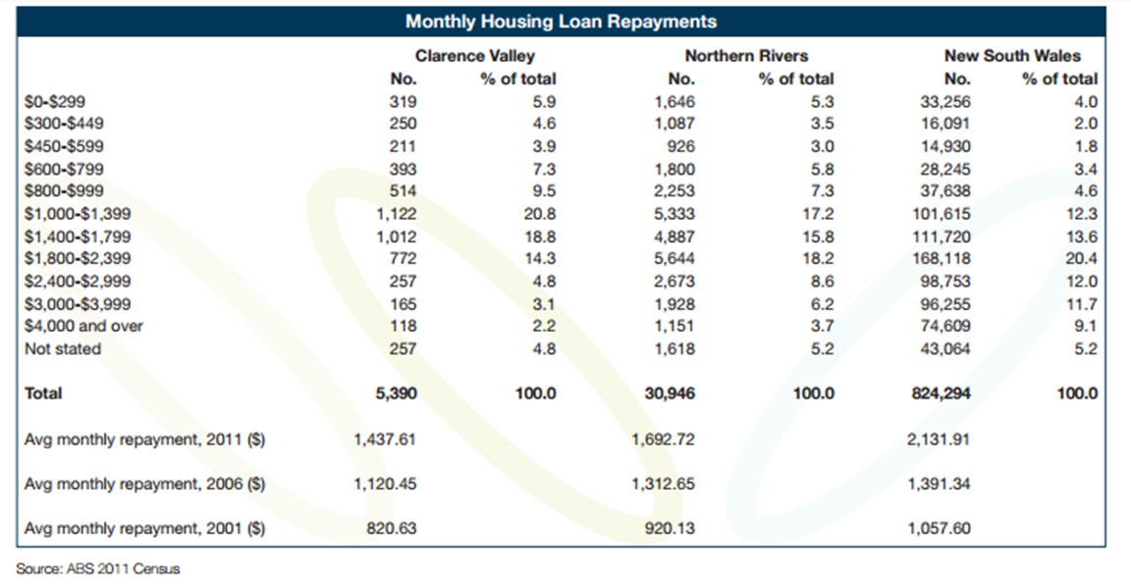

• The median weekly rent for the Clarence Valley Council LGA (per ABS 2011 Census) is $210, which is lower than the NSW average ($300) and lower than the regional NSW average ($220).

**Average Rates - Residential**

An average residential rates comparison with other similar councils **(Group 4 Council’s with a Population Density per capita/km2 of less than 10 (from 2014-15 OLG FDR Data – excluding City of Lithgow Council as accuracy of their rate was not able to be established))** has been considered in two ways. Firstly, Figure 5.2.1 compares the growth in the average residential rates since 2005-06. The graph illustrates that Clarence Valley Council’s growth in its average rate to 2014-15 has been relatively low and is average in comparison to other Council’s in the group.

**Figure 5.2.1:**

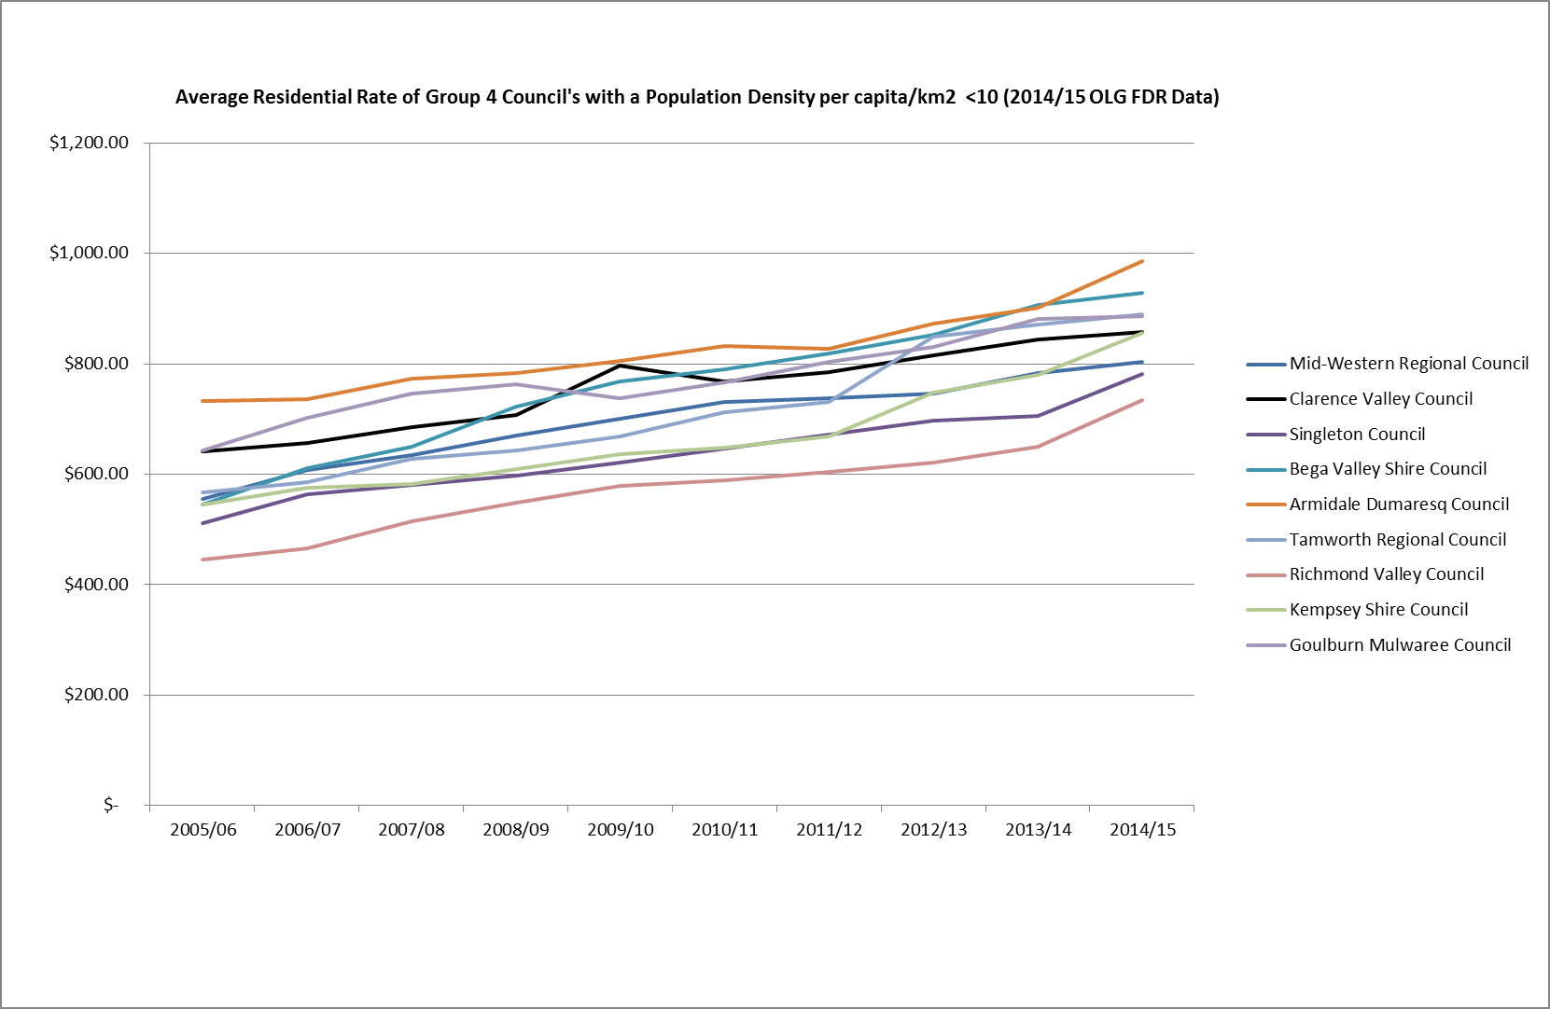

Secondly, in terms of the comparison of average residential rates for the 2014-15 year Clarence Valley Council is average in relation to comparable Group 4 Councils, see Table 5.2.1.

**Table 5.2.1:**



**Average Rates – Business**

Clarence Valley’s Business sector contains approximately 3,872 businesses (as per the 2014 Business Register) operating within 1,474 rateable assessments. With 15% of employment in the Clarence Valley originating from the Health Care sector (ABS Census of Population and Housing 2011), which supplies essential services for the wellbeing of residents within the LGA covering a 10,440 square kilometre area, the importance of a roads and road-related infrastructure network that is adequate, interconnected and maintained is crucial.

Figure 5.2.2 compares the growth in the average business rates since 2005-06 for comparable Group 4 Councils **(Group 4 Councils’ with a Population Density per capita/km2 of less than 10 (from 2014-15 OLG FDR Data))**. The graph illustrates that Clarence Valley Council’s growth in its average rate to 2014-15 has been relatively low and is below average in comparison to other Council’s in the group.

**Figure 5.2.2:**

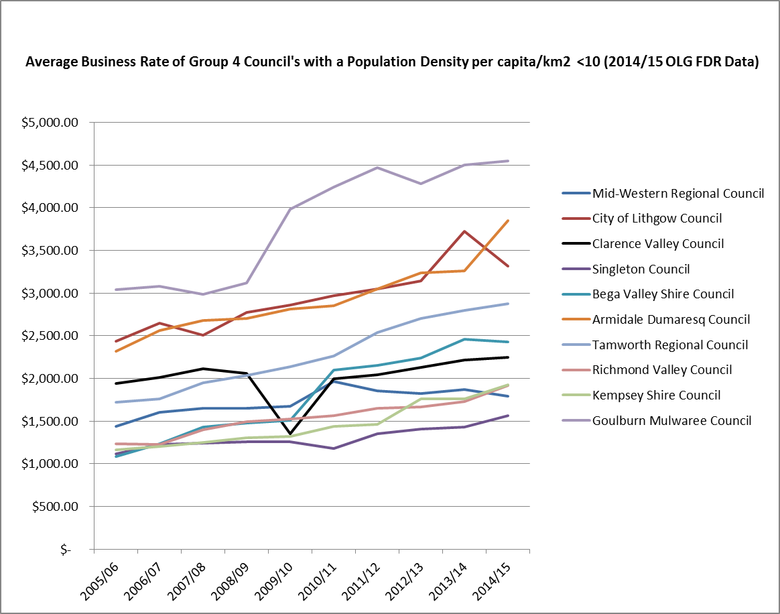

In terms of the comparison of average business rates for the 2014-15 year Clarence Valley Council is well below that of the average for comparable Group 4 Councils. Table 5.2.2 indicates Clarence Valley Council is some $401 below the group average of $2,645.

**Table 5.2.2**



**Average Rates – Farmland**

The average farmland rates for comparable Group 4 Councils **(Group 4 Councils’ with a Population Density per capita/km2 of less than 10 (from 2014-15 OLG FDR Data))** perFigure 5.2.3 shows that Clarence Valley Council’s growth in its average Farmland rate to 2014-15 has been relatively very low in comparison to other Council’s in the group.

**Figure 5.2.3:**

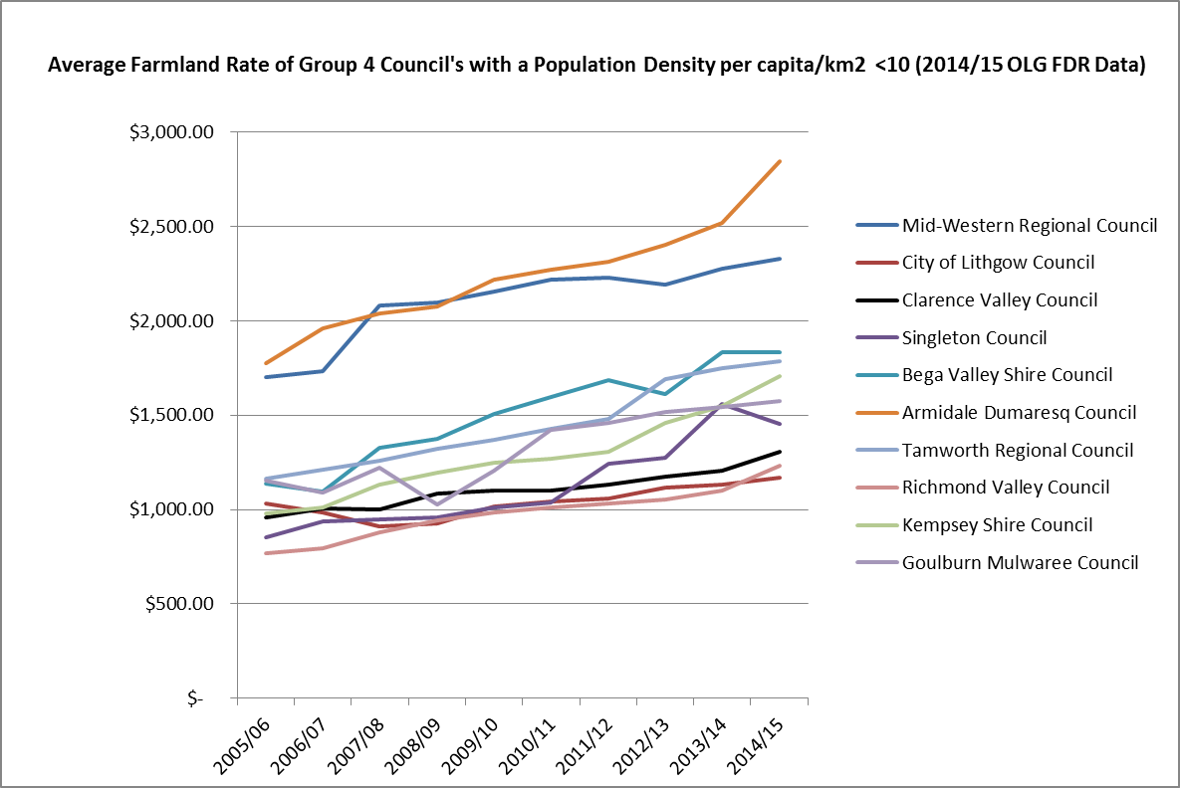

In terms of the comparison of average farmland rates for the 2014-15 year Clarence Valley Council is well below that of the average for comparable Group 4 Councils. Table 5.2.3 indicates Clarence Valley Council is some $418 below the group average of $1,722.

**Table 5.2.3**



Based on the information and analysis provided above of the average Residential, Business, and Farmland rates over the period 2005-06 to 2014-15 the rate increases are considered to be reasonable and there is sufficient evidence to conclude these increases are affordable across the community. Furthermore, based on direct feedback from the community, there is a willingness to pay increased rates in conjunction with a reduction in a range of discretionary services and amenities to support the objectives of addressing Council’s roads and road-related infrastructure renewal backlog and maintenance gap.

**Socio-economic indexes for areas (SEIFA)**

At the 10 December 2013 Council meeting (Item 14.179/13), Council adopted a rating structure based on the principles of simplicity, fairness, uniformity and legislative compliance, taking into account the Socio-Economic Indexes for Areas (commonly known by its acronym, SEIFA).

For the Clarence Valley the relative indexes are as follows:

Index of relative socio-economic disadvantage 2011 index

**Area 2011 index**

South Grafton 830.0

Iluka 868.0

Glenreagh - Lanitza and District 879.0

Rural North West 883.0

Wooli - Tucabia and District 887.0

Maclean 888.0

Rural South West 912.0

Grafton 917.0

Clarence Valley Council area 919.0

Lawrence - Woombah and District 945.0

Yamba 952.0

Ulmarra - Clarenza and District 956.0

Waterview Heights 962.0

Regional NSW 969.0

Gulmarrad - Townsend 979.0

Palmers Island - Angourie & District 995.0

Junction Hill - Southgate & District 996.0

**New South Wales 996.0**

**Australia 1,002.0**

What this data indicates is most of the areas within the Clarence Valley LGA are below the state average in terms of socio-economic wellness. Junction Hill is on par with the State Average, and 166 basis points (20%) ahead of South Grafton, which is on the lower end of the scale. Clarence Valley Council’s relative position to comparable Group 4 Councils is illustrated in Table 5.2.4 below:

**Table 5.2.4**



This information has been considered in terms of addressing the affordability aspect when developing the 2016-17 rating structure. Along those lines, to minimise the impact on the Total Rates Bill for ratepayers Water and Sewer charges increases are capped to a maximum of 1.5% per year for five (5) years from 2016-17 to 2020-21, and CPI from 2021-22 onwards. This option demonstrates Council is listening and responding to the community regarding affordability concerns while staying focused on the objective of addressing the roads and road-related infrastructure renewal backlog and maintenance gap.

## Addressing hardship

In addition to the statutory requirement for pensioner rebates, most councils have a policy, formal or otherwise to address issues of hardship.

|  |  |  |
| --- | --- | --- |
| Does the council have a Hardship Policy? | Yes | No |
| If Yes, is an interest charge applied to late rate payments? | Yes | No |
|  |  |  |
|  |  |  |
| Does the council propose to introduce any measures to reduce the impact of the proposed special variation on specific groups in the community? | Yes | No |

You should attach a copy of the Hardship Policy and explain below who the potential beneficiaries are and how they are assisted.

Please provide details of any other measures addressing hardship to be adopted, or alternatively, explain why no measures are proposed.

The council is also to indicate whether the hardship policy or other measures are referenced in the council’s IP&R documents (with relevant page reference or extract provided).

**Council’s Response:**

**Rates Hardship Policy**

Council has a ‘Rates Hardship Policy’ that was initially adopted in July 2010 and reviewed and again adopted in March 2013 and May 2015. This policy provides assistance for all ratepayers suffering from financial hardship, including writing off interest accrued on unpaid rates and legal costs.

The potential beneficiaries of Council’s Hardship Policy are any rateable people within the Clarence Valley Council LGA that meets the criteria as stated in the policy (see Attachment 33 ‘Rates Hardship Policy’ and Attachment 34 for ‘Hardship Rate Relief Application Form’). Council has referenced its hardship policy on page 99 of the Revised 2014-17 Delivery Program 2014-17 & Operational Plan 2015-16. As this policy has been proven sufficient to address financial hardship, no further measures are deemed to be required at this time.

Council’s ‘Rates Hardship Policy’ can be accessed via Council’s website under the following link:

<http://www.clarence.nsw.gov.au/res.asp?id=6837>

# Assessment criterion 4: Public exhibition of relevant IP&R documents

Criterion 4 within the OLG Guidelines is:

*The relevant IP&R documents must be exhibited (where required), approved and adopted by the council before the council applies to IPART for a special variation to its general revenue.*

Briefly outline the significant IP&R processes the council has undertaken to reach the decision to apply for a special variation. Include the details of and dates for key document revisions, public exhibition period(s) and the date(s) that the council adopted the relevant IP&R documents.[5]

You should also include extracts from council minutes as evidence that the documents were adopted.

The council is reminded that the Community Strategic Plan and Delivery Program (if amended), require public exhibition for at least 28 days prior to adoption. Amendments to the Long Term Financial Plan and Asset Management Plan do not require public exhibition.[6] However, it would be expected that the Long Term Financial Plan would be posted, in a prominent location, on the council’s website.

**Council’s Response:**

**Community Strategic Plan Review – Our Community Plan 2015-2024**

The review of the ‘Our Community Plan 2015-2024’ (CSP) in 2013-14 included a range of engagement options providing the community and other stakeholders the opportunity to contribute and provide feedback on the proposed updates to the 2015-2024 Plan.

The reviewed 2015-2024 Plan was placed on public exhibition from 9 May 2014 and concluded on 6 June 2014. The ‘Our Community Plan 2015-2024’ was adopted by Council at the 24 June 2014 Ordinary Council meeting (Item 12.008/14) - taking into consideration the community submissions made during the exhibition period.

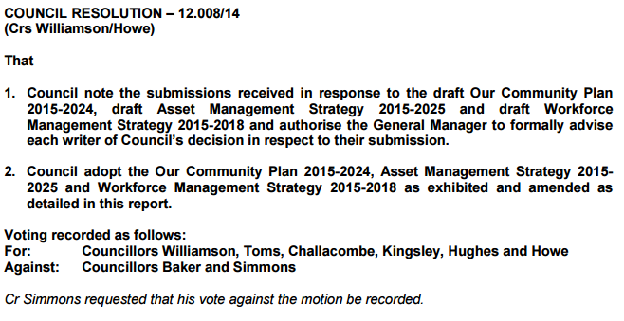

A full copy of the Clarence Valley Council Our Community Plan 2015-2024 CSP can be found using the following link:

<https://www.clarence.nsw.gov.au/page.asp?f=RES-NAH-13-07-78>

The proposed SRV is a key element of Council’s funding strategy to ensure the sustainable management of Council’s roads and road-related infrastructure assets, and works towards achieving a number of the objectives identified within the ‘Our Community Plan 2015-2024’ CSP. The SRV is directly connected to the 2015-2024 CSP themes ‘Infrastructure – providing quality essential infrastructure throughout the Clarence Valley’ (Objective 2.1 & 2.2 as mentioned in Section 3.1 of this application, “Society” (Objective 1.1.1 “provide vibrant and welcoming town centres, streets, and meeting places’’), “Economy” (Objective 3.1.3 “facilitates government funded infrastructure and services to match business and industry development in the region (education, transport, health)’’), and “Leadership” (Objective 5.2.1 “provides services that meet benchmarks determined by the community, having regard to quality and cost’’, Objective 5.2.2 “operates in a financially responsible and sustainable manner’’, Objective 5.2.3 “ensures existing and future infrastructure is affordable, funded, managed and maintained to ensure inter-generational equity and sustainability’’, and 5.2.4 “ensures financial sustainability and the community’s capacity to pay inform adopted community service levels”).

**Revised 2014-17 Delivery Program and 2015-16 Operational Plan, Revised 2015-16 to 2024-25 Long Term Financial Plan, and Revised Asset Management Strategy**

The 2014-2017 Delivery Program is a blueprint that shows how Council’s 46 Services – its ‘principal activities’ - respond to the Community Strategic Plan. It follows the thematic structure of ‘Our Community Plan 2015-2024’. All of the organisation’s plans, projects, actions and funding allocations are directly linked to the Delivery Program. The Long Term Financial Plan explains the financial strategies used to inform decision making during the development of the Delivery Program, and the Asset Management Strategy (AMS) provides a plan to manage Council’s physical assets, including establishment of a framework to guide planning, construction, maintenance and operation of infrastructure essential for Clarence Valley Council to provide services to the community

The AMS was adopted by Council at the 24 June 2014 Ordinary Council meeting (Item 12.008/14) and was based on 2013 data. It was acknowledged in the Council report that the AMS needed to be reviewed and updated periodically.

The Draft Delivery Program 2014-2017, 2015-16 Operational Plan including 2015-16 Revenue Policy and Budget (Item 14.105/15) and the Draft Long Term Financial Plan 2015-16 to 2024-25 (Item 14.106/15) were adopted for exhibition period from 15 May 2015 to 12 June 2015 at the 12 May 2015 Extraordinary Council Meeting.

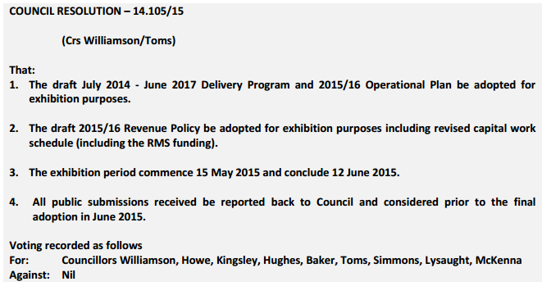

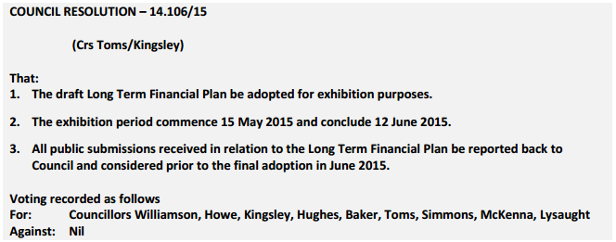

Also at the 12 May 2015 Extraordinary Council Meeting (Item 14.104/15) Council resolved to instruct the General Manager to carry out public consultation on increasing the revenue via a special rate variation of 8 % per year (including the rate peg limit) for a 5 year term.

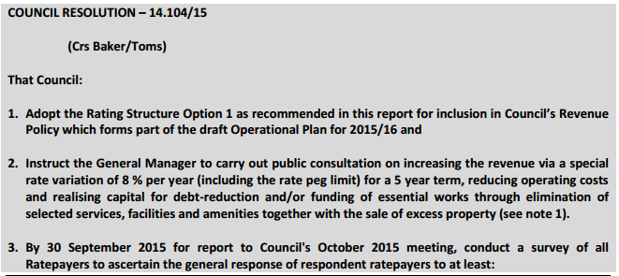

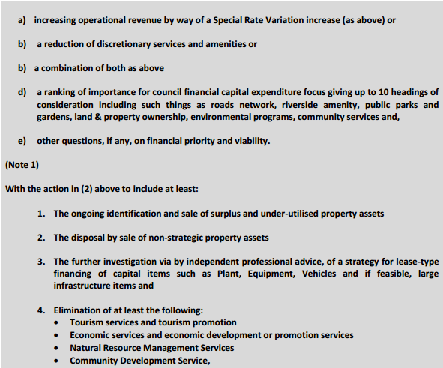

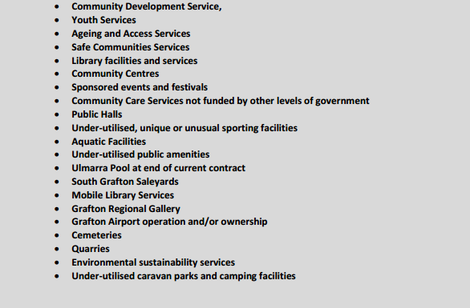



In adopting the original 2014-17 Delivery Program and 2015-16 Operational Plan at the 23 June 2015 Ordinary Council Meeting (Item 12.020/15) Council instructed the General Manager to start public consultation on a proposal to increase Council’s general rate revenue via a SRV of 8% p.a.

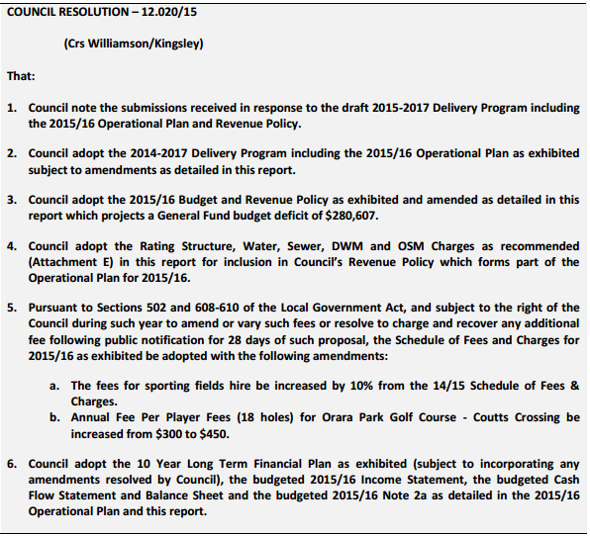

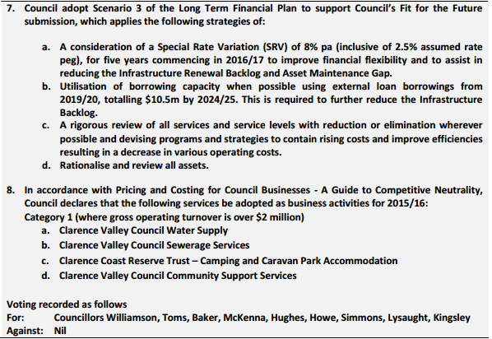

At the 24 November 2015 Extraordinary Council meeting (Item 12.060/15 – see below), Council resolved to apply for a Section 508(A) SRV of 6.5%p.a. for 5 years commencing 1 July 2016.

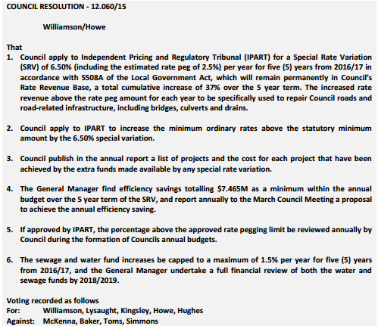

Discussions with IPART subsequent to the above resolution established that Council was required to revise its 2014-17 Delivery Program and 2015-16 Operational Plan, Long Term Financial Plan 2015-16 to 2024-25, and Asset Management Strategy.

Council at its ordinary meeting on 8 December 2015 (Item 14.221/15) adopted the Revised 2014-2017 Delivery Program including the Revised 2015-16 Operational Plan and Revenue Policy, the Revised Long Term Financial Plan 2015-16 to 2024-25, and Revised Asset Management Strategy for public exhibition.

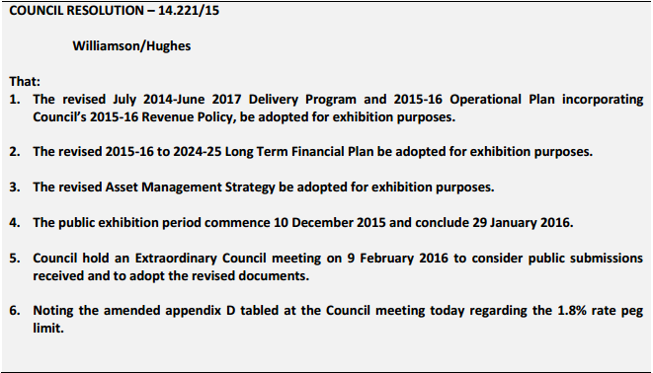

Key changes incorporated in the Revised Long Term Financial Plan and Revised Delivery Program included:

a) Changing the SRV from 8% p.a. to 6.5% p.a. over the SRV period.

b) An explanation of the compounding effect of the Section 508(A) SRV over the 5 years commencing 1 July 2016 and that this impact is built into the general rate after the 5 year SRV period has ceased.

c) That the amount of additional income generated above the rate peg over the 5 years from the SRV is stated.

d) The need for the SRV, and the program of works to which the additional income generated from SRV will be applied is stated.

e) Keeping Water and Sewer Charges increases capped to a maximum of 1.5% per year for five (5) years from 2016/17 to minimise the impact to ratepayers on their total rates bill from the increase in ordinary rates as a result of the proposed 6.5% p.a. SRV.

f) Efficiency savings of $7.465 million p.a. (the gap between the 8% p.a. to 6.5% p.a. SRV), to be realised by 2020-21 and each year thereafter.

The Final Draft Updated Asset Management Strategy adopted on 18 August 2015 (Item 14.145/15) was also updated for the above changes, the 2014-15 Annual Financial Statements Special Schedule 7 Report on Infrastructure Assets data, and updated Asset Management Plan information.

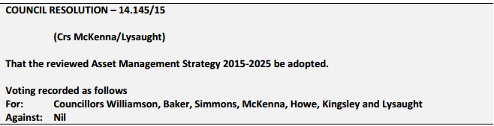

The revised 2015-16 to 2024-25 Long Term Financial Plan/2014-17 Delivery Program and 2015-16 Operational Plan/Asset Management Strategy were exhibited publicly from Thursday 10 December 2015 to Friday 29 January 2016 and were on display at Council’s administration offices, advertised in Council’s block ads in local newspapers and on Council’s website. No submissions were received.

At the 9 February 2016 Extraordinary Council meeting, the revised documents, which included further changes to the Revenue Policy section of the 2014-17 Delivery Program to clarify the methodology for the charging of Water and Sewer Connection fees and to add a reference to Council’s Rates Hardship Policy, were adopted (Item 12.001/16).

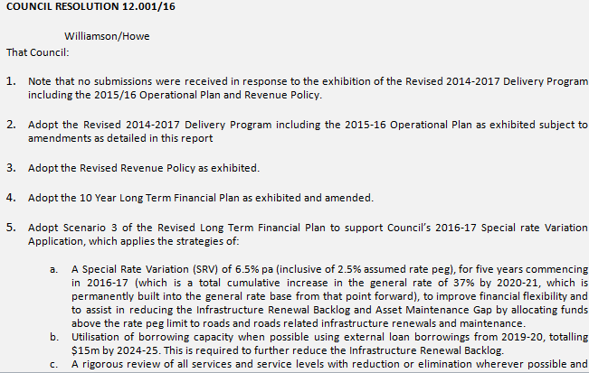

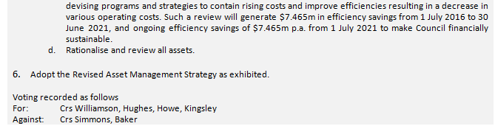

Council’s Revised 2014-17 Delivery Program and 2015-16 Operational Plan, Revised 2015-16 to 2024-25 Long Term Financial Plan, and Revised Asset Management Strategy can be found in the ‘Download Documents’ section of the ‘Delivery Program and budget’ page on Council’s website, located at:

<https://www.clarence.nsw.gov.au/cp_themes/metro/page.asp?p=DOC-CFK-74-67-61>

# Assessment criterion 5: Productivity improvements and cost containment strategies

Criterion 5 within the OLG Guidelines is:

*The IP&R documents or the council’s application must explain the productivity improvements and cost containment strategies the council has realised in past years, and plans to realise over the proposed special variation period.*

In this section, you must provide details of any productivity improvements and cost containment strategies that you have implemented during the last two years (or longer) and any plans for productivity improvements and cost containment over the duration of the proposed special variation.

These strategies, which may be capital or operational in nature, must be aimed at reducing costs and/or improving efficiency. Indicate if any initiatives are to increase revenue e.g., user charges. Please include below whether the proposed initiatives (i.e., cost savings) have been factored into the council’s LTFP.

Where possible, the council is to quantify in dollar terms the past and future productivity improvements and cost savings.

The council may also provide indicators of efficiency, either over time or in comparison to other relevant councils. We will make similar comparisons using various indicators and OLG data provided to us.

**Council’s Response:**

This section of the Clarence Valley Council SRV submission is in two parts. Part 1 is the “Productivity improvements and cost containment strategies for the last two years” and Part 2 provides an overview of the “Plans for productivity improvements and cost containment during the period of the special variation”.

**Part 1. Productivity improvements and cost containment strategies for the last two years (2013-15)**

Council has been proactive in addressing its financial sustainability challenges, introducing a range of cost saving and cost containment strategies over the past two years that have delivered a notable improvement in 2014-15 and is continuing to do so in 2015-16. Council developed a number of operational initiatives based on the adopted budget principles, which are outlined in the current 2014-2017 Delivery Program. The initiatives undertaken to date include:

***Organisational Restructure***

In August 2015 Council implemented an organisational restructure that resulted in staff reductions in some areas and a vital capability growth in the targeted area of asset management. The restructure also broadened Council’s lower levels of management, the purpose of which is to remove bottlenecks in workflow processes (i.e. approvals) in order to increase productivity and reduce time in lieu and overtime for senior management.

• *Restructure capability development in Asset Management*

Part of the organisational restructure included staff growth in asset management, an area considered business critical and identified as lacking in the organisational review preceding the restructure.

A new team, The Infrastructure Planning & Assets Team, has been formed to plan and manage assets at a corporate level. To date the organisation has not been serviced by proper asset management practices and, as such, it’s planning toward asset renewals, upgrades and maintenance has been of a low level. This team (4 people) will aid the works and civil department from an infrastructure perspective and have close links with Council’s Finance and Organisational Performance and Governance (OP&G) sections to ensure sustainable asset management and infrastructure planning practices are undertaken by Council.

***Asset disposal***

Over the past two years Council has reviewed its assets and started on a surplus asset disposal program. Significant heavy plant disposals (for assets not replaced) over the 2013-14 and 2014-15 financial years saved Council $361,000. As a result there are expected annual operational and maintenance savings to be realised from these disposals.

***Reduction in services***

In the past 24 months Council has assessed all of its services and changed the way in which many services are delivered. Significant savings have been realised already, with some notable areas being:

• Assignment of the Crown lease for the South Grafton Aerodrome to a community group.

• Devolving the operation and maintenance of the Coutts Crossing Croquet Court to the Coutts Crossing Croquet Club saving around $19,000 a year.

• Devolving the operation and maintenance of Jabour Park South Grafton to a community group saving around $5,000 a year.

***Other Productivity Improvements***

• For the 2015-16 financial year Council received an $110,000 Workers Compensation financial incentive payment for meeting Statecover KPIs. This is $50,000 more than budgeted for and reflective of WHS being well managed. In 2014-15 a $60,000 incentive was achieved.

• Movement to online human resources systems in 2015:

- During the purchase of an on line induction system in 2015, Council negotiated to include the acquisition of a Learning Management System (LMS) at nil cost ($20,000 saving). The LMS will enable on line delivery of courses at a vastly reduced cost. Four courses have been purchased from Learning Seat at a cost of $750 each, for delivery to all staff, e.g. EEO, WHS, Bullying/Harassment. For comparison, bullying & harassment training in 2014 cost $32,000 to deliver to all staff in a face to face environment.

- In 2015 recruitment advertising has primarily been online, with very few paper-based advertisements. This has realised a $10,000 saving in the 2015 calendar year. It is intended to continue with online advertising and with the purchase of unlimited packages and negotiation on price, a further $5 - $10,000 saving is anticipated.

• Complete upgrade of heating, ventilation and air conditioning systems (HVAC) in main administration centres at 2 Prince and 42 Victoria Street, Grafton, expected to realise annual savings of $40,000. Removal of inefficient, aging and ozone depleting HVAC system in these offices.

• All major building cleaning contracts reviewed with a saving of approximately $70,000.

• Review of all tender and contract documentation to standardise systems and processes across the organisation.

• Implemented gas flaring project at the Grafton Regional Landfill to reduce greenhouse gas emissions and future liability.

• Trainee staff have been engaged in scanning numerous Council paper-based records. This has reduced costs for storage of records (i.e. air conditioning, rental of storage sheds) and records management staff costs to retrieve data.

• Review work location arrangements progressively across the organisation with particular consideration to improved asset utilisation and productivity improvements. In November to December 2015 staff were transferred from Pound St Grafton office to 42 Victoria St and Prince Street, Grafton, offices to enable 70 Pound Street office to be sold or leased.

• July 2015 – new purchasing & tendering procedures implemented in accordance with Council’s Sustainable Procurement Policy. This has led to reduced operating costs as procurement has moved from being planned reactively.

• Introduction of “SmartyGrants” management tool to streamline community grant application and monitoring.

***Other Cost Containment initiatives***

• Prior to preparing the Draft 2015-16 Budget a review of Council services was undertaken. This review identified Council provides 46 services comprising 109 sub-services. The services and sub-services have been identified as either being a non essential service (i.e. Discretionary) or an essential service that Council must provide (i.e. Non-Discretionary). For the 2015-16 financial year Council introduced zero based budgeting methodologies whereby each budget amount was built from the ground up for each of these services. Where possible, all amounts included have been justified by relevant staff based on 2014-15 Budget service levels.

• During 2013-14 Council had all infrastructure assets independently re-valued, which resulted in our depreciation expense (pre-capitalisation) reducing from $48.1 million (2012-13) to $34.3 million (2013-14) and that improved Council’s operating result for 2013-14 by $13.8 million.

• Our Loan Borrowing Policy and debt level has been independently assessed by Ernst & Young (refer item 14.064/15 April 2015 Council meeting). This review indicated Council’s existing debt levels ($126 million as at February 2015) have exceeded what Ernst & Young consider to be acceptable levels i.e. $110 million, and increasing debt levels particularly in Council’s General Fund was not recommended. The Ernst & Young report also examined the options available to refinance the existing debt, given the current record low interest rates. However, after market testing it was determined savings from refinancing were limited due to the significant break costs – only $42 million of Council’s total portfolio was considered feasible for refinancing. The refinanced loan will achieve interest savings for Council of some $621,000 over 13 years and cash flow savings of $3.4 million during the first five (5) years of the refinanced loan.

• A review of Council's Telstra contract has realised savings on phone calls & data plans of $100,000 between 1/7/13 and 30/6/15, with ongoing annual savings of $50,000 p.a. expected from 1/7/15

• Increased skills base of Council IT staff has enabled many services previously outsourced to be provided in house. Such services include; server virtualisation (reducing licencing and hardware costs), SQL Server upgrade (savings $20,000 p.a. in consultancy costs), cabling of offices (saving $50,000 over the past 2 years), in-house website development in collaboration with NOROC members (compared with hosted content management system this approach is saving Council $100,000 p.a.)

• ADSL rationalisation i.e. using NBN connections instead of leased lines is saving council $72,000 p.a.

• A review of the pool management contract for Maclean pool with a new contract in place has resulted in savings and efficiencies as the contractor is meeting all chemical and power costs for the operation of the pool.

• Changes to weekly statutory and other advertising introduced in June 2015 resulted in annual savings of about $70,000.

***Revenue enhancement initiatives***

• Sports tourism collaborative marketing - $21,000 additional income p.a. generated over the past two years through an arrangement we have with Sports Marketing Australia. Local businesses (e.g. clubs, hotels, etc.) sign up through Sports Marketing Australia to sponsor our sports tourism program.

• As a result of an independent review of Fuel Tax Credits Council was able to claim an additional $196,000 in 2013-14. Additional ongoing Fuel Tax Credits as a result of this review have been calculated at $75,000 p.a.

• A Credit Card Surcharge was introduced in the 2014-15 financial year. Over the 2014-15 and 2015-16 financial years the surcharge has generated income of $36,000 offsetting direct banking costs to Council.

**Part 2: Plans for productivity improvements and cost containment during the period of the special variation (2016-17 to 2020-21).**

The prospect of the necessity for a special rate variation has been raised over a number of years. Council’s approach has been to close the sustainability gap as much as possible prior to applying for an SRV. The 2015-2016 Revised LTFP covers previous initiatives (and outcomes), those still progressing and planned initiatives in the immediate future (and built into LTFP projections), to achieve increased annual efficiency savings over the five-year SRV period.

Council is committed to meeting our projected savings targets. These are represented in Council’s strategic plans and are extracted below:

***Asset Disposal***

Strategic asset disposal has been planned across Council operations and includes:

• Capital injection from the sale of $5.305m properties which include:

- Industrial land at 32 Mulgi Drive, South Grafton, (estimated annual operations and maintenance savings of $3,350)

- The former regional library site at 110 Spring Street, South Grafton, (estimated annual operations and maintenance savings of $18,320)

- Combining five depots at Grafton into two. Depots to be disposed include; 28 Bruce Street, Grafton, (estimated annual operations and maintenance savings of $112,000. Note - does not account for annual lease payments until new depot is built and new depot operating costs), 11 Schwinghammer Street, South Grafton, (estimated annual operations and maintenance savings of $80,000. Note - does not account for annual lease payments until new depot is built and new depot operating costs), Lilypool Road, South Grafton, (estimated annual operations and maintenance savings of $14,000), and 33 Brickworks Lane, South Grafton, (estimated annual operations and maintenance savings of $17,000).

- Administration buildings at 42 Victoria Street Grafton (estimated annual operations and maintenance savings of $137,000 - Note - does not account for annual lease payments until new depot is built and future operating and maintenance costs for new works administration as part of new depot), 70 Pound Street, Grafton, (estimated annual operations and maintenance savings of $49,000), and 2 McNaughton Place, Maclean. Administration offices (estimated annual operations and maintenance savings of $13,000).

• 2015-16 – planned review of all Council landholdings including “pocket parks” in urban areas which may be surplus to Council/community needs

• 2016-17 - review provision of public halls – council currently controls 37 public halls

• 2016-17 - review provision of the 12 public tennis court complexes that council maintains

• Review of all residential and commercial properties and their tenures.

***Reducing the asset backlog***

The budget principles endorsed by Council included a commitment to reduce Council’s infrastructure backlog ratio to less than 2% over the next 10 years (which amounts to $35 million as at 30.6.15). This reduction has been included in Council’s current LTFP in scenario 3 as part of this application.

The asset backlog reduction will remove the ongoing maintenance expenditure required on those assets demolished and expenditure will be reduced in others as they will be returned to a satisfactory condition. Examples are:

• Demolition and removal of four public toilets in Grafton and South Grafton.

• Demolition and upgrade of seven public toilets in all areas to improve accessibility and function.

• Undertaking the depot rationalisation project to remove four redundant and ageing depots sites to be replaced with one new depot in South Grafton.

• Demolition and removal of four public toilets at Kent Street Grafton and Beresford Park, Durrington Park and JJ Lawrence Fields South Grafton realising an annual operation and maintenance saving of approximately $18,000. In addition a future closure of a further public toilet in Spring Street South Grafton.

• New loan borrowings to fund projects associated with reducing Council’s Infrastructure Renewal Backlog, thereby reducing asset maintenance costs. Loans projected under revised 2015-16 LTFP in General Fund for these purposes are:

o 2019-20 $2.5m

o 2020-21 $3m

o 2021-22 $1.5m

o 2022-23 $2.5m

o 2023-24 $2m

o 2024-25 $3.5m

***Reduction in services***

Per Item 12.060/15 of the 24 November 2015 Extraordinary Council Meeting, $7.465 million p.a. in ongoing efficiency savings must be achieved before 30 June 2021. These savings need to be identified and reported to the March 2016 Council meeting. Actions to achieve such savings include;

• Rubbish collection services – the review will include analysis of the collection service for public areas that is partly contracted and partly undertaken by staff. There is likely to be operational savings and efficiencies through the review in off-season collections in tourist areas

• Public toilet cleaning – with the rationalisation and upgrade of public toilets greater efficiency has been obtained in cleaning operations. Review of public toilet cleaning is scheduled following implementation of the new staff structure to ensure service provision is equitable and appropriate for seasonal use.

• Mowing operations – service levels for parks and sports field mowing have been reviewed and are being reviewed as a new staff structure is implemented across Open Spaces and Facilities.

• Review of the management and operation of Clarence Lawn and Maclean Lawn cemeteries. It is not possible to identify savings from the review at this stage, however alternate models of delivery of this service currently operating in other local government areas will be investigated.

• Pool contracts to be reviewed at Grafton, South Grafton, Ulmarra and Yamba pools with a view to realise operational savings. This contract review will take place during 2016 and based on the experience at the Maclean pool contract review may realise operational savings and efficiencies in administration.

• Senior staff currently reviewing levels of service, including the elimination of certain discretionary services. Discretionary and non essential services identified previously by Council in the Fit for the Future submission (refer Item 12.023/15, Council meeting 23 June 2015) for review include:

o Mobile Library Service

o Regional Art Gallery

o Quarries & Saleyards

o Floodplain Voluntary House Raising

o Aquatic facilities

• Market testing service provision against options for contracting the service i.e. broad acre mowing/slashing services in 2016.

• A light fleet & heavy plant review was recently completed, which projects estimated savings of $400,000 to $600,000 p.a. (realised within a five-year timeframe) plus significantly reduced risk if all recommendations are implemented. Some of the recommendations include extending changeover of Light Fleet from two years or 80,000km to five years or 150,000km, extending change-over of graders to 12 years or 10,000 hours subject to a risk assessment beyond eight years or 8,000 hours, and disposal and increased utilisation of skid steer loaders.

• Implementation of the adopted playground policy and strategy with a reduction of overall playgrounds from 58 to 37, resulting in fewer smaller quality playgrounds but improved facility experience through a structured hierarchy. The levels of service are matched to community expectations - 58 playgrounds (1 district, 57 local playgrounds) to 37 playgrounds (1 regional playground; 14 district playgrounds; 22 local playgrounds).

The playground planning process initially revealed that over the next 10 years, Council forecast it would have ~24% (Asset Renewal Funding Ratio) of the funds required for the optimal renewal and replacement of its playground assets. Through the adoption of asset management principles by Council, this developed scenario now forecasts that it has ~100% (Asset Renewal Funding Ratio) of the required funding indicating financial sustainability. The cumulative replacement value has reduced from $4,095,000 to $3,503,000. Annual operations and maintenance savings will be determined once rationalisation works completed.

• Continue to licence, lease and devolve operation of specialist community sports facilities to user groups.

***Other productivity improvements***

• Movement to online human resources systems in 2016:

- Staff inductions will move from being face-to-face to online in 2016, which will result in annual staff savings of $4,000.

- Face-to-face Microsoft training was last run in 2014 at a cost of $15,000 and provided training for 50 participants, i.e. cost per participant $300 in any one package. Council will move to on line training for Microsoft products in 2016, which will enable this training to be delivered at a cost of $50 per participant. When delivered to 50 people, a saving of $12,500 is realised.

- Assessments for competency purposes have been costing $50 or $75 per participant. This cost is now included in the on-line training module, so is a complete saving. Currently there are approximately 60 assessments required, with a potential saving of $4,500.

- An employee portal will be developed, enabling staff to manage their own payroll deductions and banking arrangements, a saving in human resource section wages of approximately $5,500 per annum will result.

• Reduced contracting for routine maintenance of buildings and facilities such as swimming pools and parks structures by direct employment of staff will result in reduced costs, rapid response and improved service levels.

• Move to consolidate and rationalise in excess of 90 Crown Reserve Trusts with NSW Trade and Investment to improve administration and reporting.

• Review Section 355 Committees across all operations.

• Expand the use of mobile in-field technology to capture asset condition and risk management data.

• Review work location arrangements progressively across the organisation with particular consideration to improved asset utilisation and productivity improvements, including;

- In 2015-16 transfer staff from admin office McNaughton Place, Maclean, to 50 River Street, Maclean

- In 2017-18 consolidate works depot and engineering staff into new depot at South Grafton

- In 2018-19 consolidate all administration staff into new refurbished Prince Street, Grafton, administration office

Operational efficiencies to be achieved – estimated to be $250,000 per year from 2015-16 to 2018-19.

• Improved field-based access and usage of asset data systems. From 2015-16 to 2017-18 continued implementation of electronic data collection of field-based asset data will lead to reduced “double handling” of asset data and allow more intelligent use of data to enable robust decision making in the management of Council’s assets.

• Continued participation in Mid North Coast Councils (MIDROC) Asset Management Project. The objectives of the project are to enable a consistent approach to:

- Assessing asset condition.

- Level of service definition/measurement

- Valuing assets and determining useful life.

- Calculating the infrastructure backlog.

- Calculating the required annual maintenance.

• In July 2016 council will implement new budgeting software that will improve financial modelling for the operational plan and long term financial plan budgets and improve performance reporting to enable informed decisions to be made.

• In July 2016 council will upgrade our Electronic Records Management System (ECM) to the latest version to enable better integration with Council’s other corporate systems. Better integration will result in operational efficiencies and improved business reporting.

• Review of the service delivery model for library and community development services - actions include;

o 2016-17 - commence review/investigate relocation of Yamba Library to Treelands Drive Community Precinct – Yamba

o 2016-17 - commence review/investigate relocation of Maclean Library to 50A River Street, Maclean, to create community precinct for Maclean

o 2017-18 - extend Treelands Drive Community Centre to accommodate Yamba Library

o 2018-19 - dispose/lease Wooli Street, Yamba, library & public hall

o 2018-19 - relocate Maclean Library to 50A River Street, Maclean, community precinct

o 2019-20 - dispose/lease Maclean Library building Stanley Street, Maclean

• Continuous rolling operational reviews of Council business units and implementation of progressive changes where considered necessary in line with identified service delivery standards and associated methods of delivery. Strategies include:

- 2015-16 to 2019-20 - Managers required to review section staff structures on an annual basis and all staff vacancies require Executive approval to proceed with recruitment (Savings from vacancies during recruitment $200,000 a year).

- 2015-16 to 2019-20 Business unit reviews to include business process reengineering to minimise costs through elimination of wastage and improvements in productivity.

***Other Cost Containment initiatives***

• Continue to utilise the sustainability cash reserve to undertake projects that focus on energy mitigation to realise an operational saving by reduced electricity and power costs in major buildings, depots and specific community buildings.

• Reviewing the potential for power generation from waste at the Grafton Regional Landfill.

***Revenue enhancement initiatives***

It has been essential for Council to maintain a focus on revenue enhancement as well as expenditure reduction to achieve the closing of the sustainability gap. Increased revenue and reduced expenditure assist in improving Council’s net operating position.

The revenue enhancement initiatives that have been identified and pursued are as follows:

• Strategic review completed of Grafton Regional Saleyards and moving to considering an alternate leasing structure for saleyard operations.

• Continued review of all fees and charges for the use and hire of buildings, and sports facilities.

• Annual dividend from surplus payments in accordance with Best Practice Management for Water Supply and Sewerage Guidelines, from Water & Sewer Operations for 2016-17 onwards, between $0.9 million and $1 million p.a.

• Review of Section 94 Plan works schedules to align with asset management plans to reduce Council’s commitment to the identified capital works – mid 2016

• As part of the building rationalisation process there will be relocation of Care & Support Services in Grafton and Maclean, moving them from private rentals to Council accommodation owned by Council’s General Fund. This will generate additional income for General Fund of $50,000 p.a. as Care & Support Services are a fully-funded business activity.

**Conclusion**

In summary the improvements Council has achieved to date has made a significant improvement in Council’s financial sustainability. However, due to the substantial infrastructure backlog, the progress and performance improvements to date are insufficient to ensure financial sustainability. As demonstrated in Council’s Revised 2015-16 to 2024-25 LTFP Scenario 3, the SRV initiative, providing sufficient funding to address the infrastructure backlog is vital to Clarence Valley Council progressing from ongoing deficits to a sustainable position of operating surpluses.

Council has progressively engaged in a series of ongoing service reviews, revenue enhancement and expenditure reduction opportunities. The significant improvement and restructuring work undertaken by Council to date, means future opportunities for further cost reduction may be limited. A service-by-service ongoing assessment of further reduction opportunities is still underway and, while many areas do not provide capacity for reduction, any opportunities to support financial sustainability in parallel with the SRV will be considered.

The option to reduce discretionary service levels is being considered, but based on community feedback from recent externally-managed customer surveys further service reductions would not be welcomed or supported by the community. It would also not be considered judicious to reduce expenditure on assets already suffering a backlog as any savings would be limited, short-sighted and, in the final analysis, counterproductive to the goal of financial sustainability.

# List of attachments

The following is a list of the supporting documents to include with your application.

Some of these attachments will be mandatory to all special variation applications eg, extracts from the Community Strategic Plan.

Other attachments will be required from some, but not all, councils. For example, extracts from the Asset Management Plan would be required from a council seeking approval of a special variation to fund infrastructure.

Councils should submit their application forms and attachments online through the Council Portal in the following order. Councils may number the attachments as they see fit.

|  |  |
| --- | --- |
| Item | Included? |
| **Mandatory forms and Attachments** |  |
| Part A Section 508A and Section 508(2) Application form (Excel spreadsheet) |  |
| Part B Application form (Word document) – this document |  |
| Relevant extracts from the Community Strategic Plan **(see Attachment 8)** |  |
| Delivery Program **(see Attachment 25)** |  |
| Long Term Financial Plan with projected (General Fund) financial statements (Income, Cash Flow and Financial Position) in Excel format **(see Attachment 7)** |  |
| NSW Treasury Corporation report on financial sustainability **(see Attachment 9)** |  |
| Media releases, public meeting notices, newspaper articles, fact sheets relating to the rate increase and proposed special variation **(see Attachments 16,17,18, 19,20,21,22,23,24, and 35)** |  |
| Community feedback (including surveys and results if applicable) **(see Attachments 1,14,15,27,28, and 29)** |  |
| Hardship Policy **(see Attachment 33)** |  |
| Resolution to apply for the proposed special variation**(see Attachment 2)** |  |
| Certification (see Section 9) **(see Attachment 36)** |  |
| **Other Attachments** |  |
| Relevant extracts from the Asset Management Plan **(see Attachment 5)** |  |
| Past Instruments of Approval (if applicable) **Not Applicable** |  |
| Resolution to adopt the revised Community Strategic Plan (if necessary) and/or Delivery Program **(see Attachment 25 for Revised 2014-17 Delivery Program and 2015-16 Operational Plan)** |  |
| Other (please specify)   * **IRIS Consulting Presentation 20 October 2015 Council Meeting (see Attachment 1)** * **Council Resolution on Property Sales (see Attachment 3)** * **Council Resolution on Review of Light Fleet & Heavy Plant (see Attachment 4)** * **Hydroscience Water & Sewer 2016-17 LTFP (Attachment 10)** * **Extract of Assessment of Fit for the Future Proposal October 2015 (Attachment 11)** * **Community Engagement Strategy (Attachment 12)** * **Letter to Ratepayers from General Manager (Attachment 13)** * **Media Release re 1.8% rate peg (Attachment 26)** * **Summary of submissions with names redacted (Attachment 29)** * **Group 4 Councils Residential Rate Comparison (see Attachment 30)** * **Group 4 Councils Business Rate Comparison (see Attachment 31)** * **Group 4 Councils Farmland Rate Comparison (see Attachment 32)** * **Hardship Rate Relief Application Form (see Attachment 34)** |  |

# Certification

**APPLICATION FOR A SPECIAL RATE VARIATION**

**To be completed by General Manager and Responsible Accounting Officer**

Name of council: Clarence Valley Council

We certify that to the best of our knowledge the information provided in this application is correct and complete.

General Manager (name): Scott Greensill

Signature and Date: 12/2/2016

Responsible Accounting Officer (name): Matthew Sykes

Signature and Date: 12/2/2016

Once completed, please scan the signed certification and attach it as a public supporting document online via the Council Portal on IPART’s website.

1. The Guidelines are available at [www.olg.nsw.gov.au](http://www.olg.nsw.gov.au)
2. See [www.ipart.nsw.gov.au](http://www.ipart.nsw.gov.au).
3. See Planning Circular 10-025 dated 24 November 2010 at [www.planning.nsw.gov.au](http://www.planning.nsw.gov.au) and for the most recent Direction issued under section 94E of the *Environmental Planning and Assessment Act 1979*. See also Planning Circular PS 10-022 dated 16 September 2010.
4. [http://www.ipart.nsw.gov.au/Home/Industries/Local_Govt/Special_Variations_and_  
   Minimum_Rates](http://www.ipart.nsw.gov.au/Home/Industries/Local_Govt/Special_Variations_and_Minimum_Rates)
5. The IP&R documents are the Community Strategic Plan, Delivery Program, Long Term Financial Plan and where applicable, the Asset Management Plan.
6. Office of Local Government (then Division of Local Government), *Integrated Planning and Reporting Manual for local government in NSW*, March 2013, pp 5-6.